

Dynamics 365 Nonprofit Accelerator

Demo Guide

**Published**: December 2020

**Accelerator Release Version**: v3.0

Contents

Nomenclature Update 4

Nonprofit Accelerator 4

Constituent Management 5

View Individual 5

View Household 7

View Benefit Recipient 8

View Organization 9

Fundraising 11

View Fundraising Dashboard 12

View Donor Commitment 12

View Planned Gift 15

Awards 16

View Award Disbursements 17

Delivery Framework 23

Program Delivery 23

View Program Delivery Dashboard 29

Project Management and Program Design 30

Sample Theory of Change 30

Case Management 35

Sample Work Item 35

Assessment 38

Sample Operation 39

Frontline Humanitarian 43

Sample Item Request 43

Program Design Canvas App 47

Personas 47

Additional Resources 47

Application Overview 48

Browse Logframes 48

Build a Logframe 48

My Logframes 48

Browse Indicators 48

Find and View a Logframe 49

Browse Logframes: View all Logframes 49

My Logframes: View only your logframes 57

View and Modify Logframe Status 58

Edit and Delete a Logframe 59

Edit a Logframe 59

Delete a Logframe 60

Create a Logframe 62

Initiate Logframe Creation 62

Enter Project Info 62

Access Contextual Help 63

Select Outcomes 64

Select Outcome Indicators 66

Enter Outcome Notes 69

Enter Outputs & Activities 70

Prepare Logframe for Review 73

Preview the Logframe 73

Send Logframe for Review 73

Browse Indicators 75

Browse Internal Indicators 75

Browse Standard Indicators 76

IATI 78

Key Tables & Navigation 78

IATI File Export process 78

IATI References 87

Administration 88

# Nomenclature Update

Please note that the follow names have been updated and changed ([More Information](https://docs.microsoft.com/en-us/powerapps/maker/common-data-service/data-platform-intro#terminology-updates)):

|  |  |
| --- | --- |
| **Legacy term** | **Current term** |
| Entity, entities | Table, tables |
| Field, fields, Attribute, attributes | Column, columns |
| Record, records | Row, rows |
| Option set, multi select option sets  Picklist, picklists | Choice, choices |
| Two Options | Yes/No |

# Nonprofit Accelerator

The Microsoft Dynamics 365 Nonprofit Accelerator is a solution designed to extend and enhance Dynamics 365 with day-to-day nonprofit constituent management, fundraising, award and program delivery capabilities. The Accelerator contains installable applications with standard table column extensions, nonprofit tables and columns, pre-built dashboards, workflows, sample data, as well as other tools to help customers and partners build and deploy nonprofit solutions.

This documentation provides a walkthrough of key components of the core Nonprofit Accelerator solution. The solution also includes optional IATI solution.

#### Personas

This walkthrough was created with the following nonprofit personas in mind:

1. **Fundraiser:** The Fundraiser will use the system to facilitate constituent management and execute fundraising.
2. **Award Manager:** The Award Manager will use the solution to facilitate constituent management and manage awards.
3. **Program Manager:** The Program Manager will use the solution to plan for and execute nonprofit programs and track results.
4. **Field Staff:** The Field Staff will use the solution to facilitate constituent management and track results of nonprofit programs.
5. **Leadership:** Leadership will use the system to gain insights into nonprofit operations.

#### Additional Resources

Additional resources about Microsoft Industry Accelerators can be found on Microsoft Docs [here](https://docs.microsoft.com/en-us/common-data-model/industry-accelerators). Specific references for the Nonprofit Accelerator can be found on Microsoft Docs [here](https://docs.microsoft.com/en-us/common-data-model/nfp-accelerator) and on AppSource [here](https://appsource.microsoft.com/en-US/product/dynamics-365/msnfp.msftnonprofitcommondatamodel?src=office&tab=overview).

## Constituent Management

The Nonprofit Accelerator includes an extensible model for nonprofit constituent types, including:

#### Individuals

Any person with whom a nonprofit has a relationship. The person may be a donor, volunteer, advocate, member, etc. Individuals are Contacts.

#### Households

Any family or partner grouping of people with which a nonprofit has a relationship. Households are Accounts.

#### Accounts

Any organization with which a nonprofit has a relationship. The entity may be a corporation, foundation, etc. Organizations are Accounts.

#### Benefit Recipients

Any person or entity that is the recipient of the benefit of a nonprofit’s activities.

### View Individual

1. Using the search bar, search for an Individual (Contact) record named **Bertram Christoffersen**.



1. Click on the record for **Bertram Christoffersen** in the Search Results.

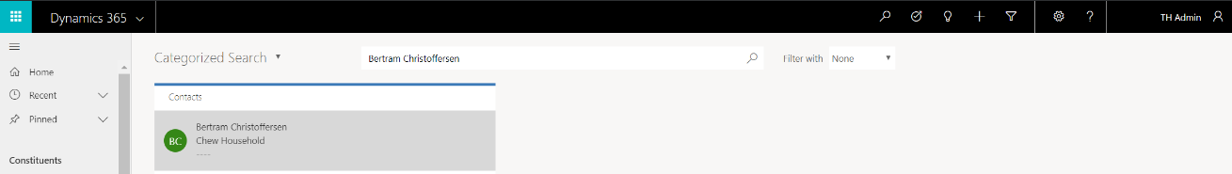

1. View the Individual Profile Page for **Bertram Christoffersen**. Bertram is a Donor, as identified by the Primary Constituent Type value. Profile information about the constituent is available including phone, email, address, account and preferred contact method details.

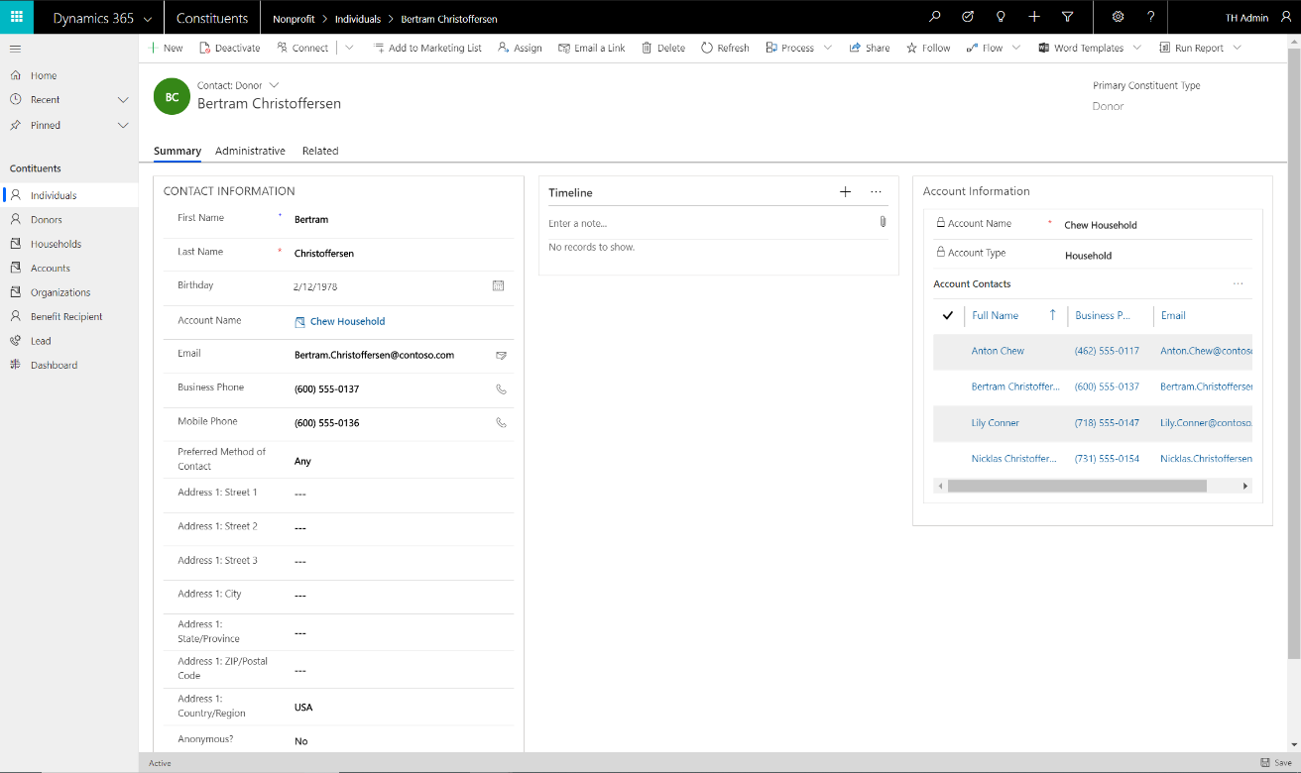

1. Bertram’s Household Information is available on the right side of the profile. Bertram is a member of the Chew Household, along with three other individual Contacts (Anton Chew, Lily Conner and Niklas Christoffersen).
2. Individual profiles include the following components, enabling complete profiling of Individual Constituents (available via **Related**):
   1. Addresses – any number of addresses
   2. Connections – any number of connections to other Individuals and/or Organizations
   3. Education – current and/or historical Education
   4. Employment History – current and/or historical Employment
   5. Memberships – any number of Memberships by Membership Category
   6. Preferences – any number of classifications, groups, tags, etc. for use in profiling to support constituent engagement and/or marketing
   7. Salutations – any number of names

### View Household

1. Using the search bar, search for a Household (Account) record named **Christoffersen Household**.



1. Click on the record for **Christoffersen Household** in the Search Results.

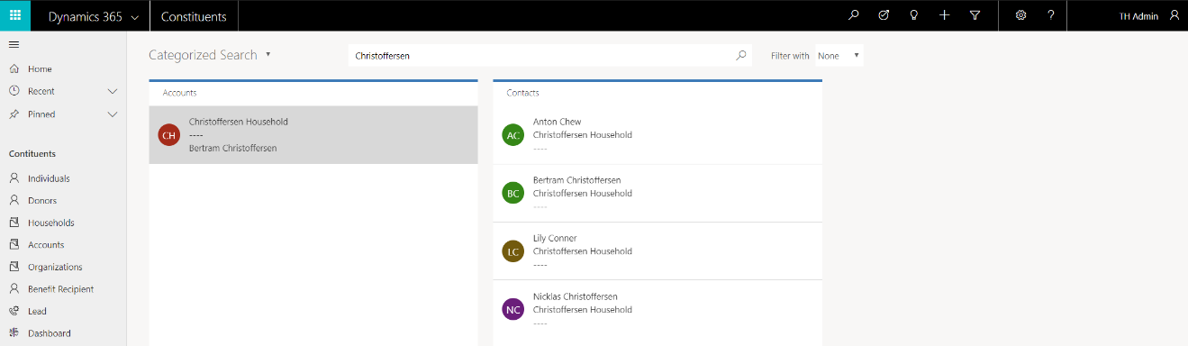

1. View the Household Profile Page for **Christoffersen Household**. This Household has a Primary Contact, Bertram Christoffersen, as identified by the Primary Contact. Profile information about the Household is available including phone, email, address, account and preferred contact method details.

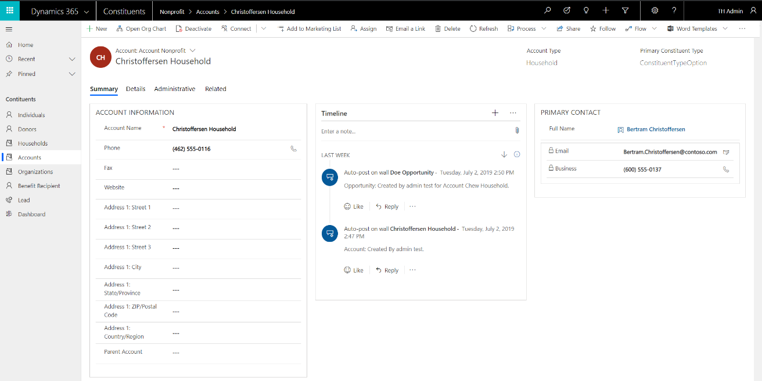

1. Household profiles include the following components, enabling complete profiling of Household Constituents (available via **Related**):
   1. Contacts – any number of Individual Contacts included in the Household
   2. Addresses – any number of addresses
   3. Connections – any number of relationships to other Individuals and/or Organizations
   4. Memberships – any number of Memberships by Membership Category
   5. Preferences – any number of classifications, groups, tags, etc. for use in profiling to support constituent engagement and/or marketing
   6. Salutations – any number of names

### View Benefit Recipient

1. Benefit Recipients connect nonprofit program activities to the subjects that benefit from the nonprofit’s program related activities. Benefit Recipients can be linked to an Account, Contact or Resource Catalogue. A linked Account represents a legal entity. A linked Contact represents a person. A linked Resource Catalogue represents an entity that is not a legal entity, i.e. a beach, sculpture, animal, etc.
2. Navigate to the **Constituents** sample application and select **Benefit Recipient** in the left navigation.

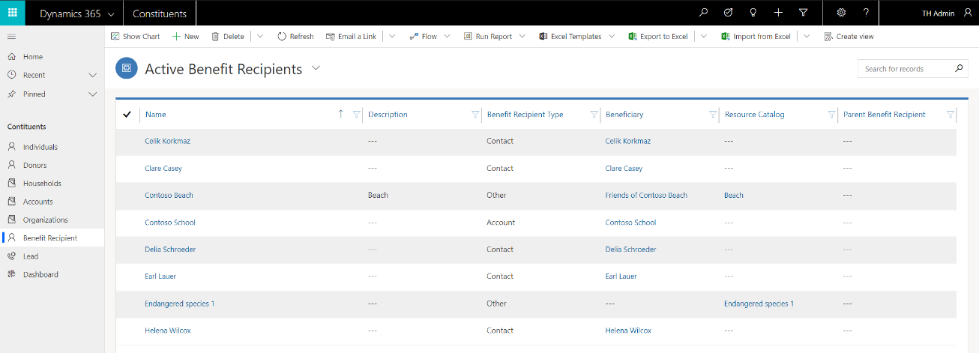

1. This view provides several examples of Contact, Account and Other Benefit Recipients. Other is a placeholder value that represents Benefit Recipients that are neither Accounts nor Contacts and can be updated to meet customer requirements.
2. Select the **Delia Schroeder** Benefit Recipient. This record is a Contact, as defined by the Benefit Recipient Type “Contact,” and the Beneficiary lookup “Delia Schroeder.”

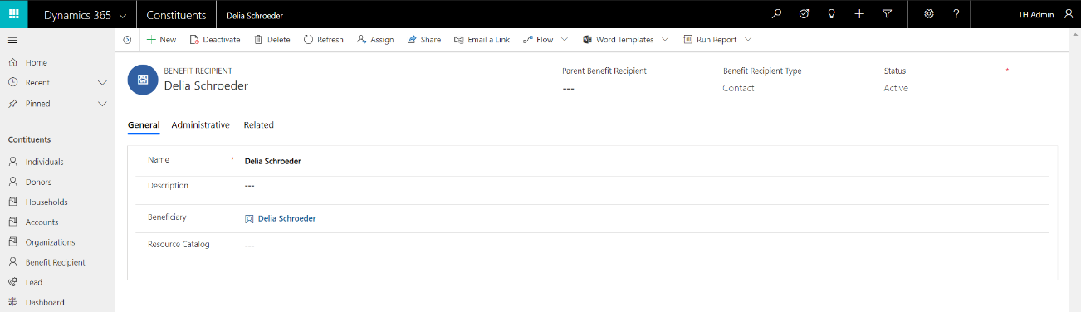

1. Select the **Contoso School** Benefit Recipient. This record is an Account, as defined by the Benefit Recipient Type “Account,” and the Beneficiary lookup “Contoso School.”

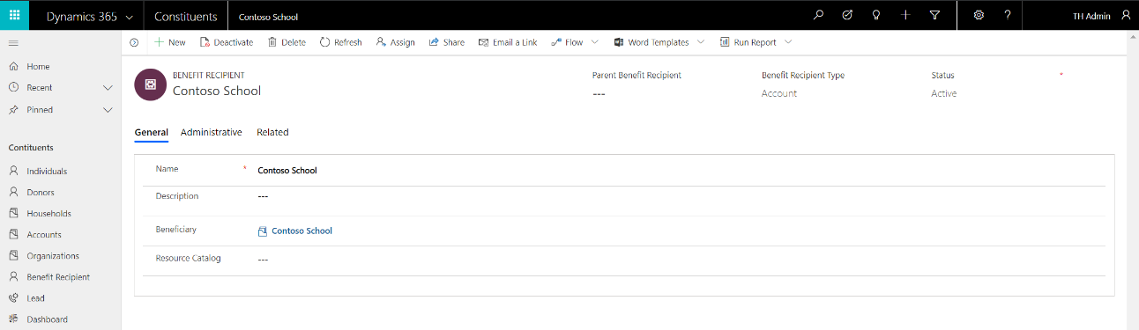

1. Select the **Contoso Beach** Benefit Recipient. This record is a beach, as defined by the Benefit Recipient Type “Other,” and the Resource Catalog “Beach.”

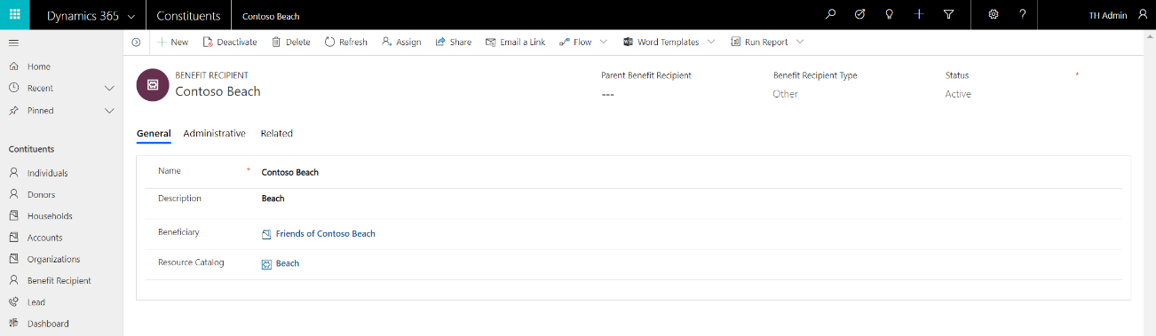

### View Organization

1. Using the search bar, search for an Organization (Account) record named **Contoso, Ltd**.



1. Click on the record for **Contoso, Ltd.** in the Search Results.

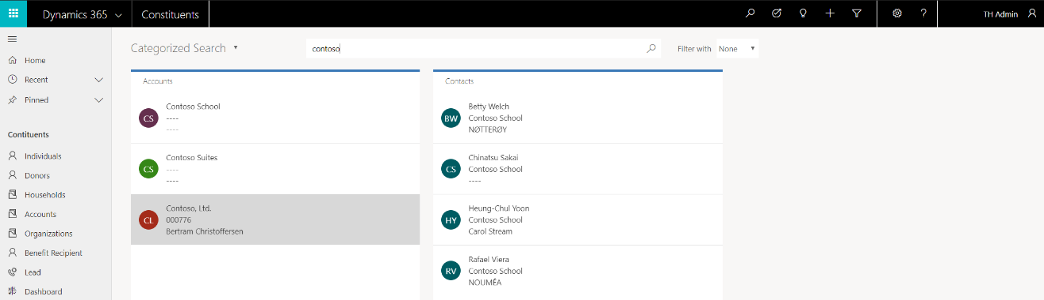

1. View the Organization Profile Page for **Contoso, Ltd.** This Organization has a Primary Contact, Bertram Christoffersen, as identified by the Primary Contact. Profile information about the Organization is available including phone, email, website and address details.

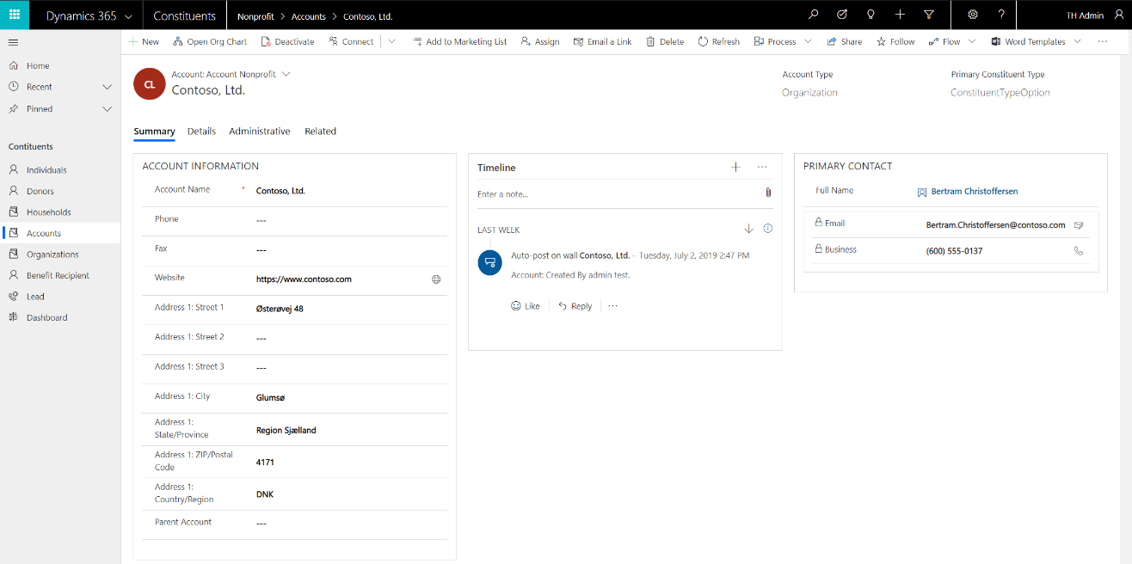

1. Organization profiles include the following components, enabling complete profiling of Organization Constituents (available via **Related**):
   1. Contacts – any number of Individual Contacts included in the Organization
   2. Addresses – any number of addresses
   3. Connections – any number of relationships to other Individuals, Households and/or Organizations
   4. Memberships – any number of Memberships by Membership Category
   5. Preferences – any number of classifications, groups, tags, etc. for use in profiling to support constituent engagement and/or marketing
   6. Salutations – any number of names

## Fundraising

The Nonprofit Accelerator includes an extensible model for standard nonprofit fundraising, including:

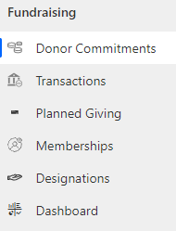

#### Donor Commitments

An actual or prospective agreement between a donor and an organization for the donor to make a gift to the organization.

#### Transactions

Transactions (also referred to as donations) represent payments from a constituent to the nonprofit.

#### Planned Giving

A planned gift is a gift made during a donor's lifetime or at the time of their death that involves their estate and/or tax planning.

#### Memberships

Representation of a Constituent Membership.

#### Designations

An area to which funds may be allocated, including a GL-relevant accounting code. Designations are the way a donor instructs the nonprofit to direct their donation.

### View Fundraising Dashboard

1. Navigate to the **Fundraising** sample application. Select **Dashboard** from the left navigation. The sample Household dashboard displays several key insights:
   1. Donor Commitments pledged by Account
   2. Donor Commitments by Type
   3. Total amount pledged over time
   4. List of key Donor Commitments by Households

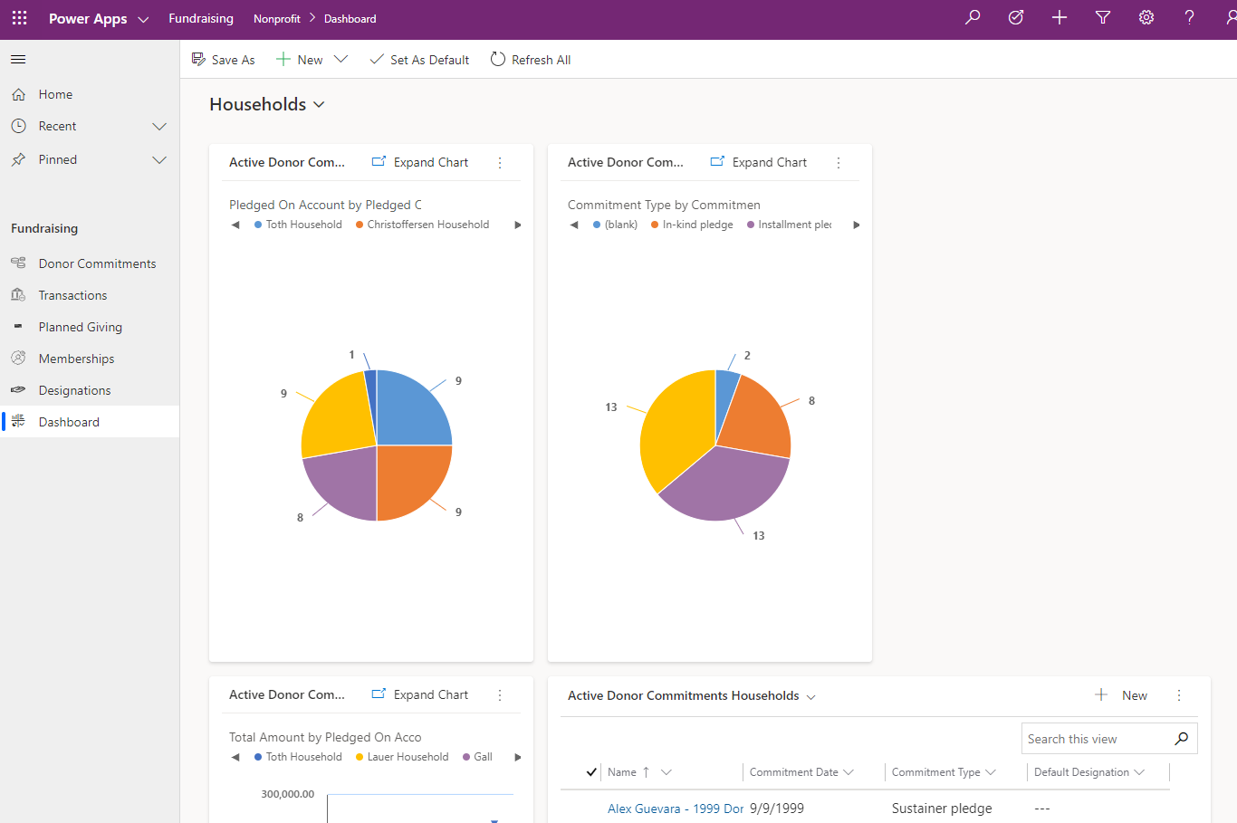

### View Donor Commitment

1. Using the search bar, search for an Individual (Contact) record named **Bertram Christoffersen**.



1. Click on the record for **Bertram Christoffersen** in the Search Results.



1. View the Individual Profile Page for **Bertram Christoffersen**. This Individual is a Donor, as identified by the Primary Constituent Type value “Donor.” Profile information about the constituent is available including phone, email, address, account and preferred contact method details.



1. Click on **Related** and select **Donor Commitments**, to view Bertram’s Donor Commitments. Each Donor Commitment record represents Bertram’s commitment to donate to the Nonprofit. This view displays three commitments on three different dates in 2016, 2018 and 2019. Note each record is linked to a Default Designation.

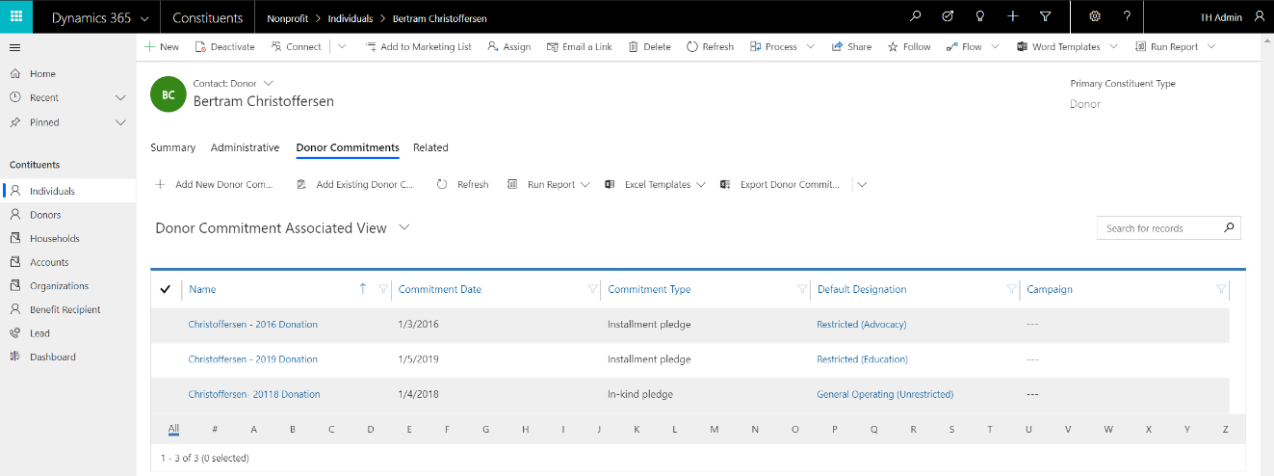

1. The Default Designation on a Donor Commitment represents the project or fund the commitment is for – this may be a restricted or unrestricted Designation. Click on the link for the Default Designation **Restricted (Education)** on Bertram’s 2019 Donor Commitment to view the Designation:

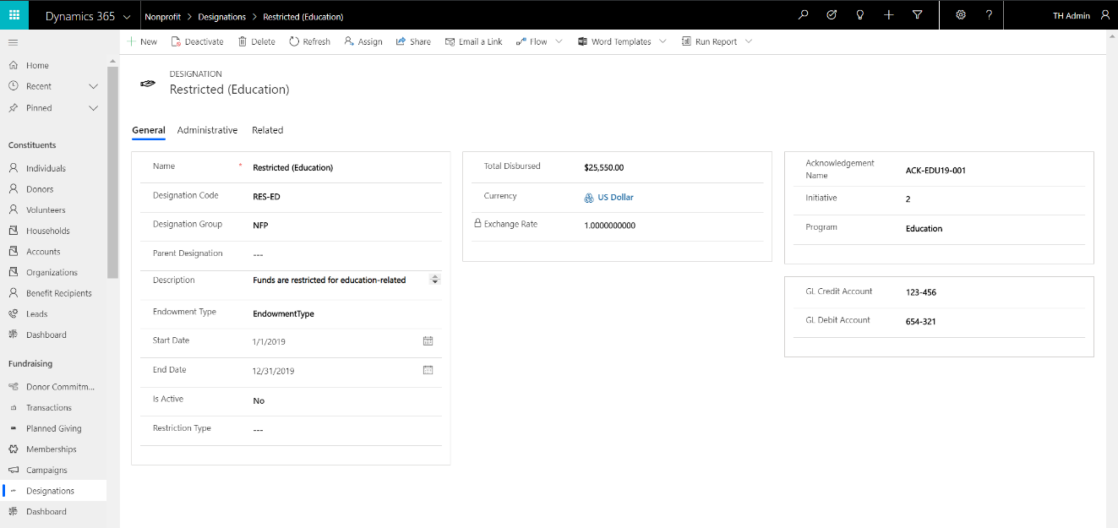

1. On the Restricted (Education) Designation, click on **Related**, then **Connections**. The Connections define how the Designation is related to Delivery Framework(s), indicating which funds are allocated to which program delivery activities. In this case, Bertram’s Donor Commitment is designated for the Restricted (Education) Designation which is connected to the Health Education Initiatives Delivery Framework. These links associate Bertram’s commitment to the nonprofit’s Health Education Initiatives activities, ensuring Bertram’s restricted donation is directed to program delivery activities according to his preference.

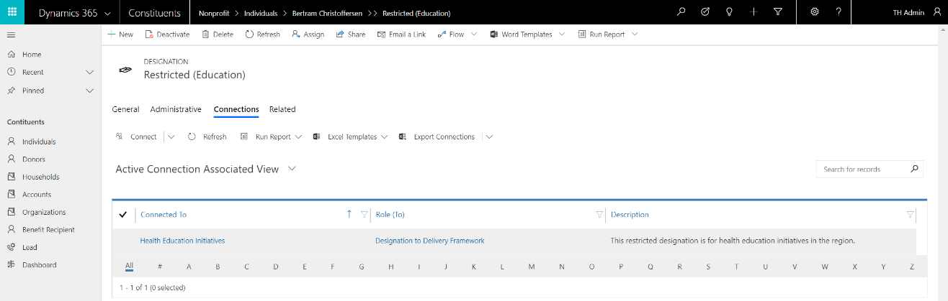

### View Planned Gift

1. Navigate to the **Fundraising** Sample Application, view **Planned Giving**:

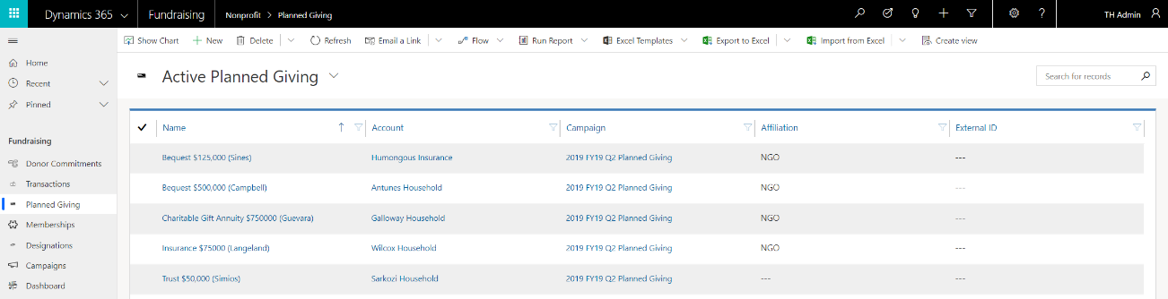

1. Click on the record for **Trust $50,000 (Simios).** The Planned Gift profile includes information related to tracking typical nonprofit prospective and/or actual planned gifts. The sample record below is related to the Sarkozi Household.

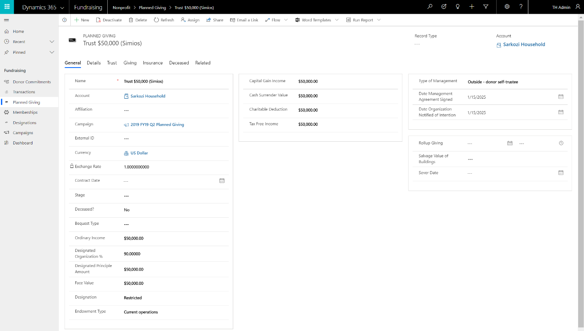

1. Planned Gift profiles include the following **Related** components, enabling end-to-end management of the planned giving process:
2. Connections – represents a link to a related entity or stakeholder.
3. Donor Commitment – represent the actual or prospective agreement or agreements between a donor and an organization for the donor to make a gift to the organization. Donor Commitments can be linked to a planned gift at any time during the process.
4. Payment Asset – represents the asset or assets associated with specific types of payments including, but not limited to, in-kind gifts, stocks and securities.

## Awards

The Nonprofit Accelerator includes an extensible model for standard nonprofit Awards (i.e., Grant, Scholarship) types, including:

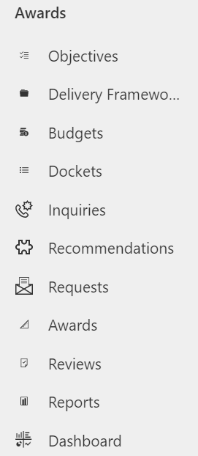

#### Objectives

One or more high-level priorities for the nonprofit. For example: “End Poverty” or “Equitable Access to Education.” Objectives can be structured into any hierarchy.

#### Budgets

An allocation of funds to support achievement of Objectives.

#### Delivery Frameworks

A unit of work via which a nonprofit, or third parties, achieves Objectives. Delivery Frameworks can be structured into any hierarchy, i.e., a program with multiple projects and tasks.

#### Requests

A request from an individual or institution for funding or support.

#### Awards

An agreement to provide or receive funding or support.

#### Disbursements

A payment related to an Award.

### View Award Disbursements

1. Navigate to the **Awards** Sample Application, view the Objectives by selecting **Objectives** in the left navigation:

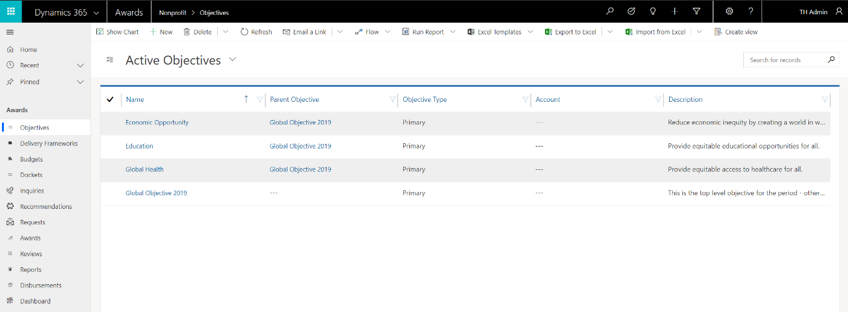

1. Select the **Global Health** Objective. The nonprofit’s objective for Global Health is to “Provide equitable access to healthcare for all.” This objective is scheduled for January 1 through December 31, 2019:

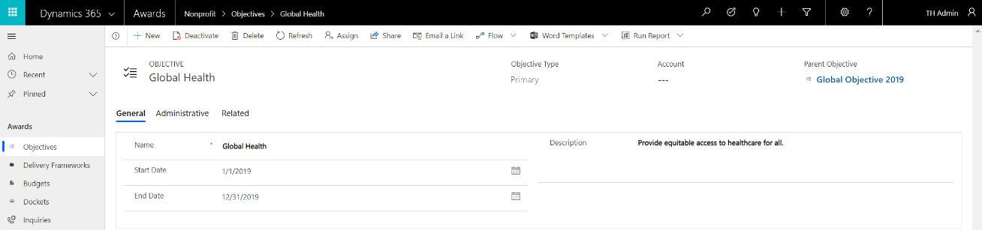

1. On the Global Health Objective, click on Related, then **Delivery Frameworks**. 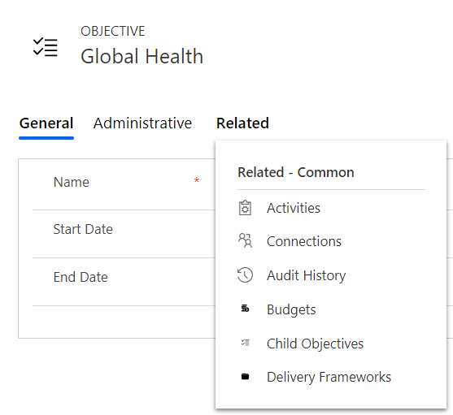
2. The Delivery Frameworks related to an Objective represent the initiatives or activities the nonprofit, or a third-party, will execute to achieve the Objective. Select the **Health Education Initiatives** Delivery Framework:

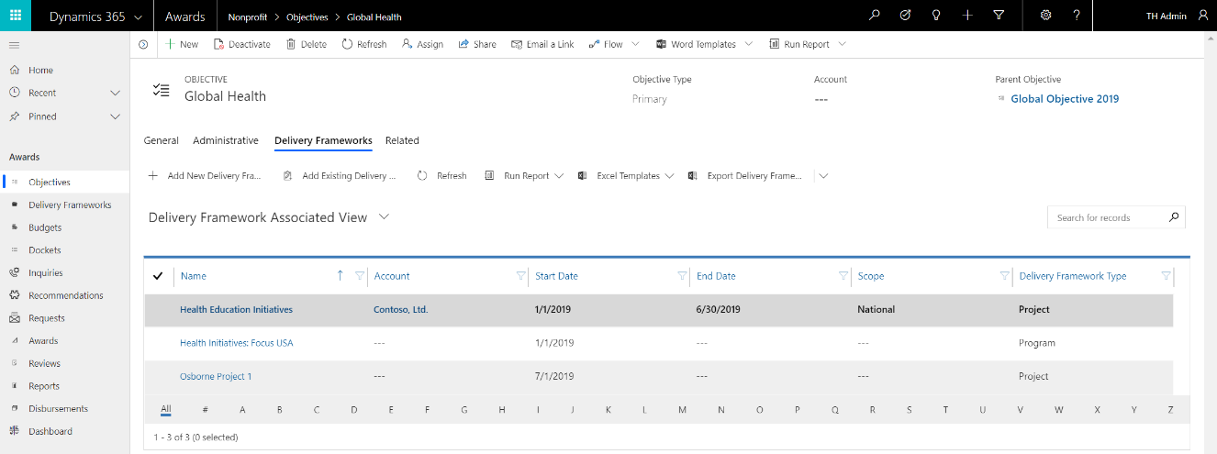

1. View the **Health Education Initiatives** Delivery Framework. The purpose of this project is to work “with local partners throughout the region to develop training and education services around health in a community environment.” The record includes important scope, date, and status details for the Project (based on the Delivery Framework Type) which is in Implementation (based on the Status):

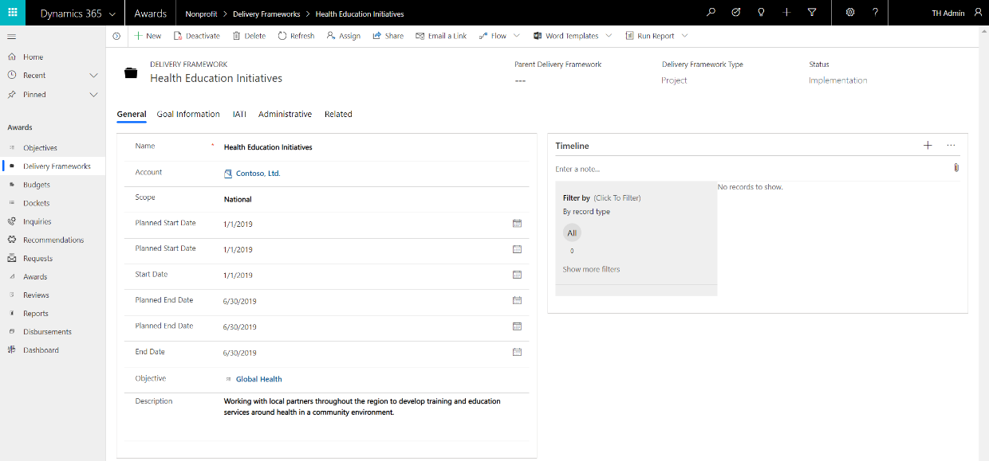

1. View the **Related** Disbursement Distributions. Disbursement Distribution link Award Disbursements, or specific allocations of funds, from an Award Disbursement (aka “payment”) to the Delivery Framework. This link represents the funds that enable the activities that will be executed via the Delivery Framework.

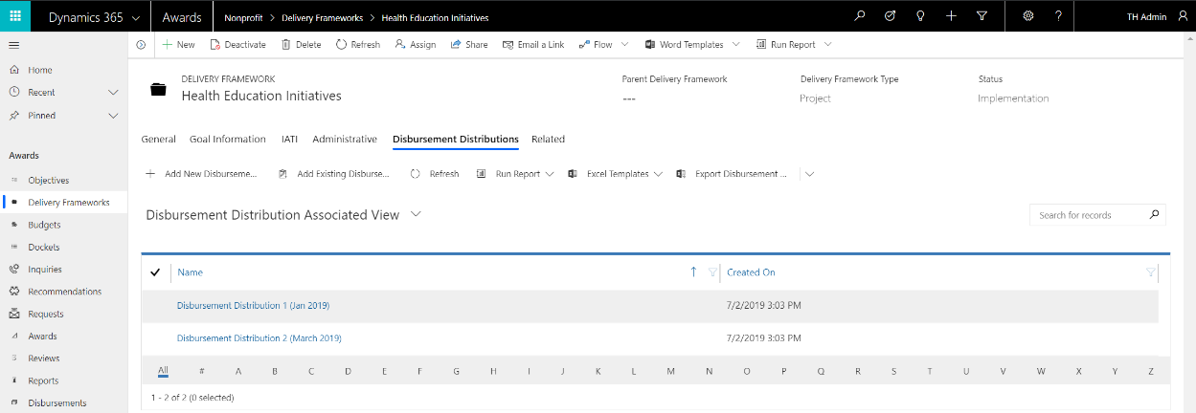

1. Select the **Disbursement Distribution 1 (Jan 2019)** Disbursement Distribution. This is the first of two payments to fund the Delivery Framework “Health Education Initiatives”:

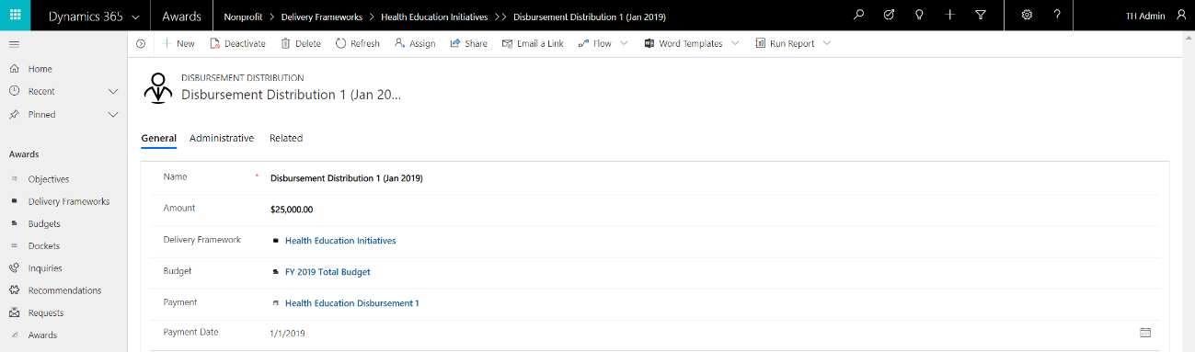

1. View the related Disbursements, which represent the individual payments supporting the Delivery Framework. In this case, a **$15,000 Disbursement** is recorded:

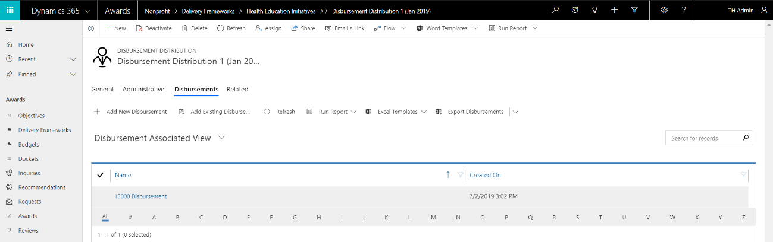

1. Select **Requests** from the App Navigation to view Requests. Select the **Health Education Request:**

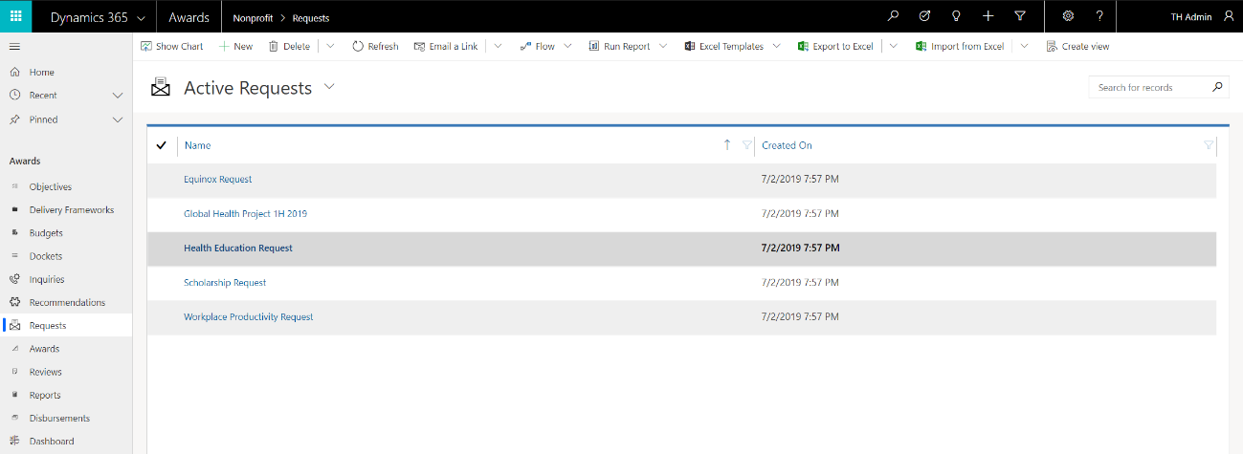

1. The **Health Education Request** details the type, stage, requested and actual amounts, dates and duration, Docket, Recipient, Sponsor, and other related information about the Request for support:

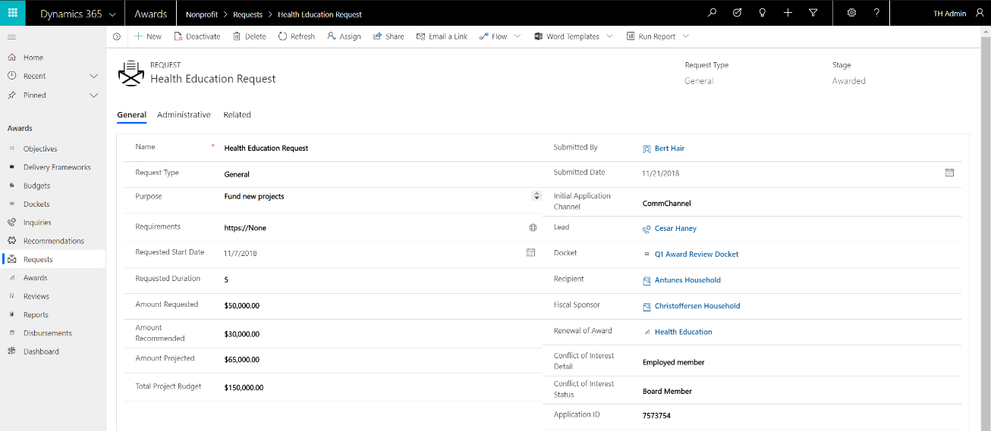

1. If a Request is accepted, it will have an associated Award. Requests that are not accepted do not have associated Awards. In this case, the Health Education Request was accepted, and therefore has Stage of “Awarded,” and is related to a **Health Education** **Award**. The Award record is the central point for all details related to the Award, including important dates, related Constituent records including the Recipient and Internal Contact and the Fiscal Sponsor. The Award is also related to Disbursements (as detailed above) which record one or more planned or actual payments related to the Award, Reports which represent reviews of the Award at a point in time and Award Versions which can be used to track changes in key Award details for compliance, regulatory or audit purposes.

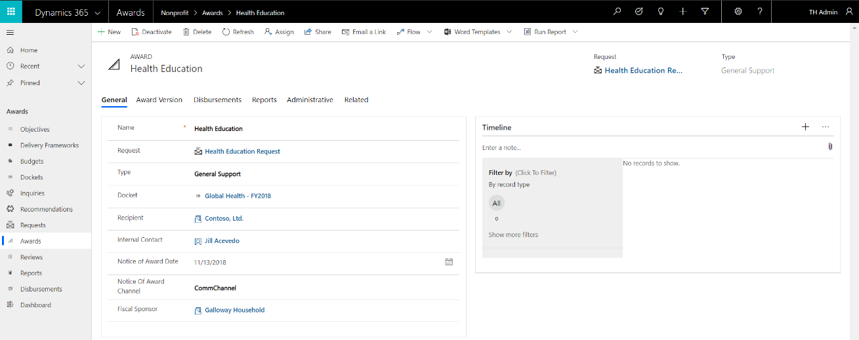

1. The related Award Disbursements record one or more planned or actual payments related to the Award. In this case, there are two payments:

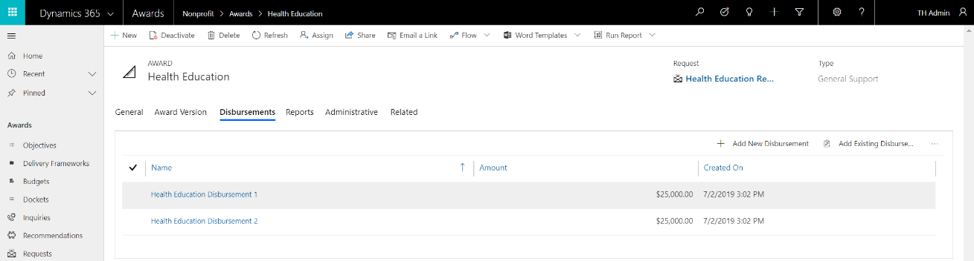

1. The related **Health Education Disbursement 1** record is the first Disbursement. This record includes the important detail of the payment, including but not limited to amount, currency, date, recipient, type and adjustment information, if necessary:

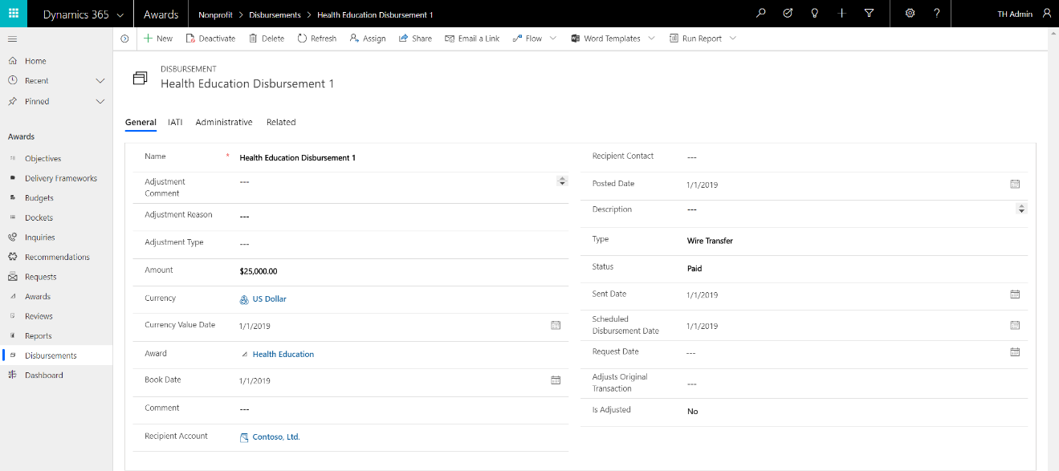

1. The related **Disbursement Distributions** link the Disbursement to one or more **Budgets** and/or **Delivery Frameworks**. This is the critical link between the Disbursement of funds from an Award and the Budgets allocated for the purpose of and/or the specific Delivery Frameworks, or activities, planned for accomplishing the nonprofit’s Objectives.

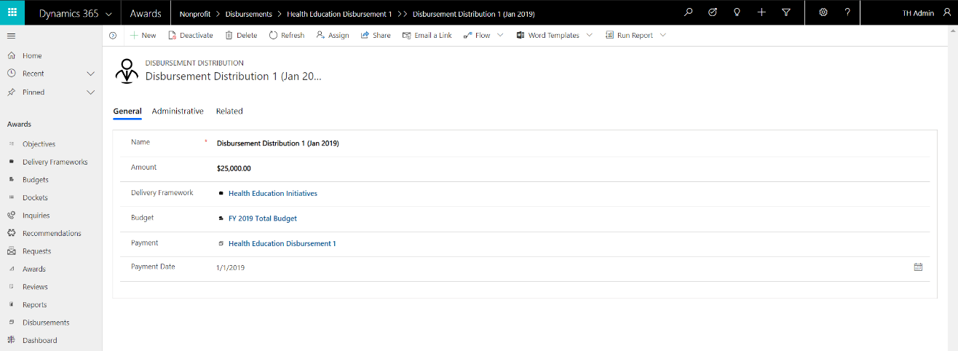

## Delivery Framework

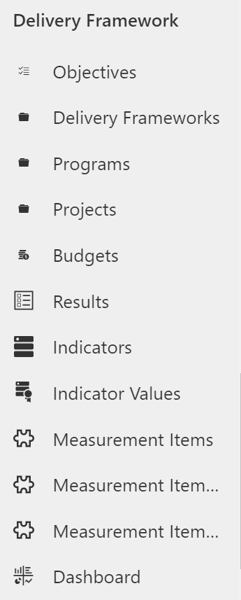The Nonprofit Accelerator includes the following components which enable end-to-end tracking of nonprofit program delivery activities:

#### Objectives

One or more high-level priorities for the nonprofit. For example: “End Poverty” or “Equitable Access to Education.” Objectives can be structured into any hierarchy.

#### Delivery Frameworks

A unit of work via which a nonprofit, or third parties, achieves Objectives. Delivery Frameworks can be structured into any hierarchy, i.e. a program with multiple projects and tasks.

#### Budgets

An allocation of funds to support achievement of Objectives.

#### Results

A container that represents the changes in the context in which an organization operates.

#### Indicators

Describes what will be measured to track evidence of a Result. Indicators can be qualitative or quantitative and may or may not be aggregable.

#### Indicator Values

A quantitative or qualitative value of measurement of an Indicator. Indicator Values may be but are not limited to baseline, target or actual values of measurement.

#### Measurement Items

Library used to store Goals, Objectives, Targets, Outcomes, Indicators, and other items for measurement.

#### Measurement Item Relationships

Records the details regarding the relationships between measurement items.

#### Measurement Item Usages

Used to track where measurement items have been used.

#### Benefit Recipients

Any person or entity that is the recipient of the benefit of a nonprofit’s activities.

### Program Delivery

1. Navigate to the **Delivery Framework** Sample Application, view the **Objectives**:

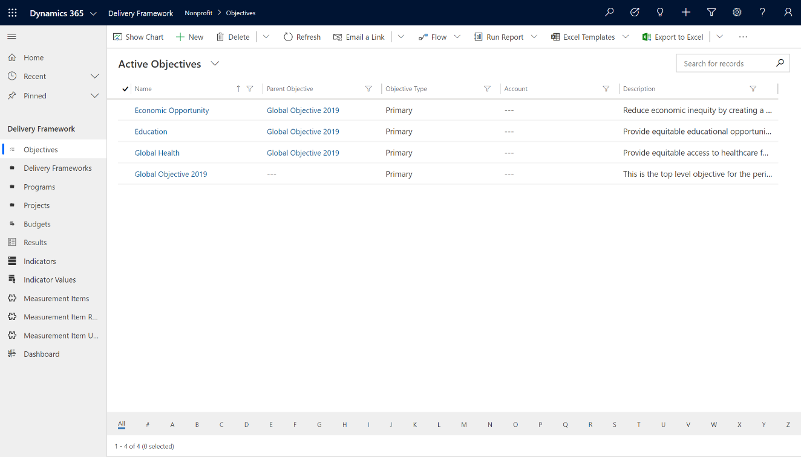

1. Select the **Global Health** Objective. The nonprofit’s objective is to “Provide equitable access to healthcare for all”:



1. On the Global Health Objective, click on Related, then select **Delivery Frameworks**.

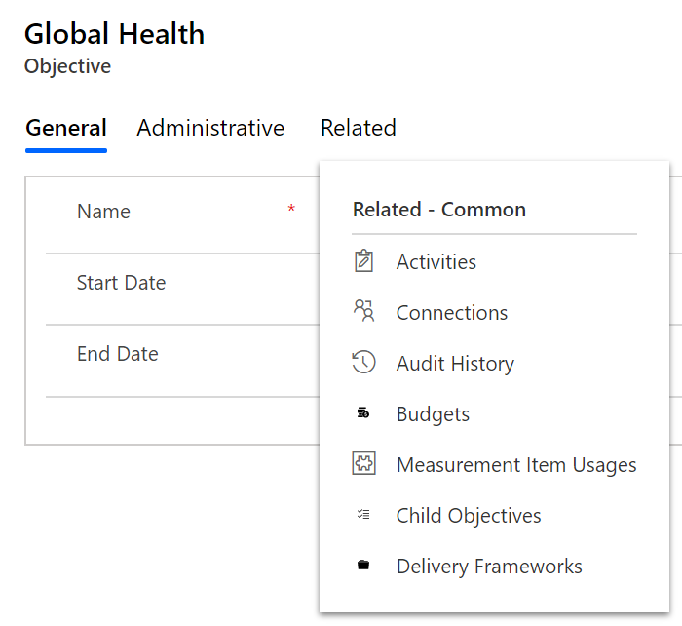

1. The Delivery Frameworks related to an Objective represent the activities the nonprofit, or a third-party, will execute to achieve the Objective. Select the **Health Education Initiatives** Delivery Framework: 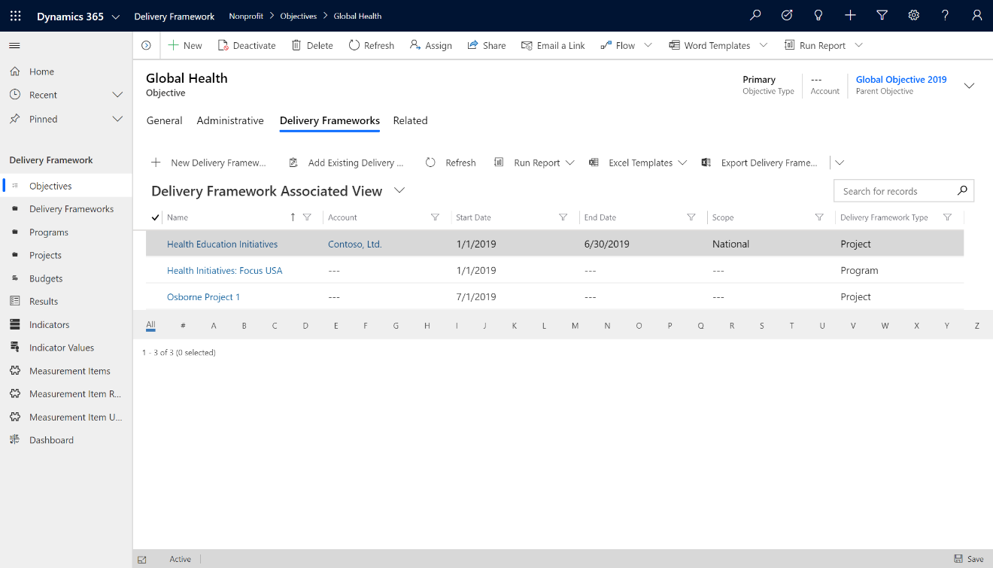
2. View the **Health Education Initiatives** Delivery Framework. The purpose of this project is to work “with local partners throughout the region to develop training and education services around health in a community environment.” The record includes important scope, date and status details:

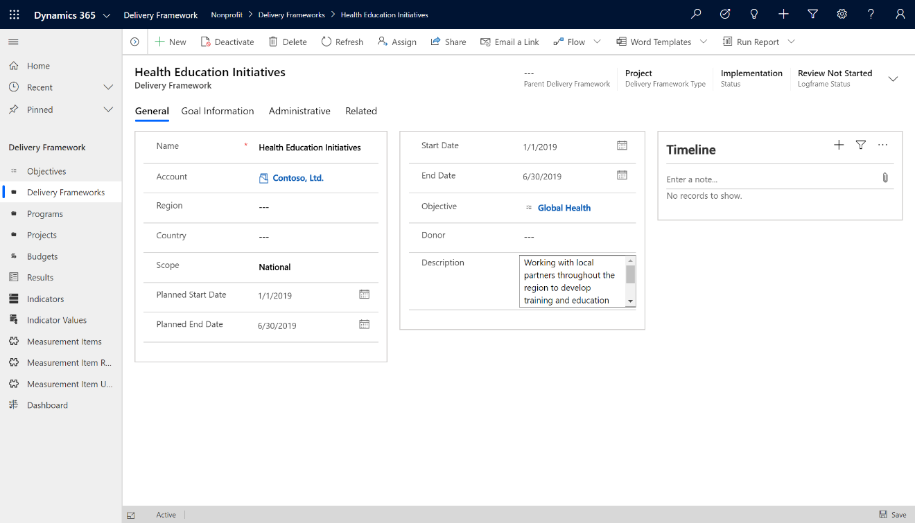

1. Select Related then **Measurement Item Usage**. This Measurement Item Usage record links the Measurement Item to the Delivery Framework. In this case, Health Education Initiatives is being measured by the ability to “Ensure healthy lives and promote well-being for all at all ages” (which also happens to be Goal 3 of the United Nations Sustainable Development Goals). NOTE: You may also choose to link this Measurement Item to Indicator Values for more specific measurements.

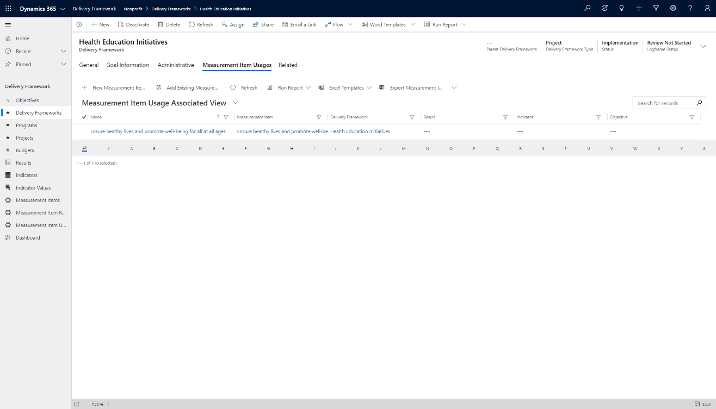

1. View the Results related to the Health Education Initiatives Delivery Framework project by selecting Related, then Results. elect the **Q1 Training Delivery** Result. 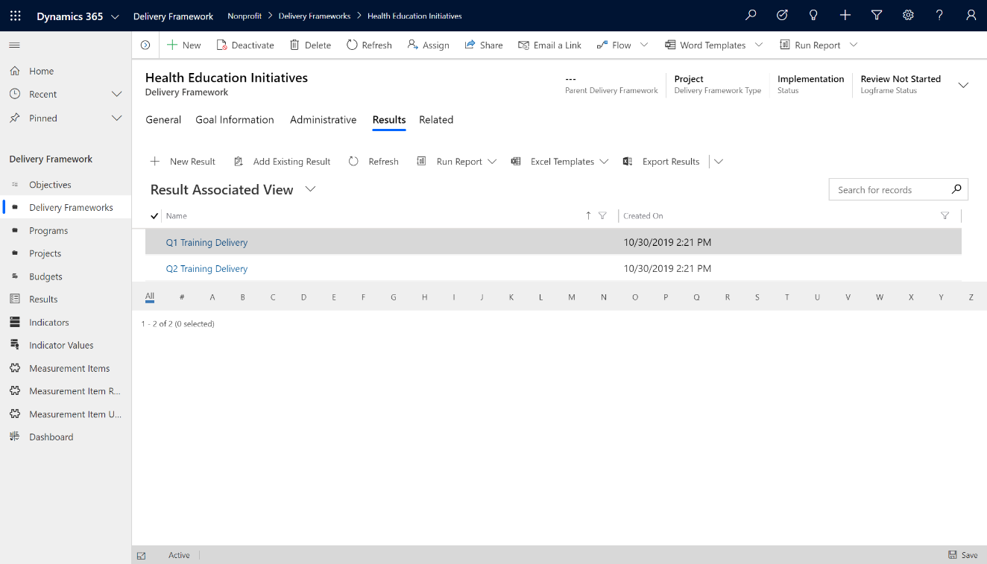
2. The Result is a time-based (see start and end dates) summary of the intended Outputs, Outcomes and/or Impacts related to the Health Education Initiative Project. This key value is defined in the Result Type.

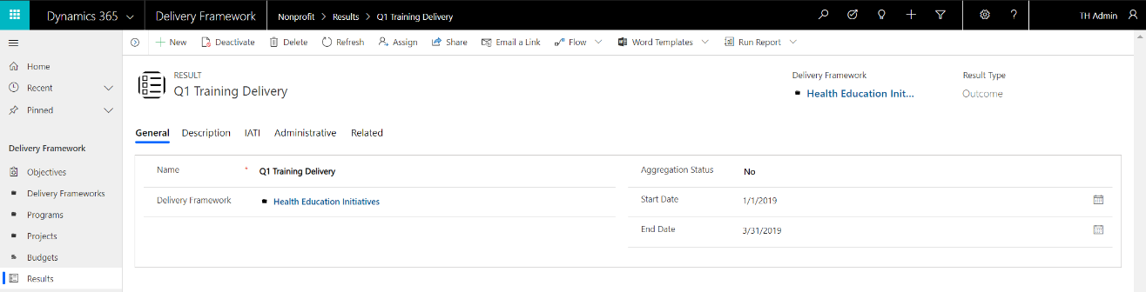

1. Select **Related** then **Indicators** and select the **# of Trainings Delivered** Indicator. This Indicator defines what will be measured and/or monitored, for what period and whether the measurement is ascending and/or aggregable. In this case, the nonprofit will measure the number of trainings delivered from January through March 2019. The number is ascending and aggregable.

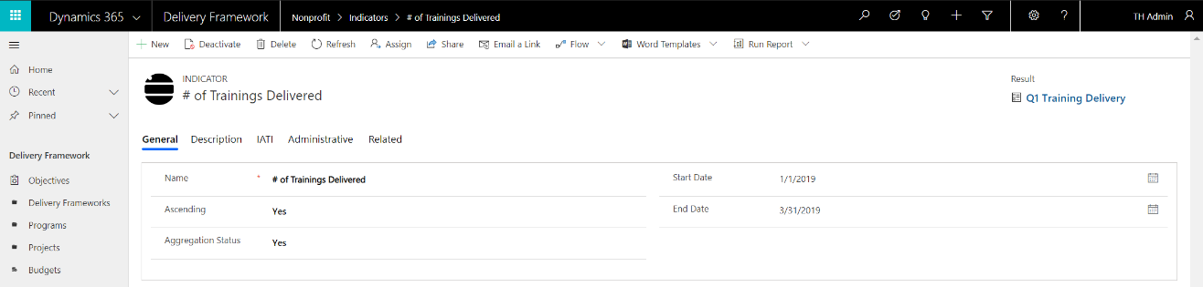

1. Select **Related** then **Indicator Values** and select the **1. Jan 19 Trainings** Indicator Value. This Indicator Value defines specifically what will be or has been measured and/or monitored. In this case, eight (8) trainings were delivered in January 2019. Note that Indicator Values can be structured hierarchically using the Parent Indicator Value. 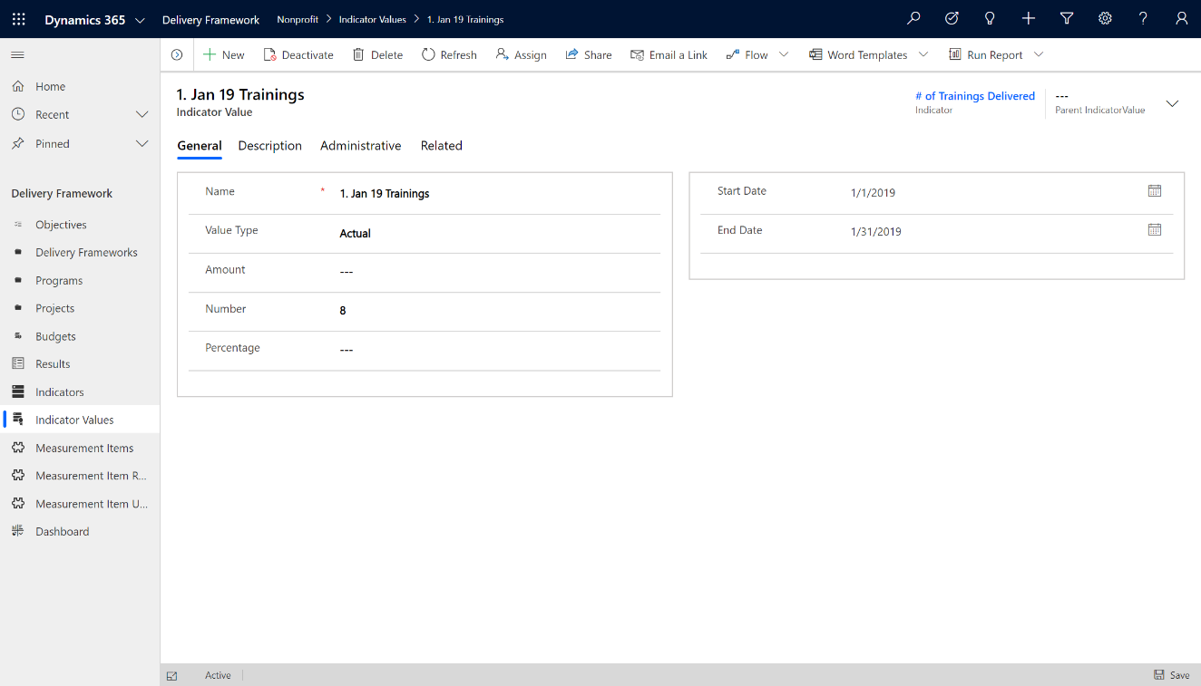
2. Select Related then **Benefit Recipients**. The Benefit Recipient view details the specific Individuals that were trained during the month of January 2019. In this case, four Contacts and one Account are named.

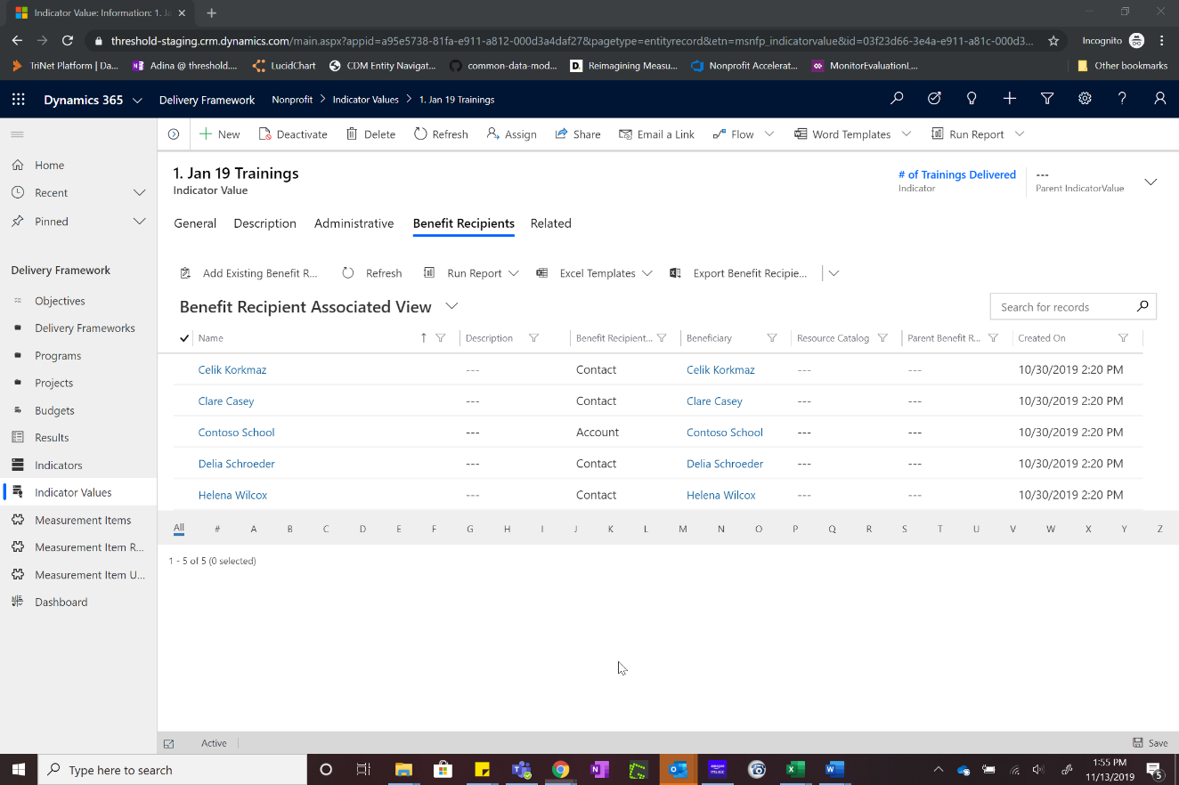

### View Program Delivery Dashboard

1. Navigate to the **Delivery Framework** Sample Application, select **Dashboard** in the left navigation. The sample **Delivery Framework Objectives and Results** dashboard displays several key insights:
   1. Delivery Frameworks by Objective
   2. Delivery Framework by Type and Status
   3. Total Budget by Objective
   4. Total Budget by Delivery Framework
   5. A list of Delivery Frameworks by Account
   6. A list of Indicators

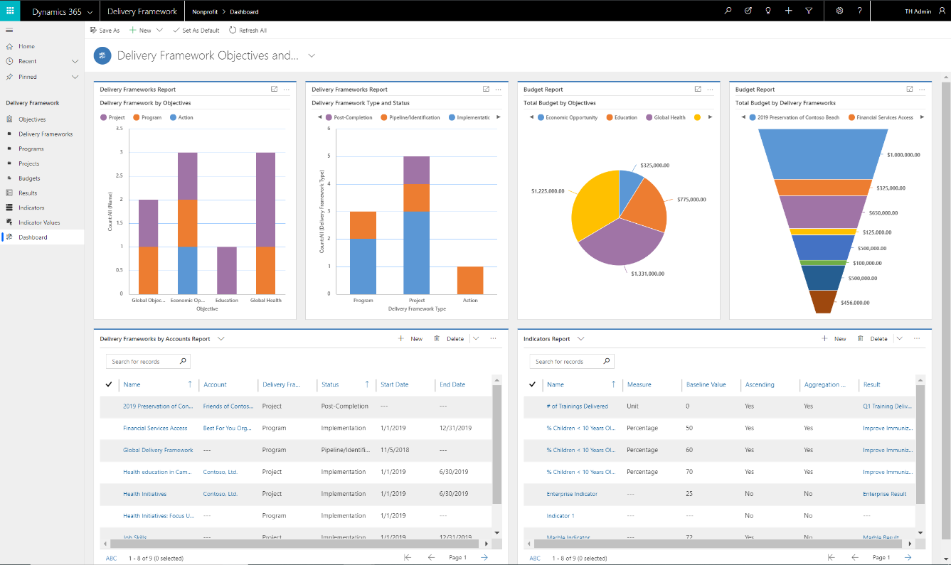

1. An additional sample dashboard **Delivery Framework by Budget** is also available in the sample application.

## Project Management and Program Design

The Nonprofit Accelerator has a Project Management and Program Design application that can be added on to core functionality. This section outlines some of the functionality that this add-on solution provides.

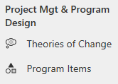

#### Theories of Change

Theories of Change are hypotheses for achieving a desired social impact and are comprised of a sequence of cause-and-effect actions or occurrences.

#### Program Items

Program Items detail the program elements that contribute to proving or disproving a Theory of Change such as assumptions, deliverables, decisions, milestones, obligations, observations, or risks.

### Sample Theory of Change

1. Navigate to the **Project Management and Program Design** solution, and view the **Theories of Change**:

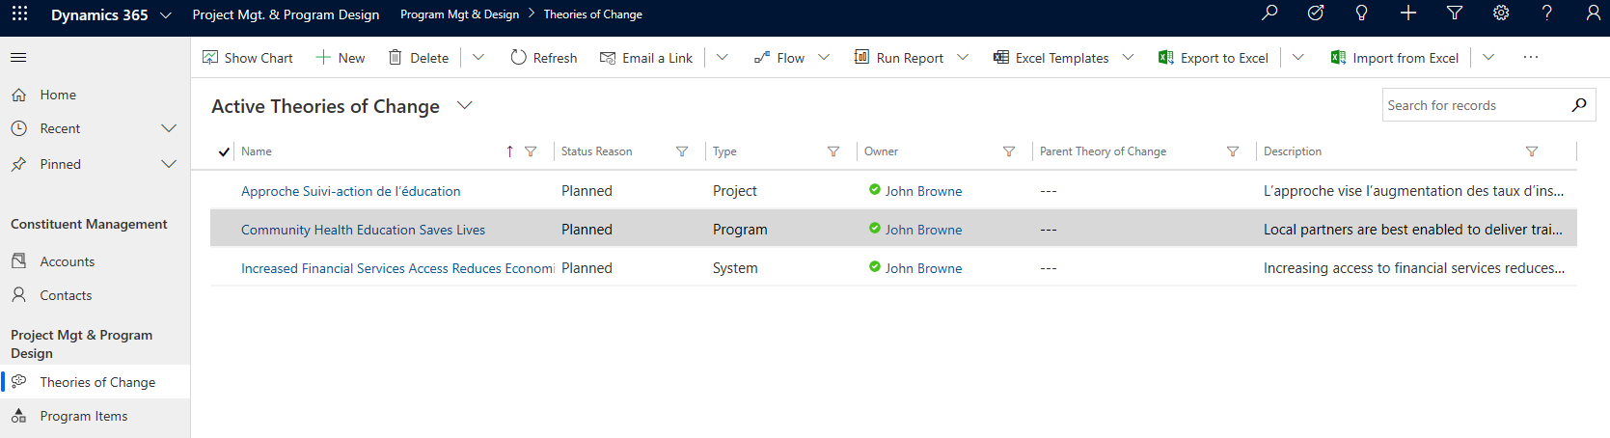

1. Select the **Community Health Education Saves Lives** Theory of Change, which corresponds to a planned program (denoted by the Status Reason and Type), and is summarized in the description that “Local partners are best enabled to deliver training to increase knowledge of good health practices and availability of healthcare services, leading to healthier lives and improved societal outcomes.”

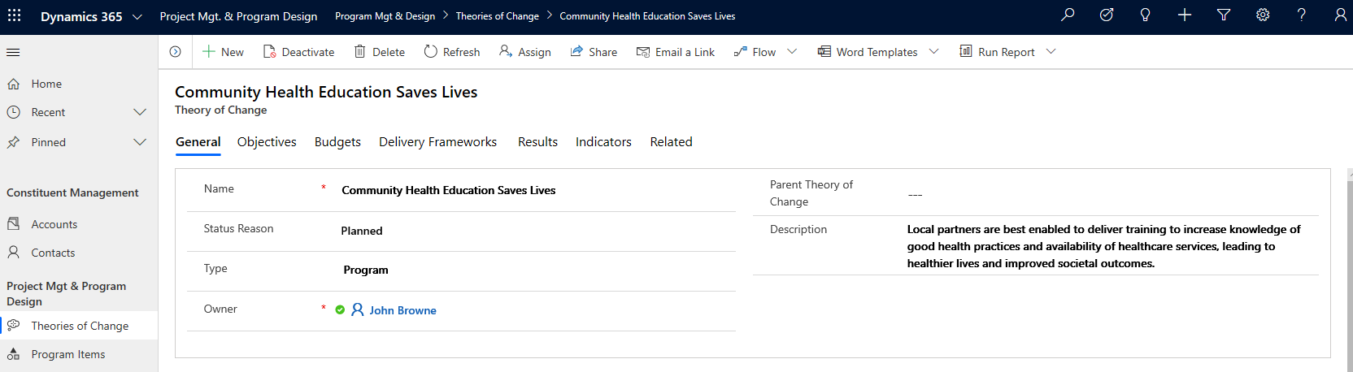

1. Take note of the tabs across the top of the Theory of Change. Each of these tabs displays the Program Design tables (i.e., Objectives, Budgets, Delivery Frameworks, Results and Indicators) which document the plan required to prove or disprove the Theory of Change. Click the **Objectives** tab and take note of the Type field, which indicates a Causal relationship between the Theory of Change and this Objective.

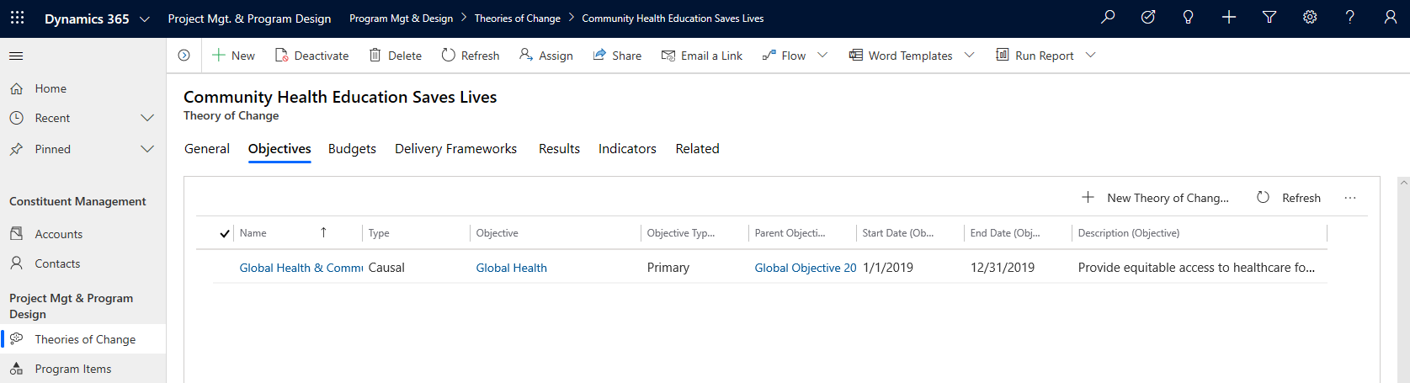

1. Return to the **General** tab and observe the **Program Items** section at the bottom of the page. This section lists all the Program Items which contribute to proving or disproving this Theory of Change.

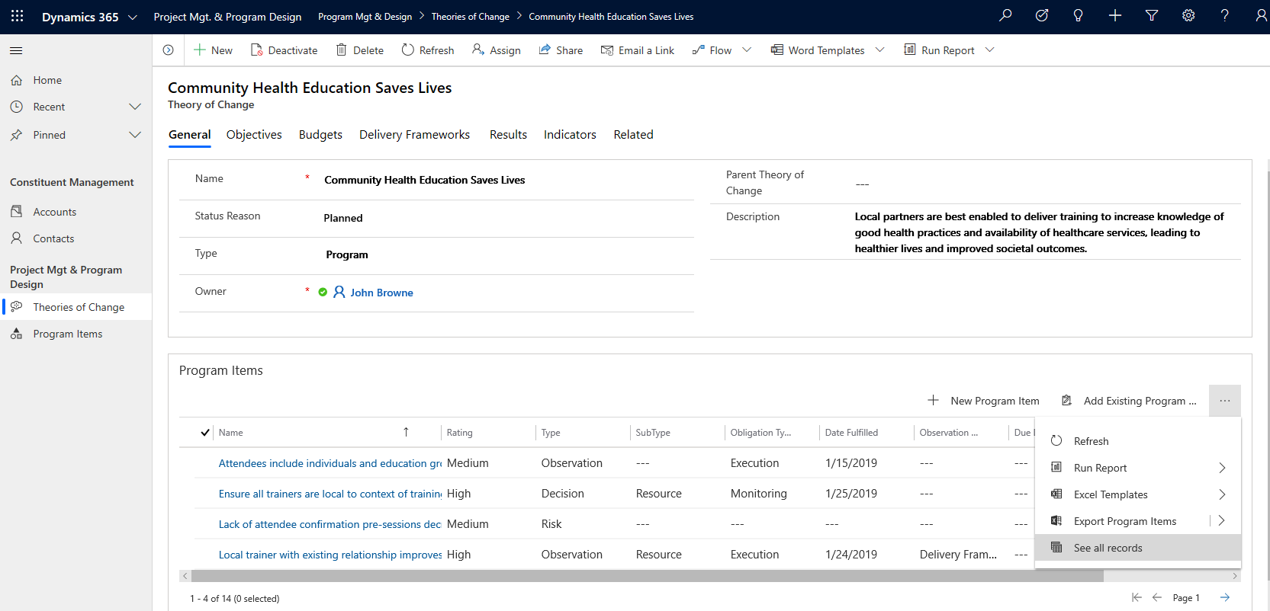

1. Click the ellipsis to the right of ‘Add Existing Program…’ in the Program Items section and select **‘See all records.’** In this view, all 14 related Program Items are displayed. Take note of the Type field, where there are six Status Reports, two Quarterly Reports as well as several other Types of Program Items.

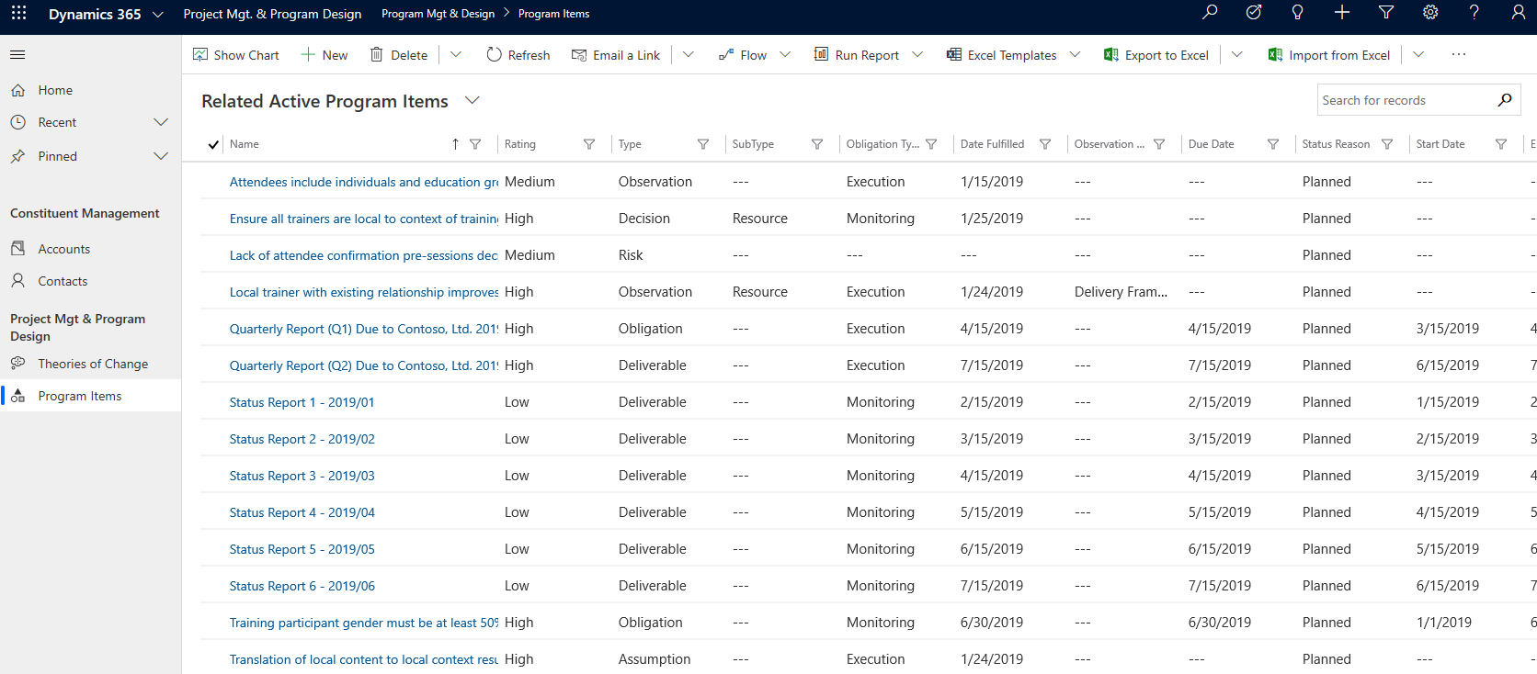

1. Per the Type column, there is one risk to the project: the “Lack of attendee confirmations pre-sessions decreases participation.” Click on the row.

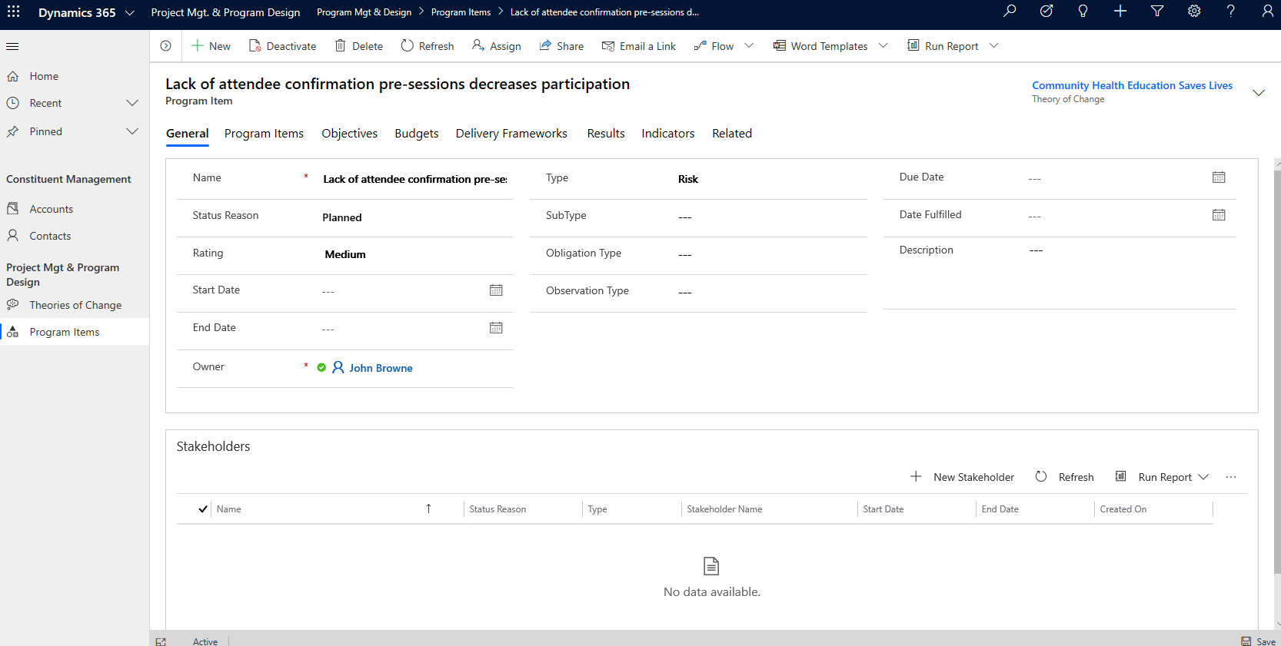

1. There are a number of data points and tabs displayed. As with a Theory of Change, the tabs across the top show all Program Design records related to this Program Item, including other Program Items. Click the **Program Items** tab.
2. The Risk, “Lack of attendee confirmations pre-sessions decreases participation” was a result of trying to “Determine how to increase attendance” (listed in the Name column). There is an Observation that “Local trainer with existing relationship improves attendance and participation.”

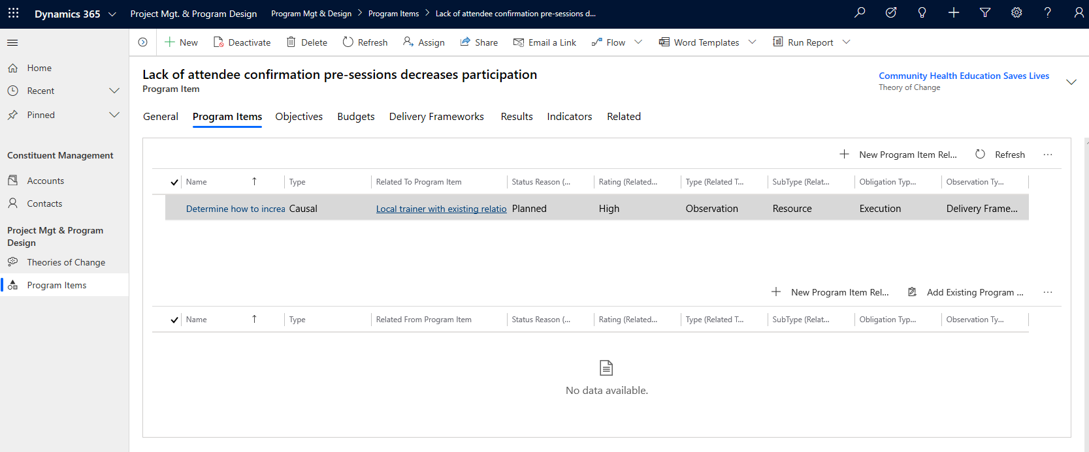

1. Given a Rating of High, it is obvious that having local trainers resulted in better participation and may help to mitigate the Risk previously observed.

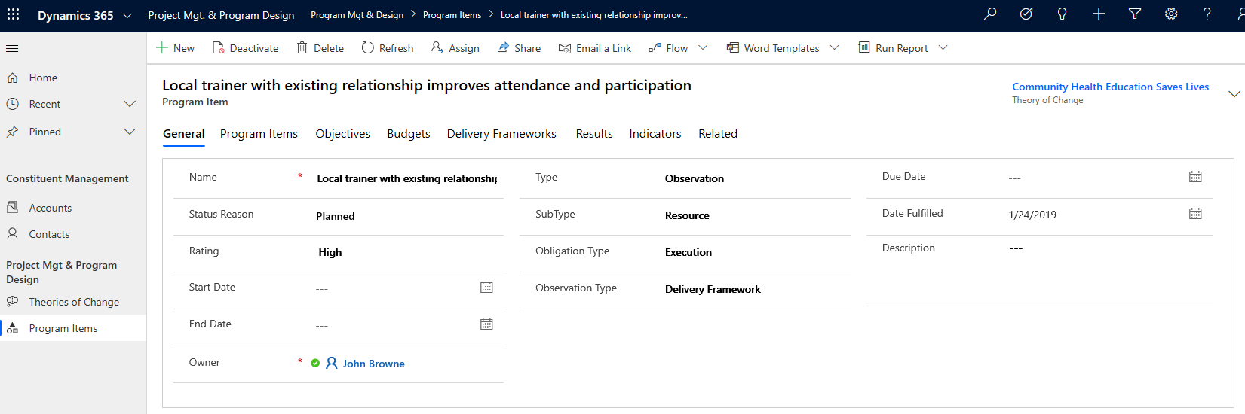

1. To view a chain of all Program Items related to “Local trainer with existing relationship improves attendance and participation,” click the **Program Items** tab. The bottom grid shows that the Risk “Lack of attendee confirmation pre-sessions decreases participation” caused program personnel to make the current Observation that, “Local trainer with existing relationship improves attendance and participation”. This in turn caused the Decision to “Ensure all trainers are local to context of training venue.” This models how the app can be used to track complex causal and other relationships across the multitude of Program Design and Project Management tables.

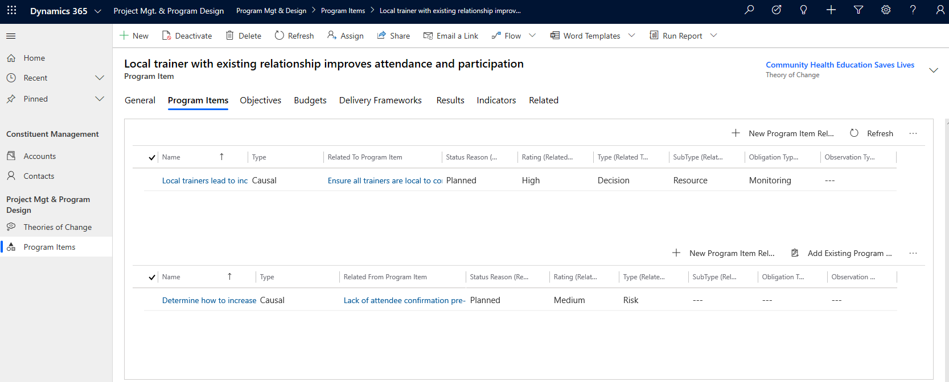

## Case Management

The Nonprofit Accelerator has a Case Management solution that can be added to provide basic case management functionality. This section outlines some of the functionality that this add-on solution provides.

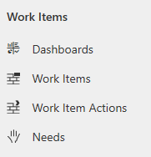

#### Dashboards

This will show a basic dashboard with various data points on current Work Items and Work Item Actions.

#### Work Items

Work Items are the root units of work in the Nonprofit Accelerator’s case management solution and can be used independent of or in conjunction with Work Item Actions, Needs and Indicators.

#### Work Item Actions

Work Item Actions are units of work that are assigned and tracked under a Work Item.

#### Needs

Needs provide a method of tracking a beneficiary’s needs, and case work that has been done to address those needs.

### Sample Work Item

1. Navigate to the **Case Management** Sample Application, and view the **Work Items**:

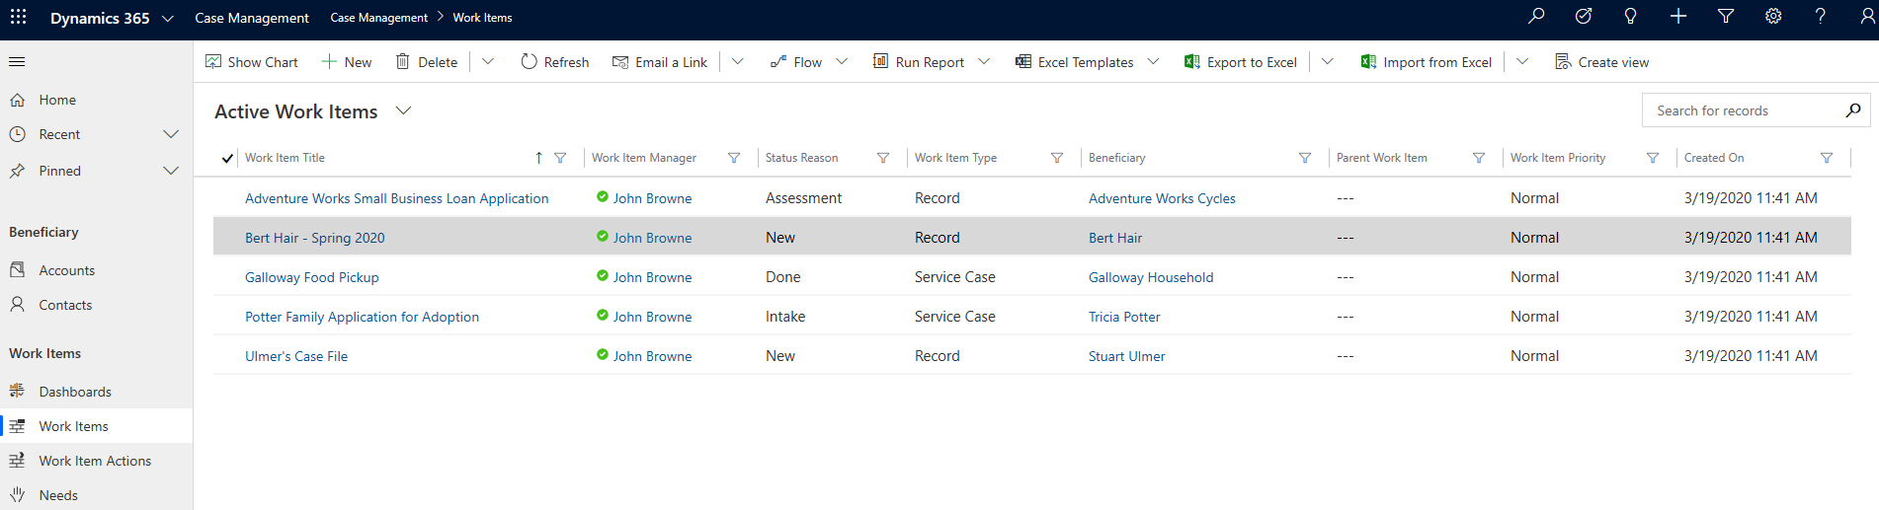

1. Click and open the **Bert Hair – Spring 2020** Work Item. This screen displays an overview of all activity related to working with the Beneficiary **Bert Hair**, as it pertains to this case. At the top right of the screen, there are three important fields:
   1. Status Reason shows the work item is **New**
   2. The Work Item Manager and person responsible for the work item is **John Browne**
   3. This work item is related to a Delivery Framework **Job Skills**

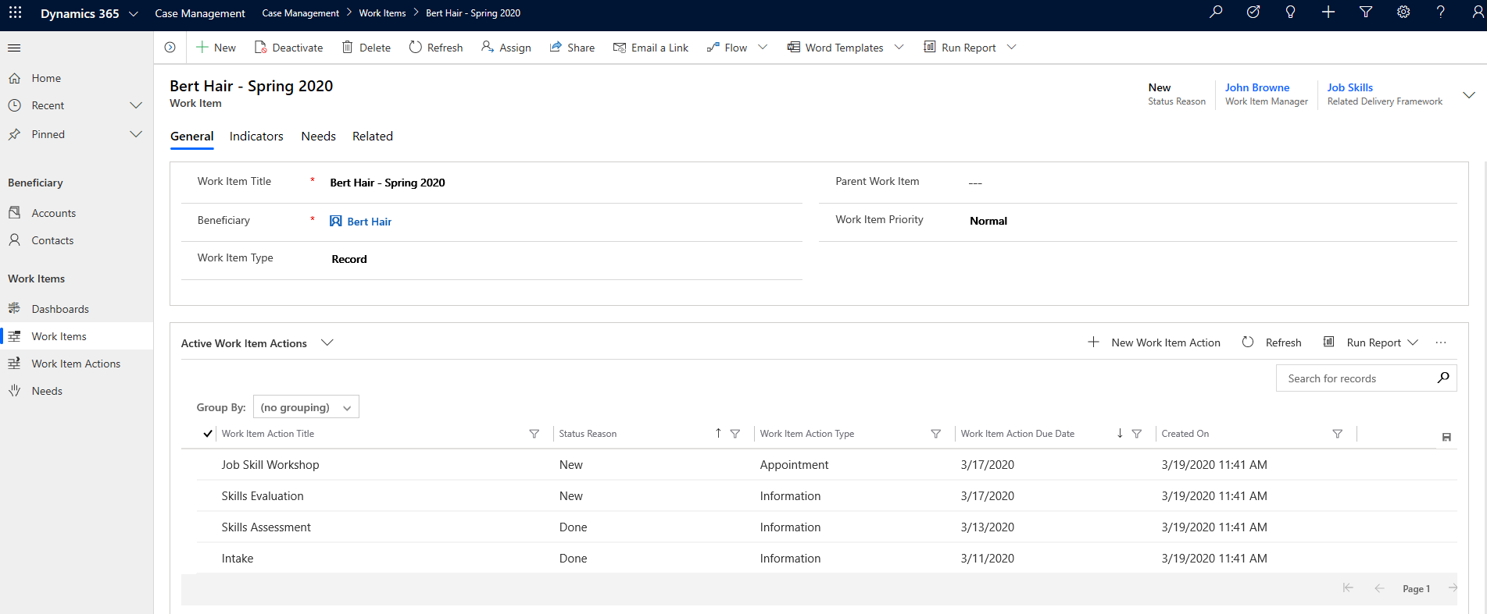

1. Scroll to the bottom of the page to see a list of all the Work Item Actions related to Bert’s record. It seems Bert has completed his Intake and Skills Assessment and is scheduled to attend a Job Skill Workshop and have a Skills Evaluation, but both on the same day. That seems odd.
2. Double click on the **Skills Evaluation** line item. This screen shows details for the Skills Evaluation. The Description field indicates that the Jobs Skills Workshop and Skills Evaluation are part of the same event, which provides insight as to why these two events are scheduled at the same time.

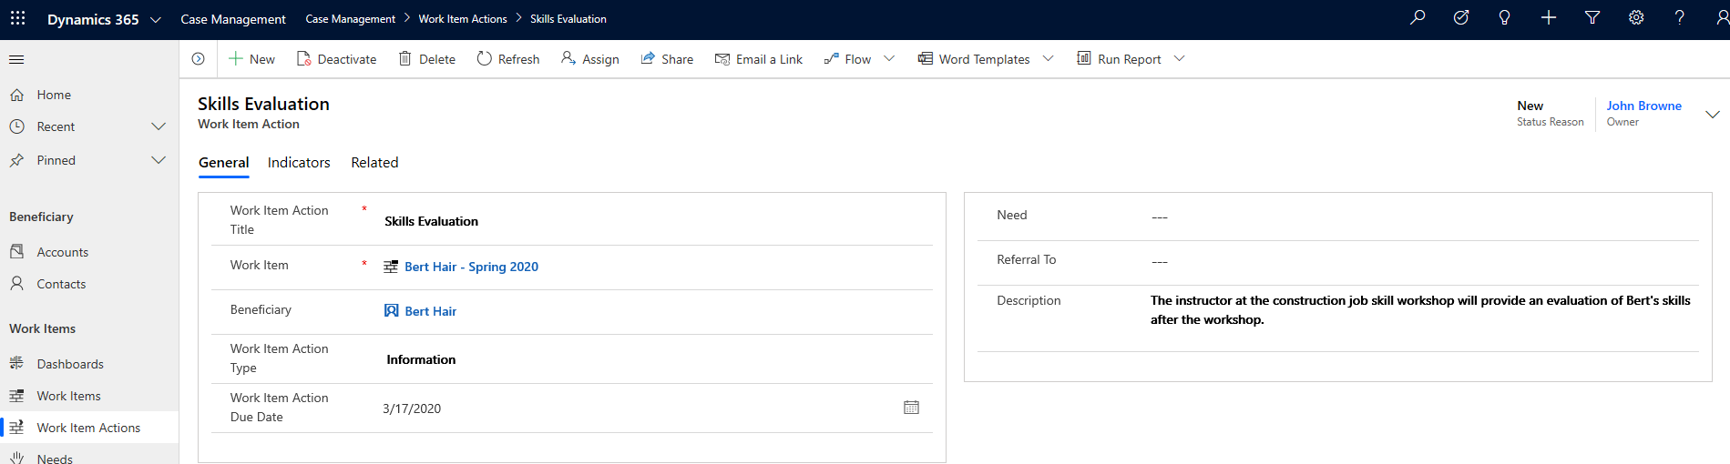

1. Return to the Work Item by clicking on the blue work item text **Bert Hair – Spring 2020**.
2. To find out why Bert is in the system, click the **Needs** tab. Here, Bert’s need for **Employment** is recorded.

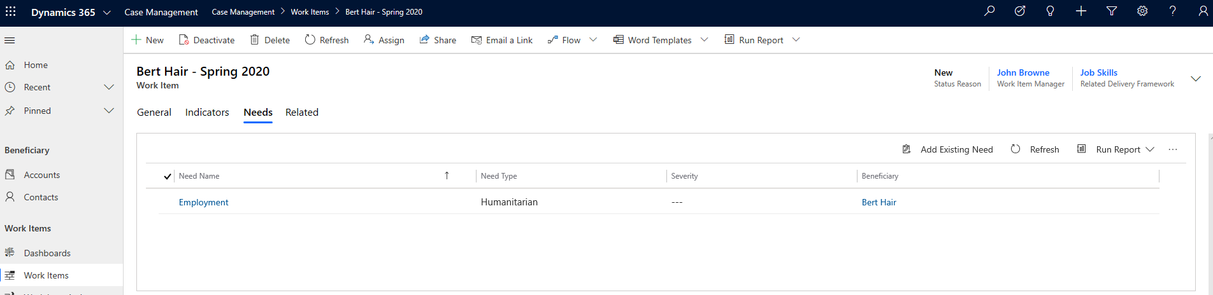

1. Click the **Indicators** tab to see how success on this case will be measured. Two indicators are listing that indicators for this case will be based on **Number of People that Receive Career Counseling** and **Number of skills learned**.

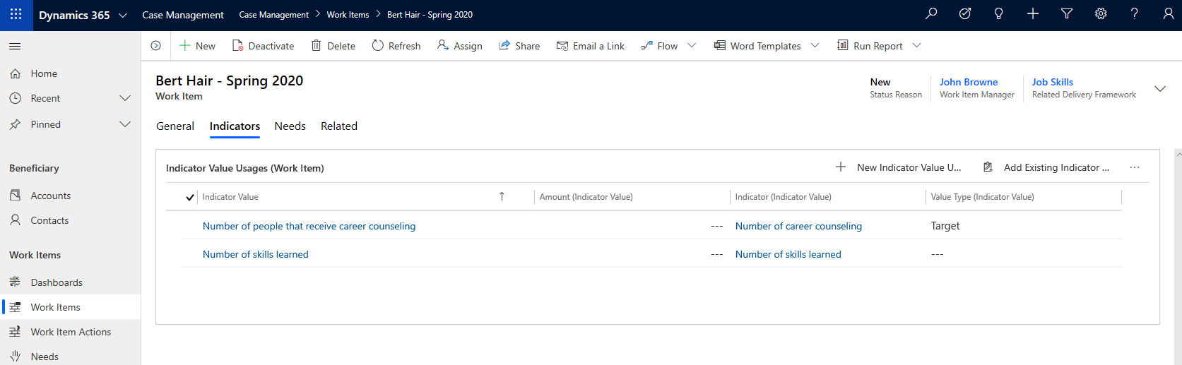

1. In the left navigation, click **Dashboards** to view the Dashboard showing all the Active Work Items by Status Reason, Recent Work Items and Work Item Action by type.

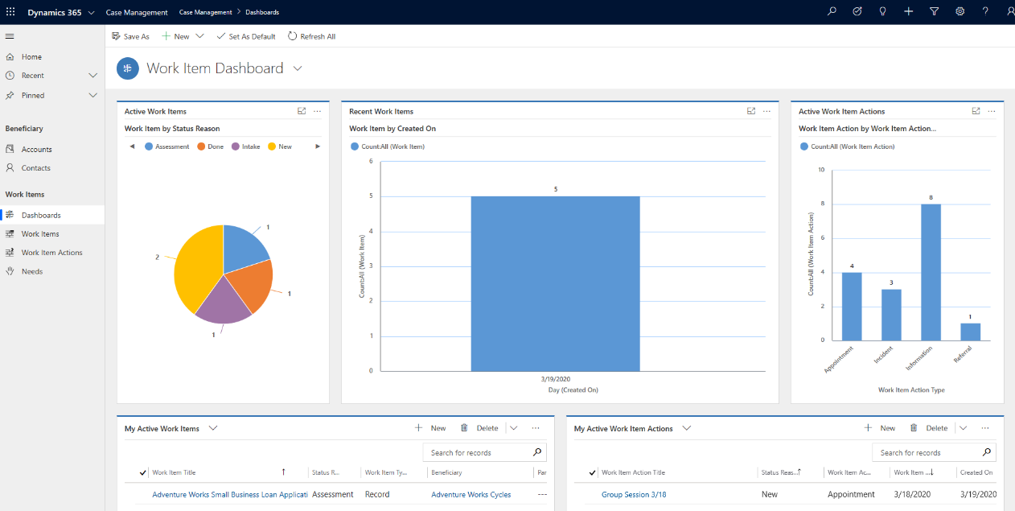

## Assessment

The Nonprofit Accelerator has an Assessment solution that can be utilized to provide basic assessment functionality. This section outlines some of the functionality that this solution provides.

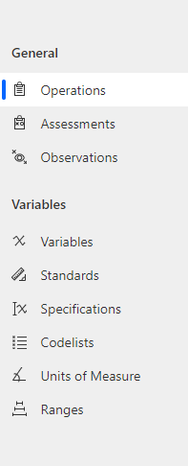

#### Operations

Records the operation(s) being conducted by the organization(s) and/or person(s) conducting the Assessment of Observation(s).

#### Assessments

Records one or more Observations by type related to an Operation.

#### Observations

Records one or more Variables at a point in time and geographic location. Multiple Observations may be grouped into an Assessment.

#### Variables

Defines a generally understood representation of a variable as defined by the Variable itself and/or (Recommended) one or more of the following references: Codelist, Range, Unit of Measure and/or Spec.

#### Standards

Defines a recognized standard for defining a Specification or Specifications.

#### Specifications

Defines the source of a Codelist for a Variable.

#### Codelists

Defines values of a Variable set by a Specification.

#### Units of Measure

Defines the unit(s) of measure of a Variable.

#### Ranges

Determines the minimum, maximum and target values of a Variable.

### Sample Operation

1. Navigate to the **Assessment** Sample Application, and view the **Operations**

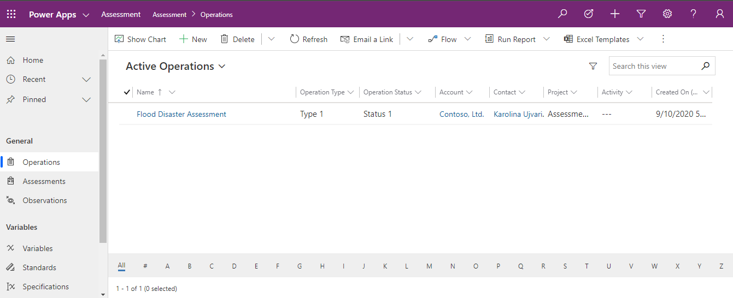

1. Click **Flood Disaster Assessment** to view a summary of the operation. Note the operation can be linked to a contact, account, and a program delivery to connect it to a larger program or initiative. Operations are composed of one or more assessments. Each Assessment is in turn comprised of one or more Observations.

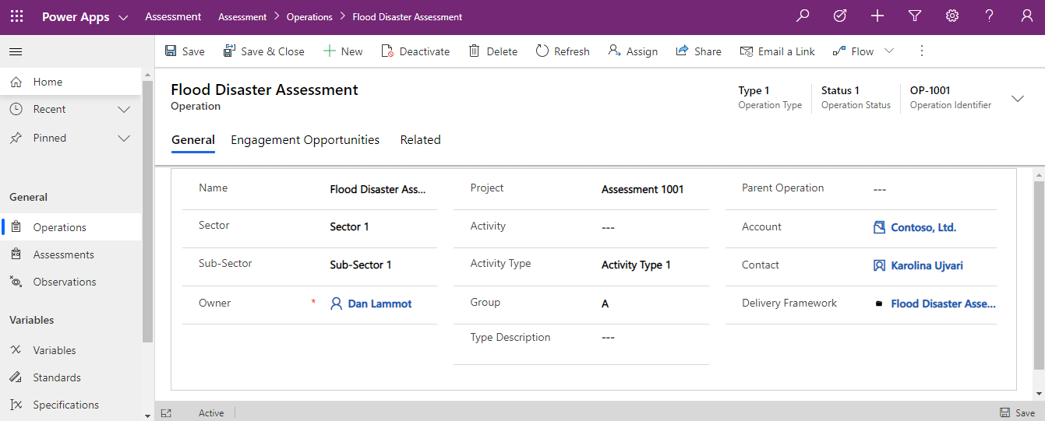

1. To view the related Assessments, click **Related** and then click **Assessments**.

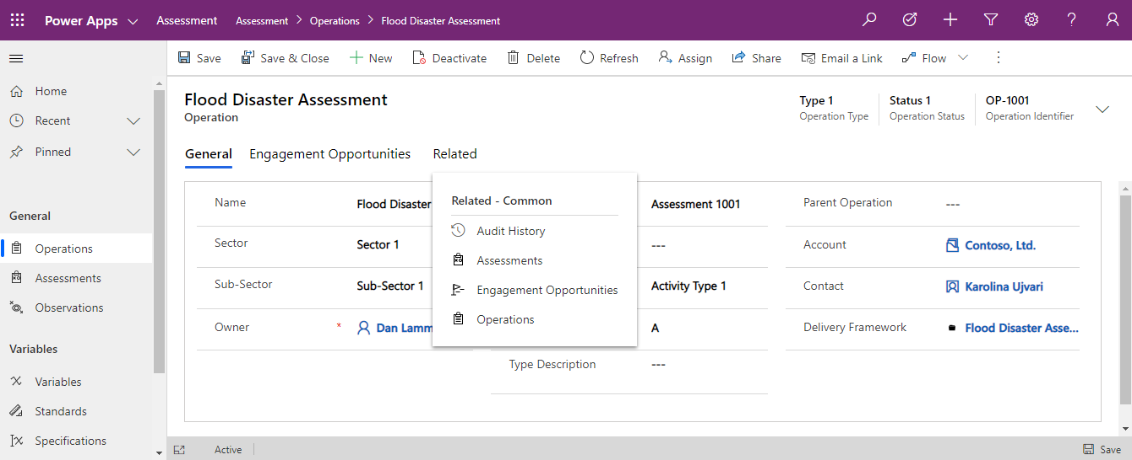

1. On the related Assessment screen, click **Disaster Assessment: Flood** to view an example assessment. Note, a new assessment can be added by clicking on New Assessment on this screen.

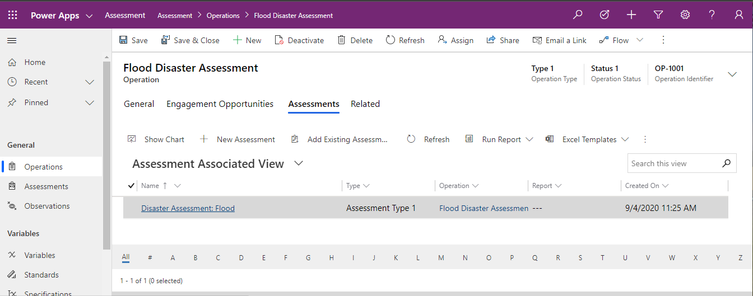

1. The assessment page is primarily focused on observations, but other fields such as the type field can be used to categorize. Also note that a report can be linked to the assessment.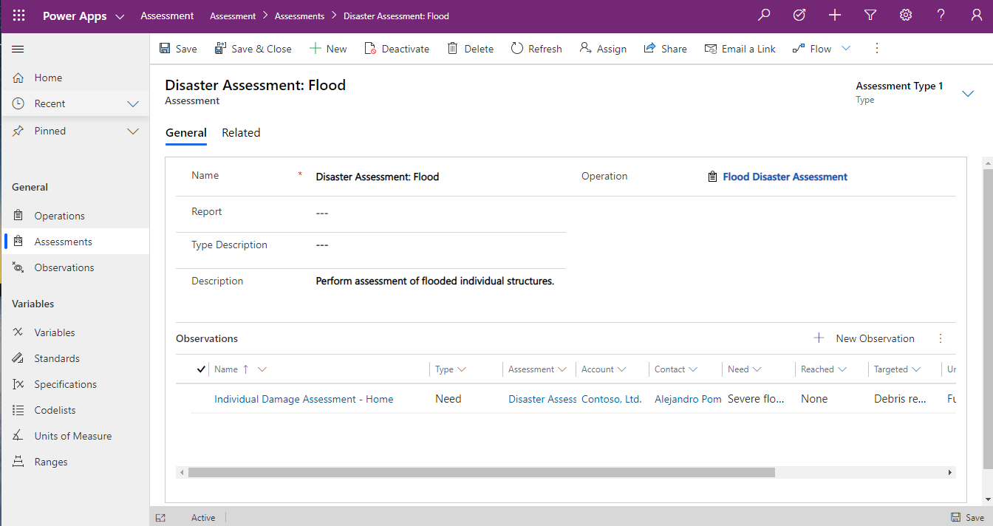
2. Click **Individual Damage Assessment - Home** to view the related Observation. The assessment General tab provides places to outline the precise time, location, as well as details related to needs and services. Click **Observed Variables** tab to view the details of the observation.

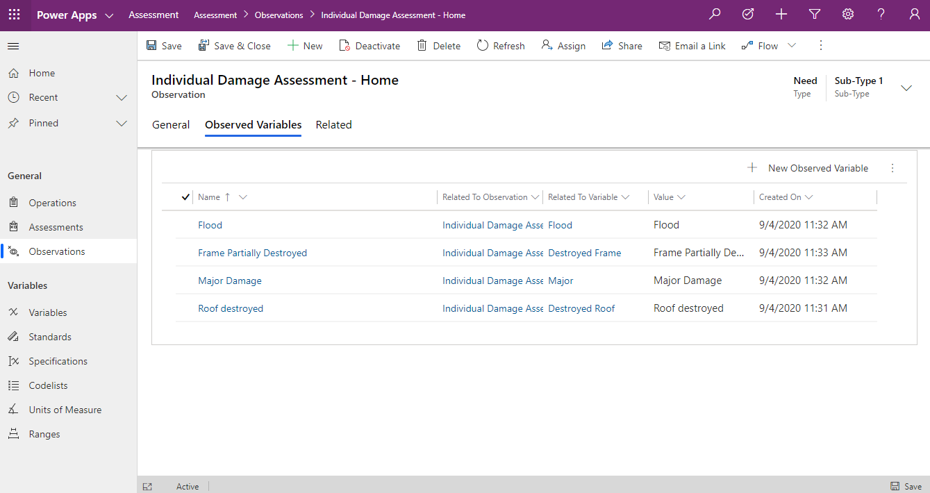

1. In the Observed Variable tab all the specifics of the observation in the form of variables that have been observed can be seen in list form. Click the **Roof Destroyed** to see more about the observed Variable. Additional observed variables can be added by clicking the New Observed Variable.

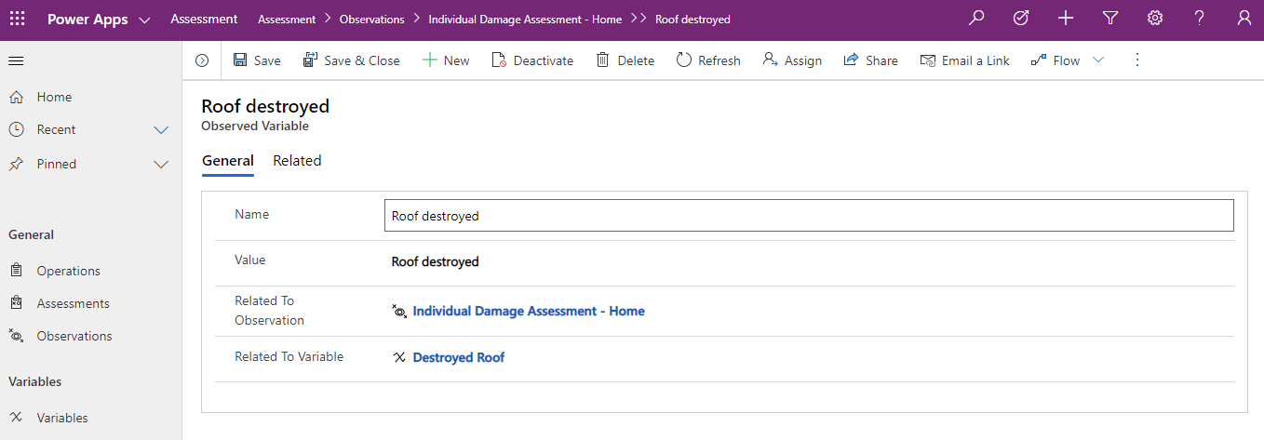

1. The observed variable serves a link between Observation and Variable and allows for the entry of a Value. In this instance the Value is that the roof was destroyed but in more detailed scenarios could be the precise measurement or counts related to the variable. To see how these variables are configured click the Related To Variable **Destroyed Roof**.

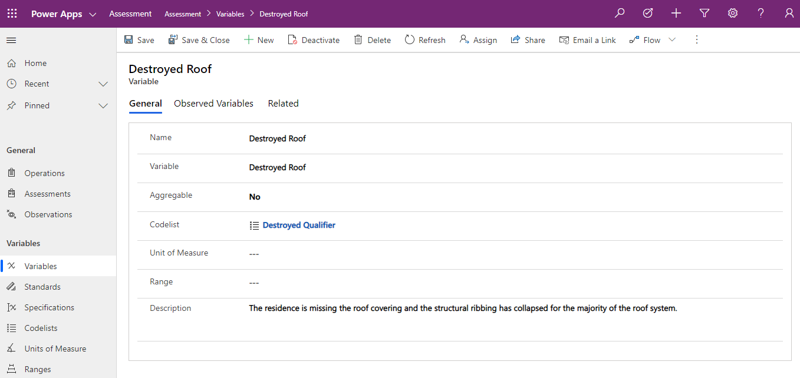

1. The variable screen shows all the setting and details around the variable. Worth noting are the Unit of Measure used to denote what type of measurement unit is being used in this variable for measuring. The Range defines the maximum, minimum, and target of the variable. The Codelist is used to tie Variables together into specifications. Each can be browsed by clicking on the links.

## Frontline Humanitarian

The Nonprofit Accelerator includes the following components which enable tracking of nonprofit item management.

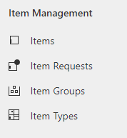

#### Items

Defines an individual article or unit that may be part of a group of articles or units required for a program activity or donated by a donor.

#### Items Requests

Defines a request for an item or items of varying types and quantities for a location and date.

#### Item Groups

Defines a group of items that are logically handled together as a unit such as a kit.

#### Item Types

Defines a type of item or a type of item group.

### Sample Item Request

1. Navigate to the **Nonprofit Hub** Sample Application, and view the **Item Request**

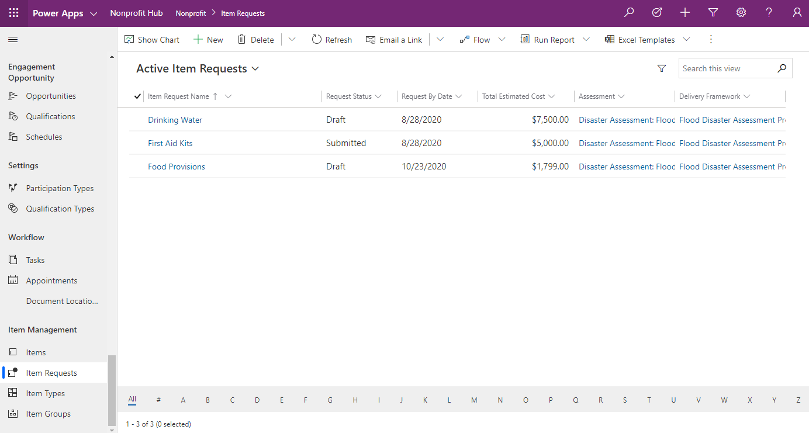

1. Click the **Drinking Water** item request. This form allows you to view the details of the request as well as the related items requested. Note the request can be related to a **Delivery Framework** or an **Assessment**. In this case, the request is for 7,500 units of drinking water, but item requests can also support multiple different item types. New Item requests can be added by clicking New Item Request Line.

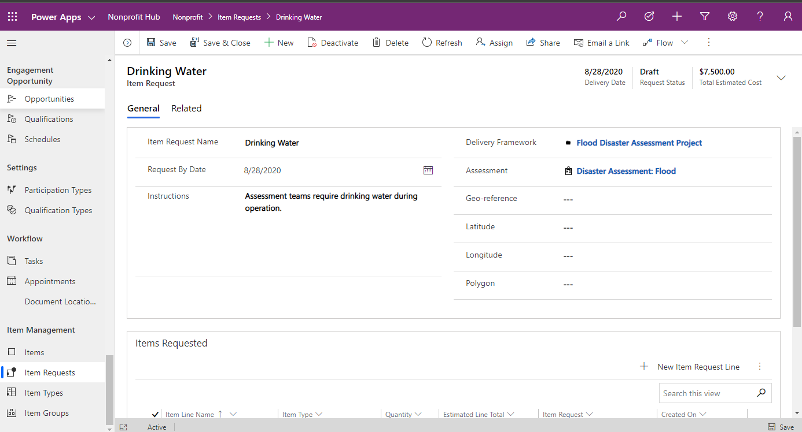

1. Scrolling to the bottom of the item request, you can see the Items Requested. Click on Drinking Water item type.

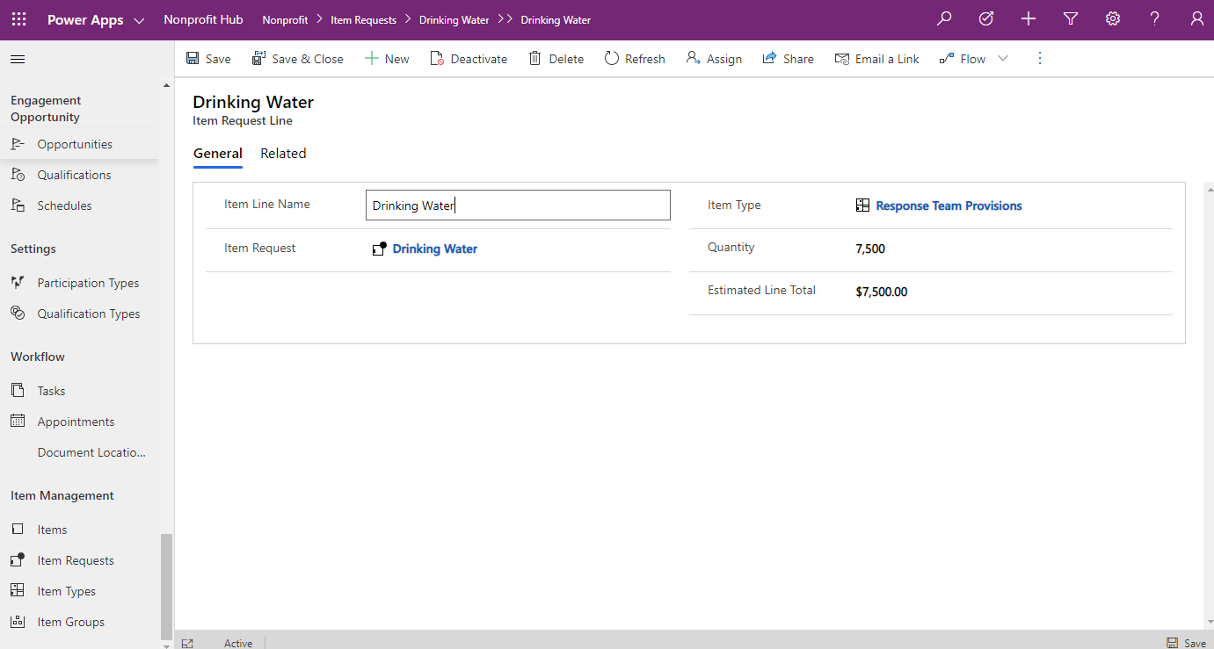

1. Item requests are based on a request for a certain number of an item type which is a prototype of the item or item groups that may fill that request. Click on the item type **Response Team Provisions** to view the item type that is being requested.

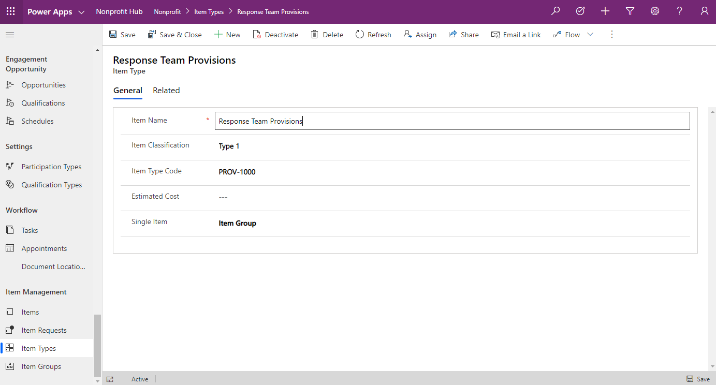

1. Click **Related** and select **Items** to see the items of this item type.

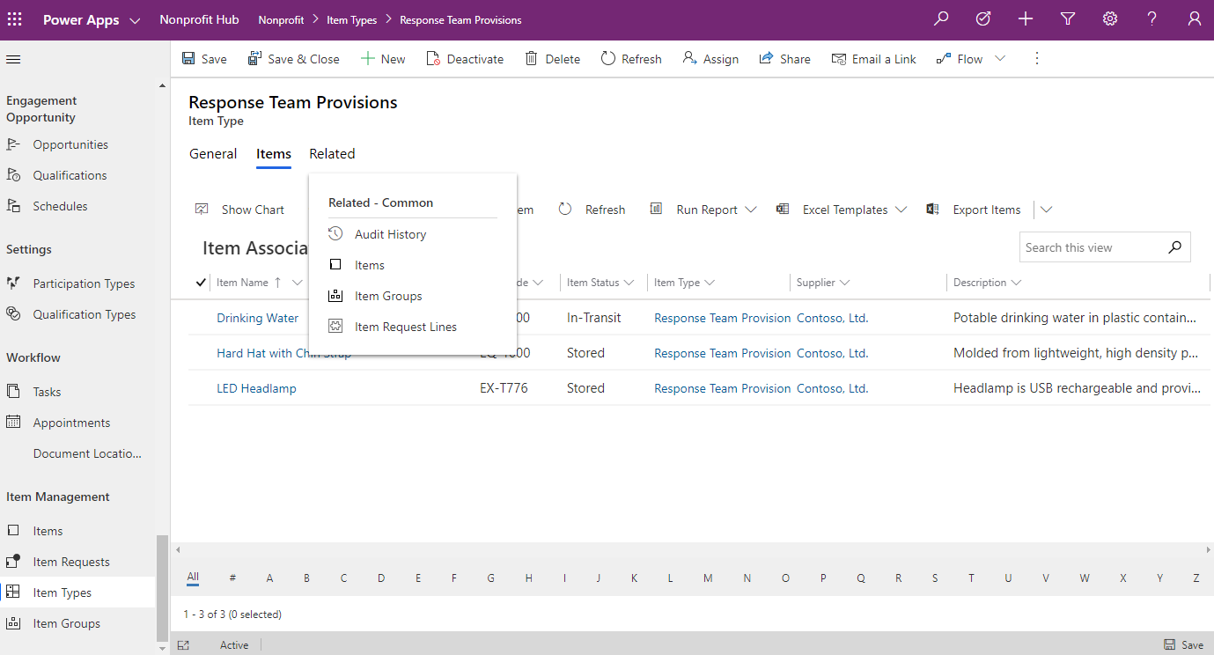

1. Click on **Hard Hat with Chin Strap** to view the item. Items represent a specific item and should be identifiable based on some sort of identifiable number that can be used to track their location.

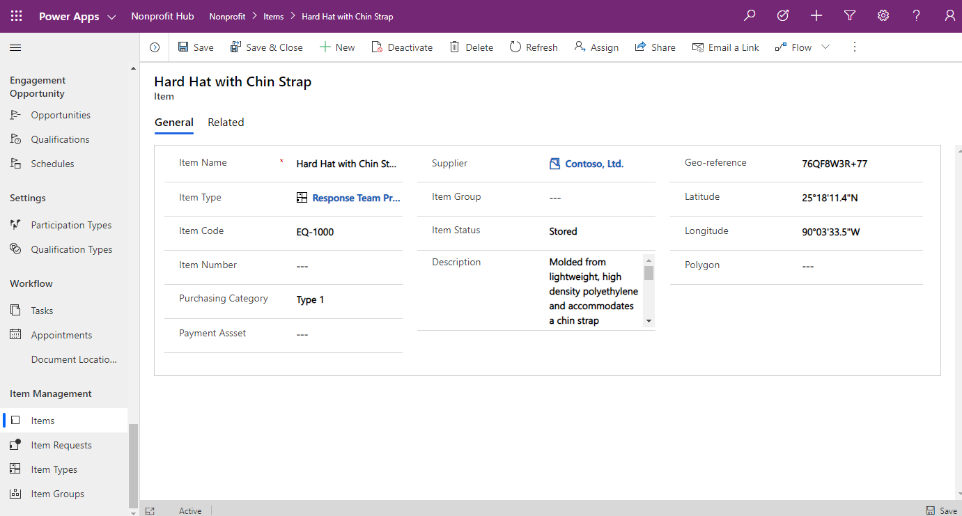

# Program Design Canvas App

The Microsoft Dynamics 365 Nonprofit Accelerator is a solution designed to extend and enhance Dynamics 365 with day-to-day nonprofit constituent management, fundraising, award and program delivery capabilities. The Accelerator contains installable solutions with standard tables column extensions, nonprofit tables and columns, pre-built dashboards, workflows, sample data as well as other tools to help customers and partners build and deploy nonprofit solutions.

This documentation provides a walkthrough of the accelerator’s new (released with v2.2.3.1) Program Design Template Application. This application provides basic Program Design functionality, including creating and browsing logframes, and browsing indicators. Further enhancements may be included in future releases.

### Personas

This walkthrough was created with the following nonprofit personas in mind:

1. **Logframe Creator:** The Logframe Creator (e.g., Technical Coordinator) will use the app to create a logframe which will be used to support a grant application and, subsequently, carry out project activities.
2. **Reviewer:** The Reviewer (e.g., Technical Advisor) will use the app to review and approve a logframe before it is sent to a prospective donor.
3. **Program Manager:** The Program Manager will use the app to check on logframe status to ensure timely delivery to prospective/actual donors.

### Additional Resources

Additional resources about Microsoft Accelerators can be found on Microsoft Docs [here](https://docs.microsoft.com/en-us/common-data-model/industry-accelerators). Specific references for the Nonprofit Accelerator can be found on Microsoft Docs [here](https://docs.microsoft.com/en-us/common-data-model/nfp-accelerator) and on AppSource [here](https://appsource.microsoft.com/en-US/product/dynamics-365/msnfp.msftnonprofitcommondatamodel?src=office&tab=overview).

## Application Overview

The Program Design Template App is comprised of four key modules, accessible via the persistent main navigation at the top of the screen. Below is a brief description of each of these modules.

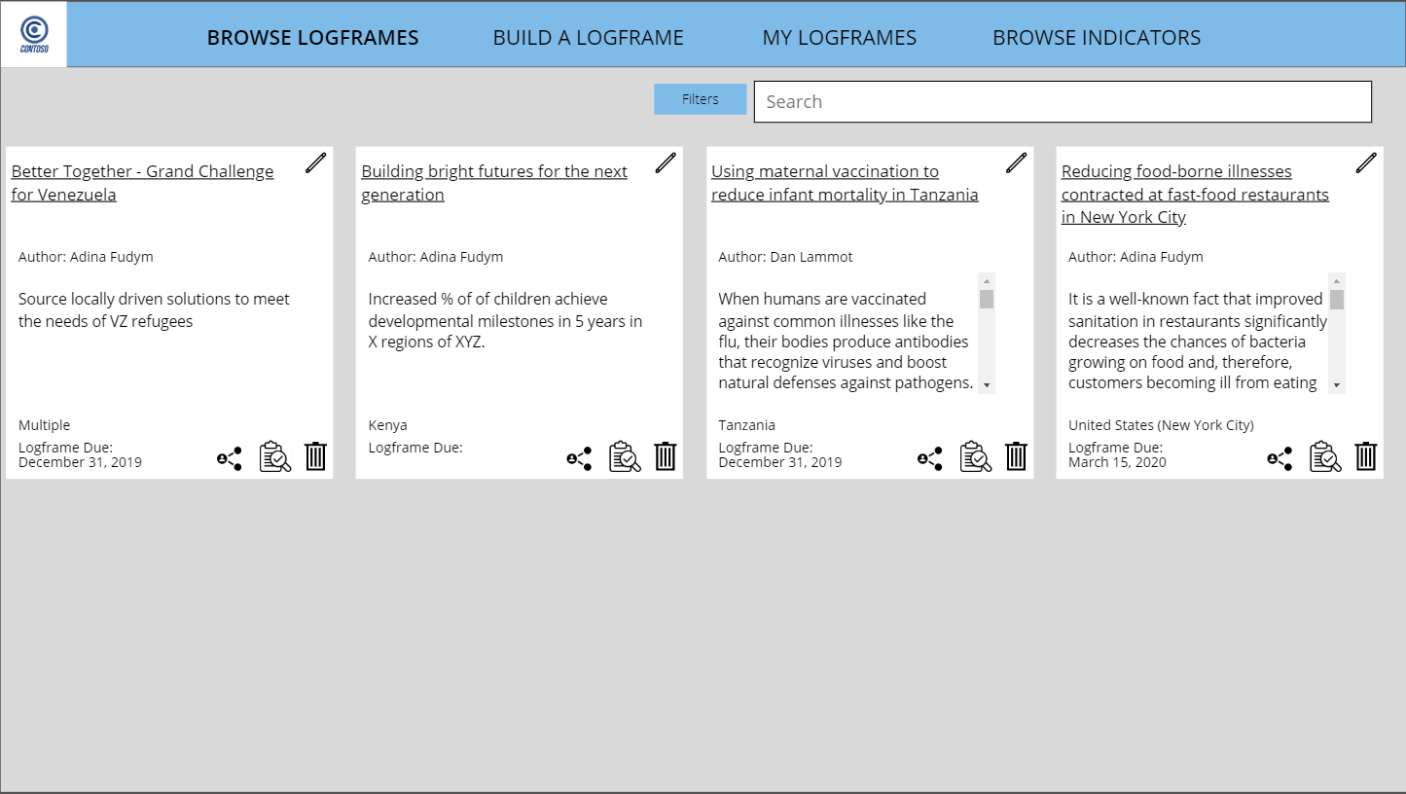

### Browse Logframes

Users can find logframes that they or other users in their organization have created. To view a sub-set of logframes, users have the option to use the page’s search and filter functionality.

### Build a Logframe

Users engage with this module in order to create a new logframe. The module takes users step-by-step through the process of adding outcomes, outputs, and indicators, and creates a logframe document at the end of the process which can be shared internally or externally. Potential functionality in subsequent releases will enable users to copy and modify a previous logframe to expedite the creation process, and to conduct reviews and approval within the application via a built-in review and approval workflow.

### My Logframes

This module is similar to Browse Logframes, but auto-filters the logframes so that users only see logframes they have authored. This makes it easier to quickly locate, access and continue work on logframes most pertinent to the user.

### Browse Indicators

In this module, users can view indicators outside the context of building a logframe. This could be helpful as part of training for new employees looking to familiarize themselves with the organization’s indicators, as a refresher for veteran employees, or as a helpful resource when doing initial project planning and brainstorming. In this release, this module includes the ability to load and view Internal, External and Standard indicators, and the app is pre-loaded with the Sustainable Development Goals (SDGs) in the Standard indicators. Subsequent releases may showcase other libraries of Standards.

## Find and View a Logframe

There are two methods for finding a logframe: via Browse Logframes or My Logframes. Browse Logframes can be used to locate a logframe that anyone in the organization has created, while My Logframes, as the name suggests, is a quick way to access logframes that the logged-in user has authored.

### Browse Logframes: View all Logframes

1. By default, the user will begin on the **Browse Logframes** screen, with all organizational logframe displayed (*NOTE: in future releases, there may be role-based access control built in to allow/disallow users from seeing certain logframes*).

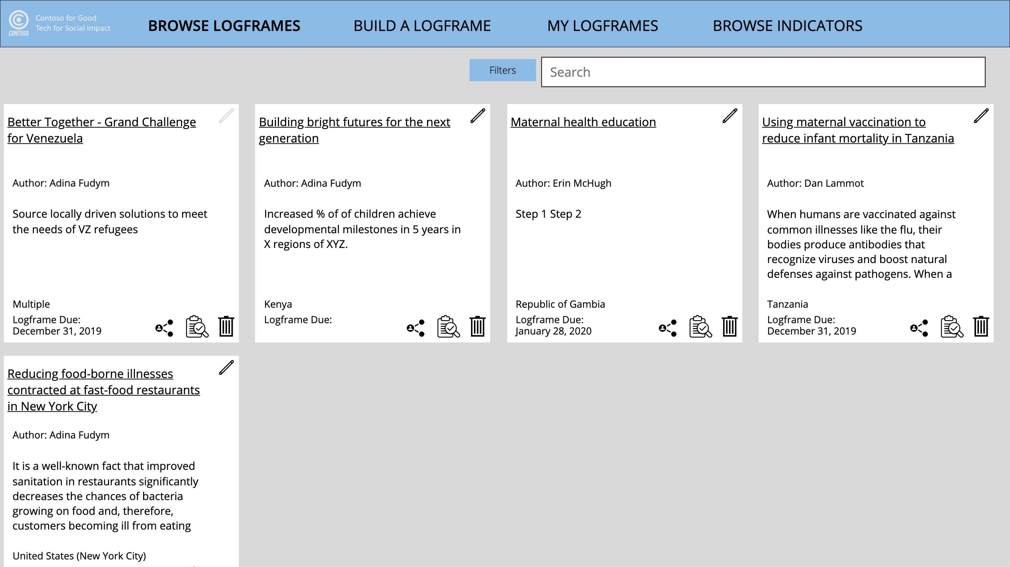

1. Easily search for a specific logframe or group of logframes. Using the search bar, search for **maternal**.

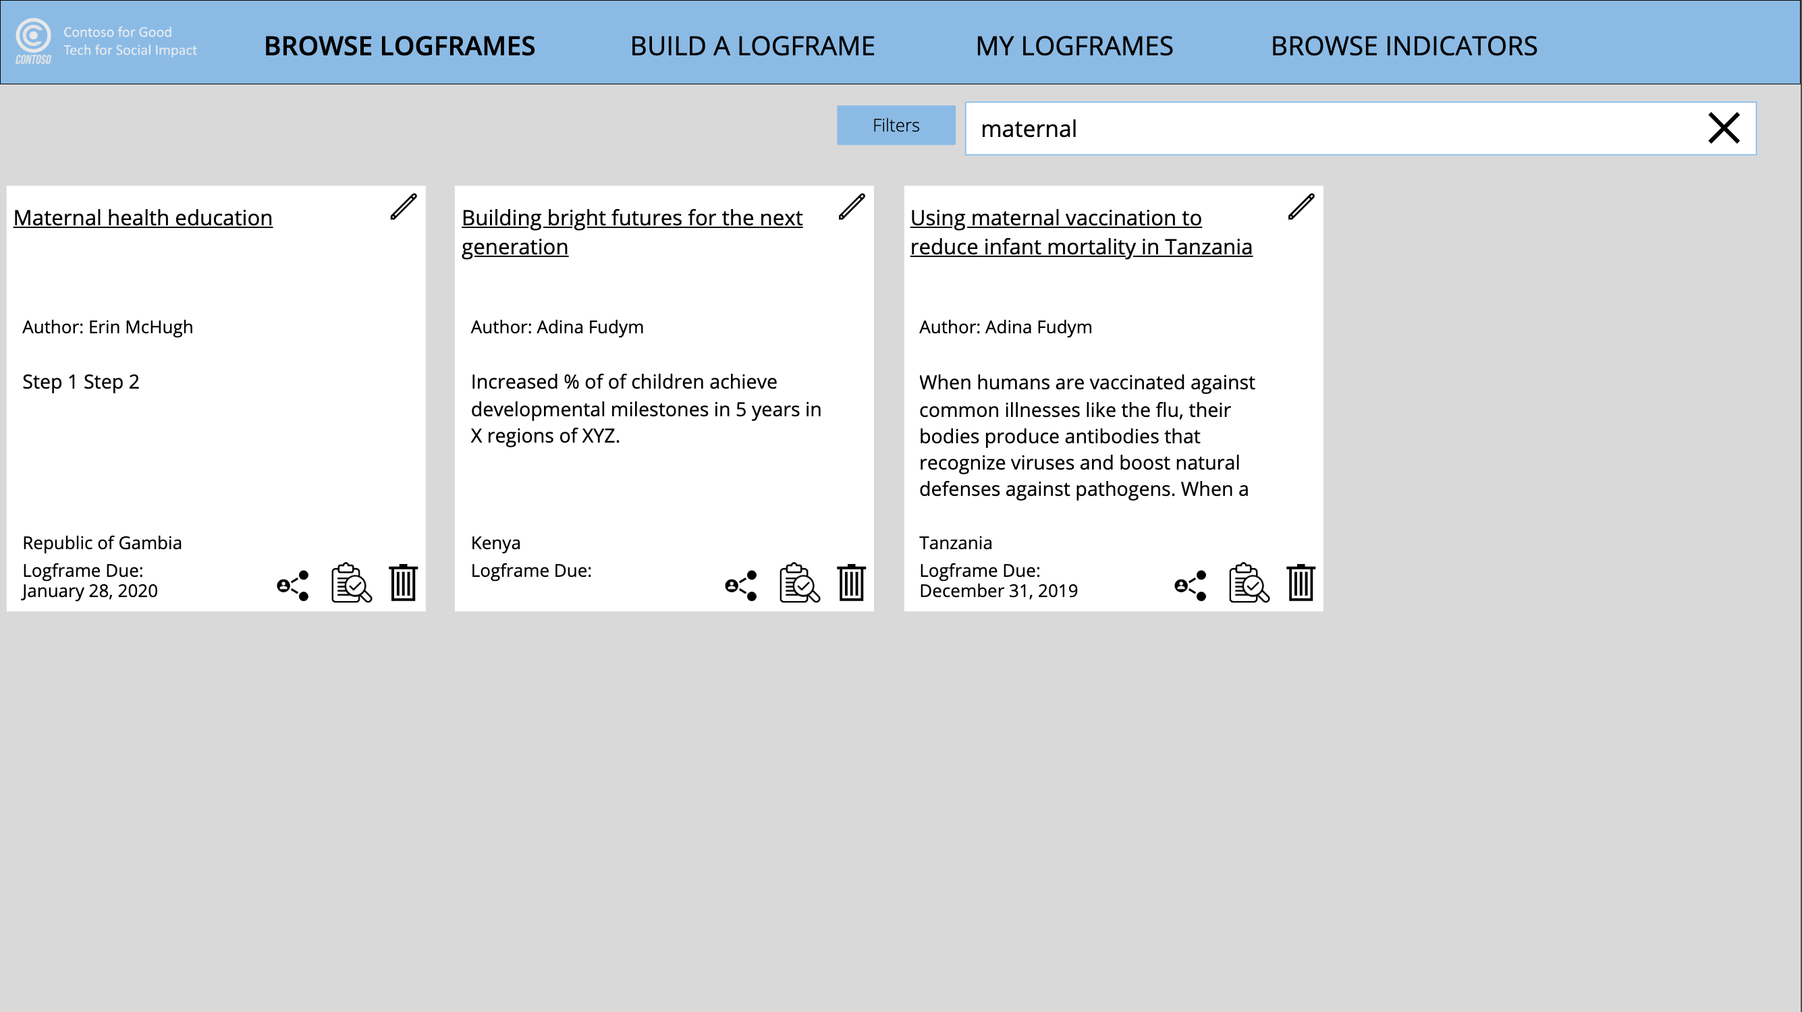

1. Click the **Filters** button to further refine the search results. The default is to filter by Outcome Area. Select **Immunization and Infectious Diseases** and click **Apply Filters**.

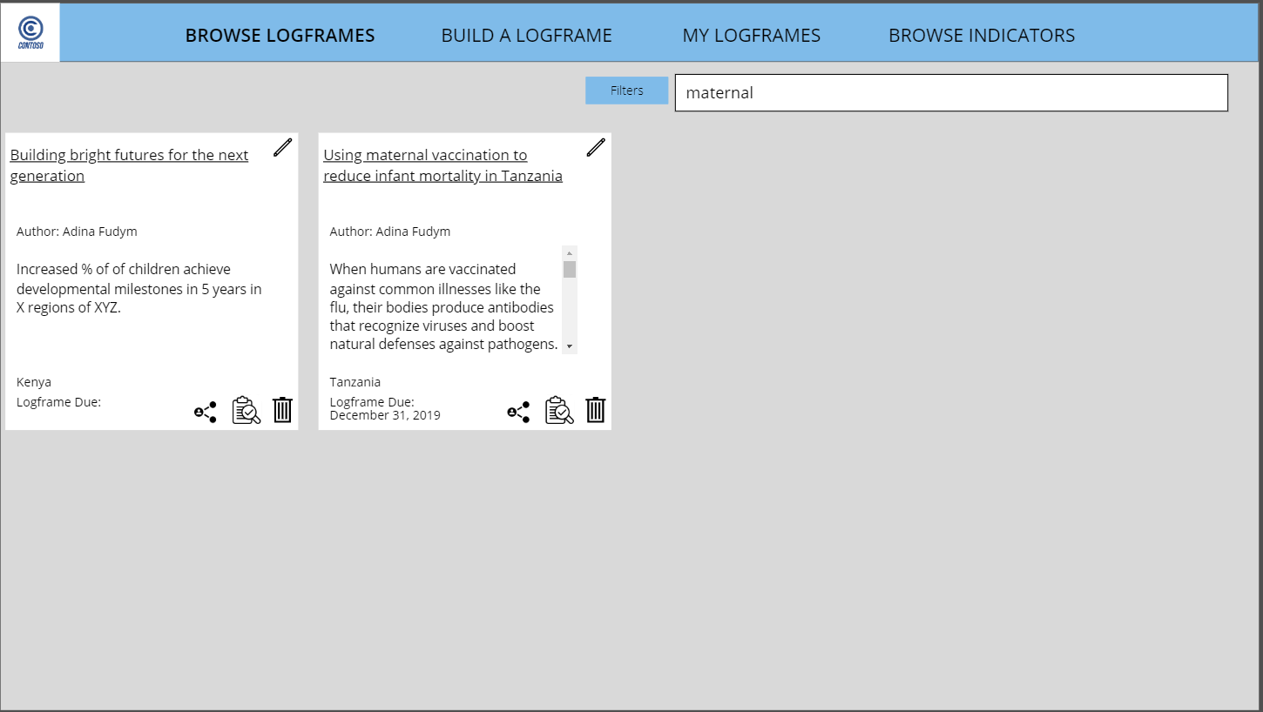

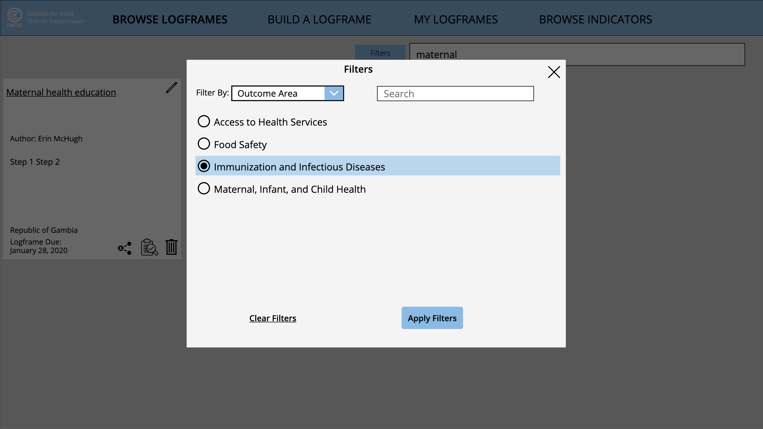

1. Click the logframe entitled **Using maternal vaccination to reduce infant mortality in Tanzania** in the Search Results to preview the logframe in its current state.

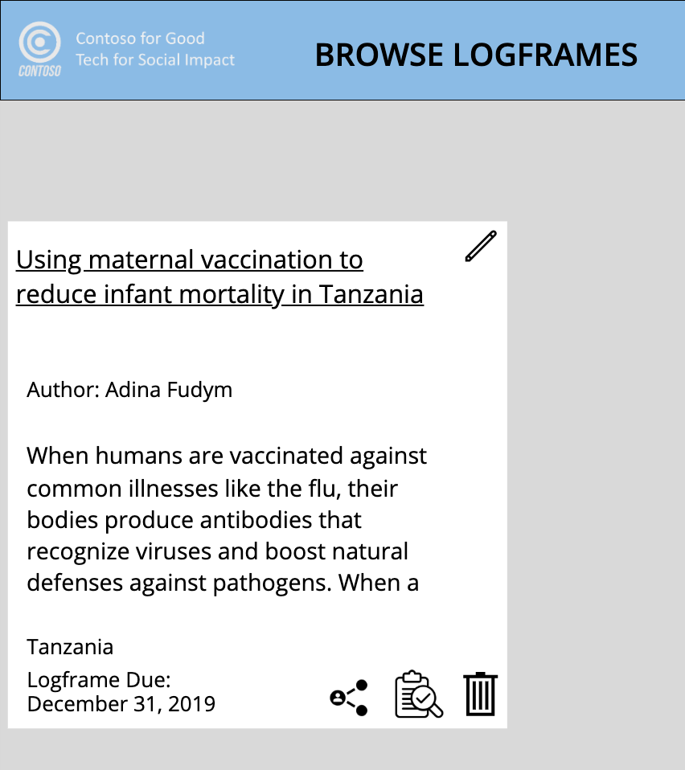

1. View basic information about the logframe at the top of this screen (e.g., country where project will take place, donor name, etc.) and scroll through the page to view all selected outcomes, outputs and indicators.

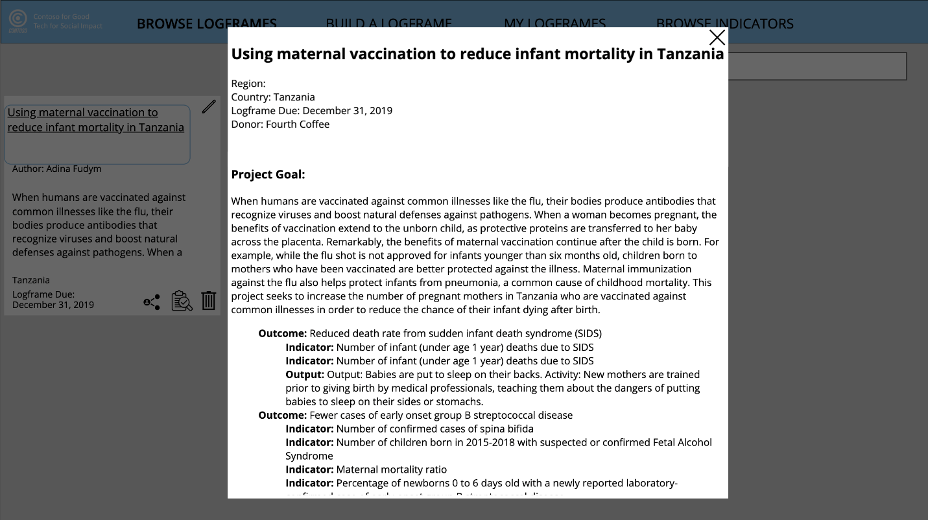

1. Close the preview screen by **clicking the X** at the top right of the screen.

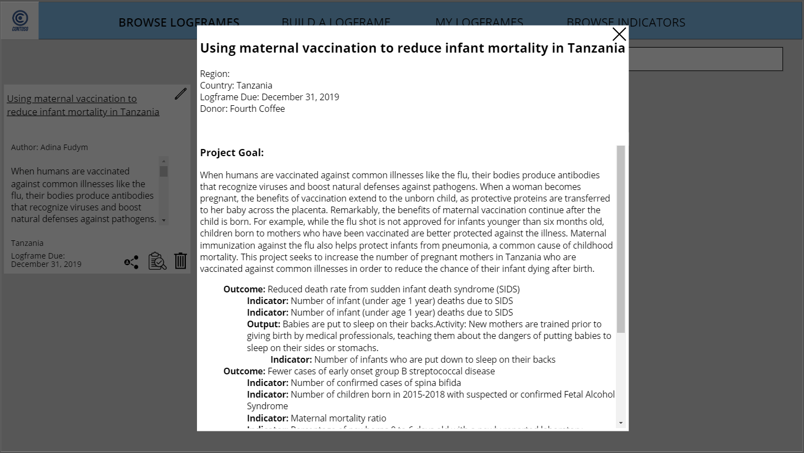

1. To share the logframe with yourself or others, click the **Share icon**. A pop-up with two sharing options appears: **Option 1: Email Logframe** (logframe text or link to Word document) and **Option 2: Generate Logframe Link**.

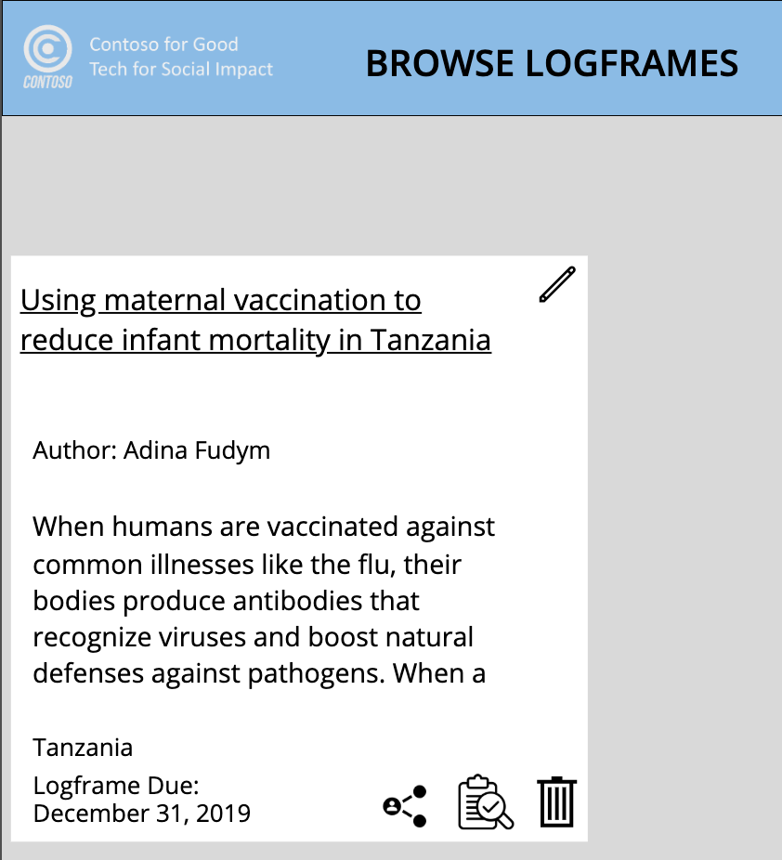

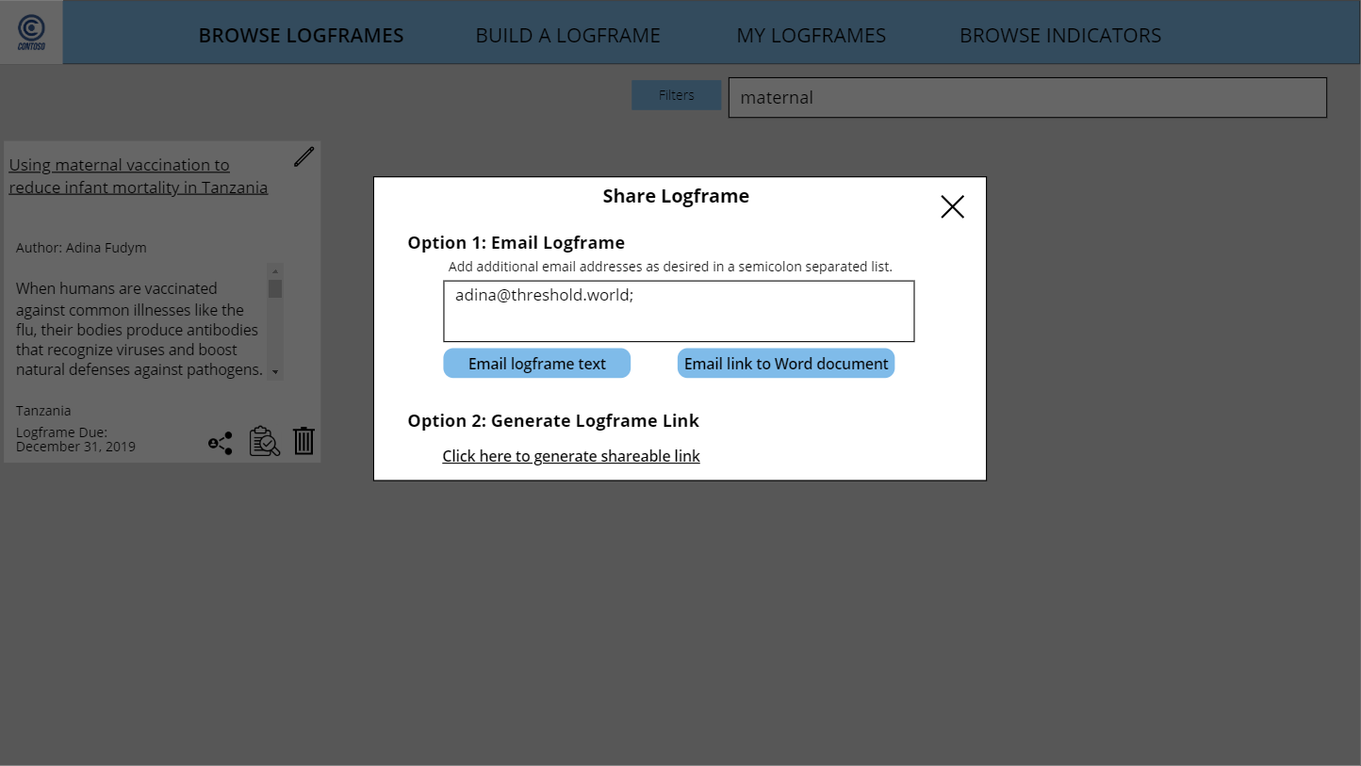

1. Enter a co-worker’s email address in addition to yours, which is listed by default. Click the **Email logframe text** button to send an email containing the logframe text in the body of the email.

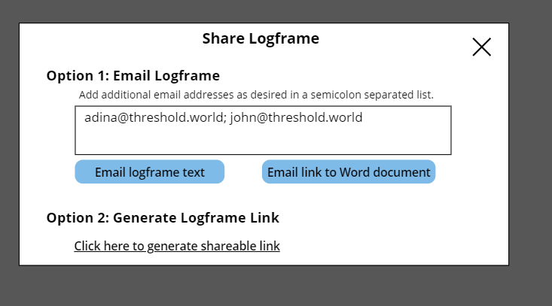

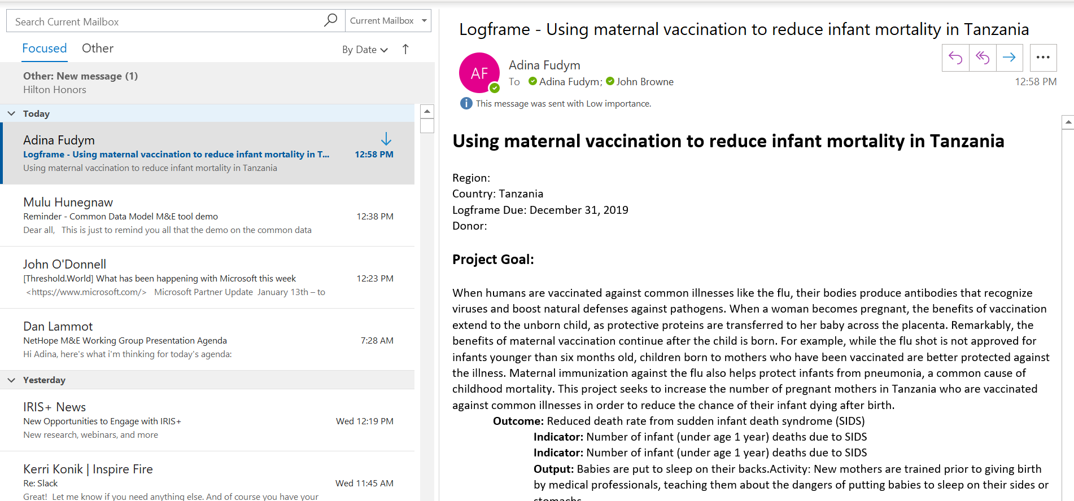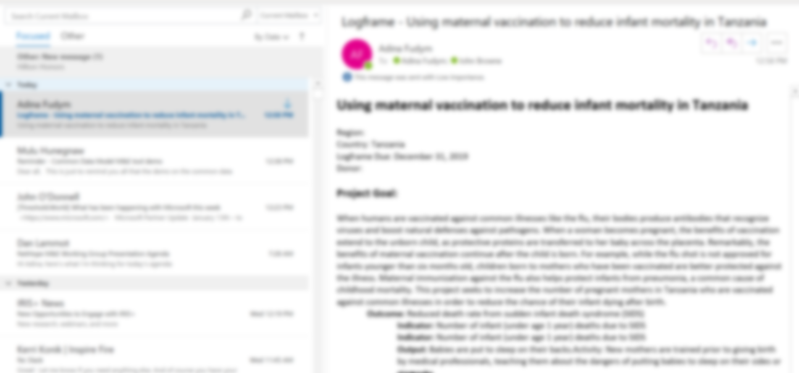

1. Send an email with a link to a Word document containing the logframe contents by clicking **Email link to Word document**. Clicking the link in the email will open a Word document saved to a SharePoint folder designated by the organization’s admin.



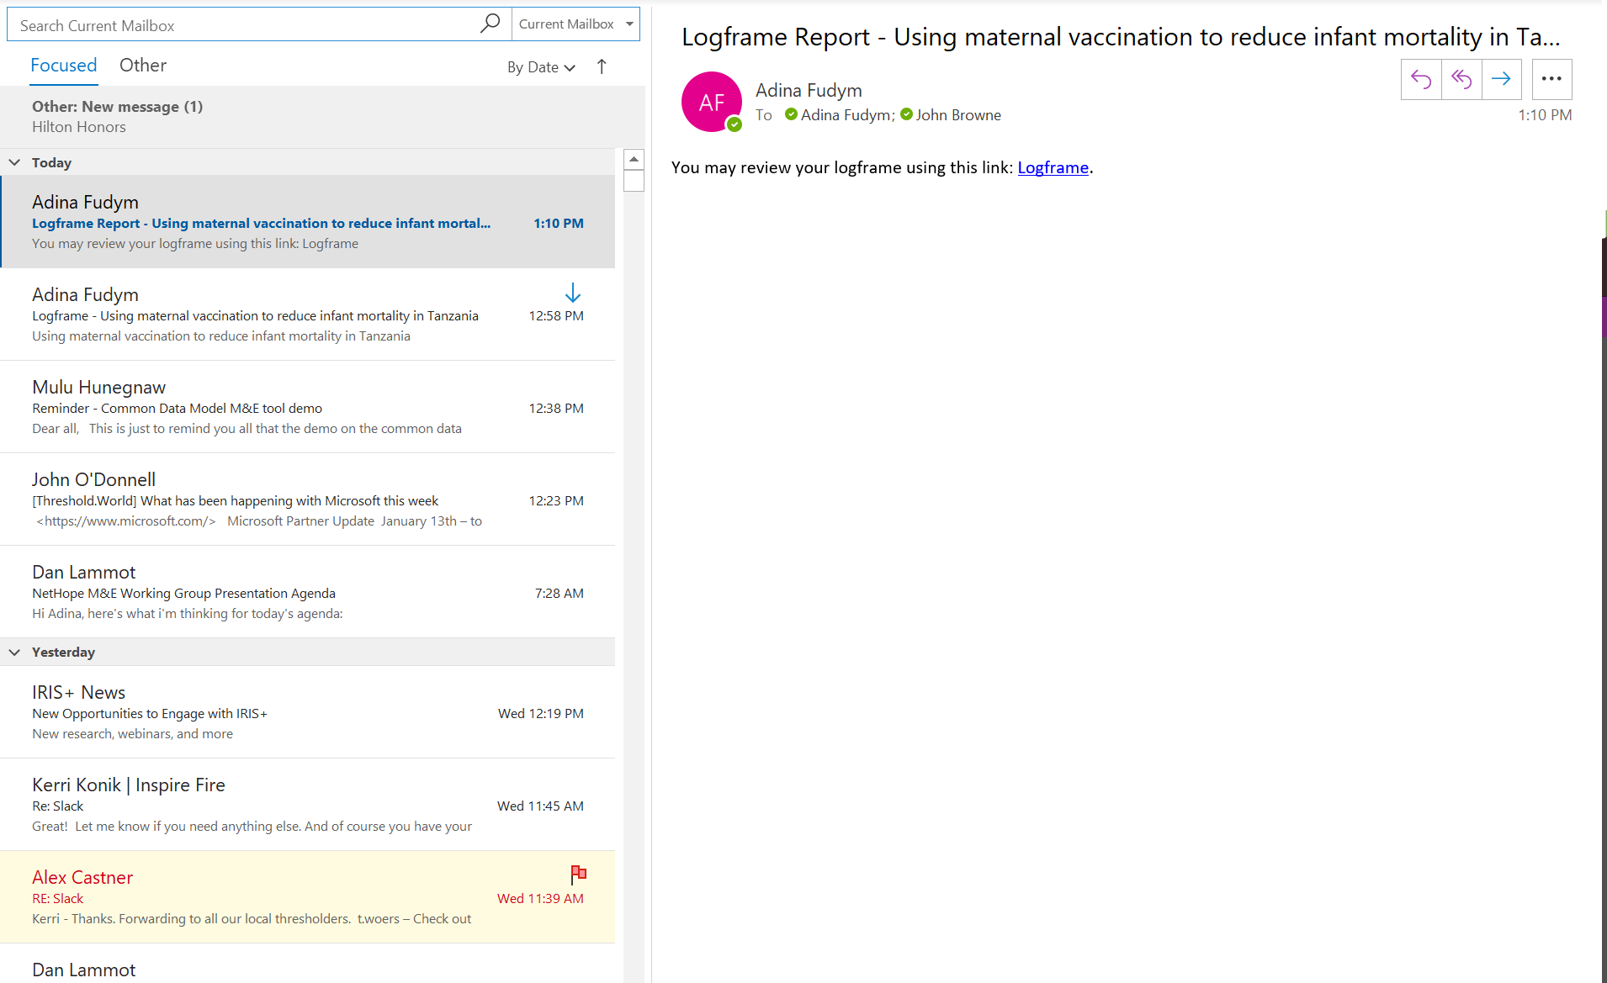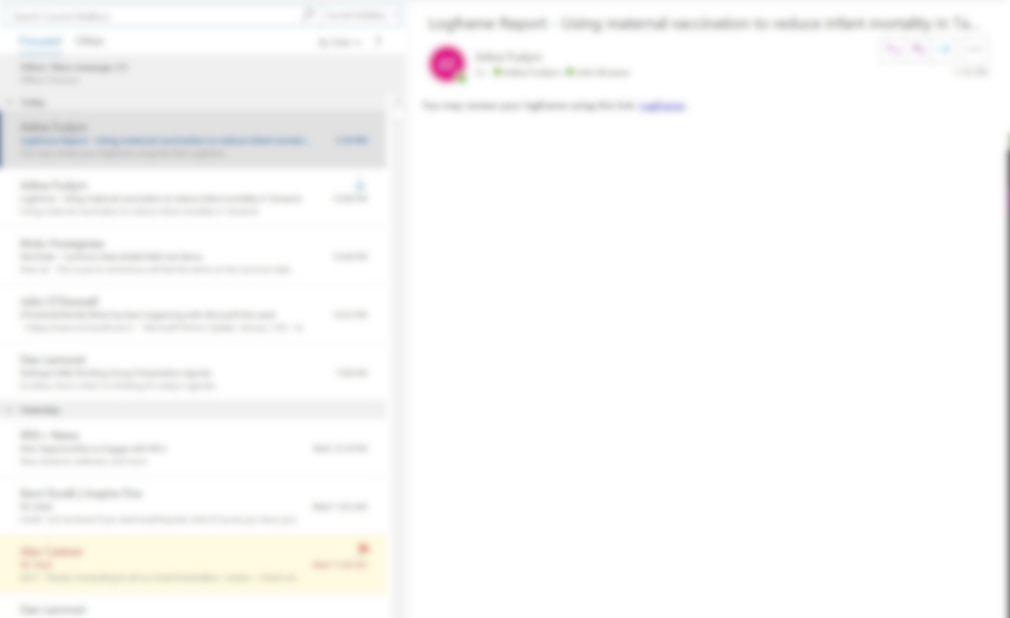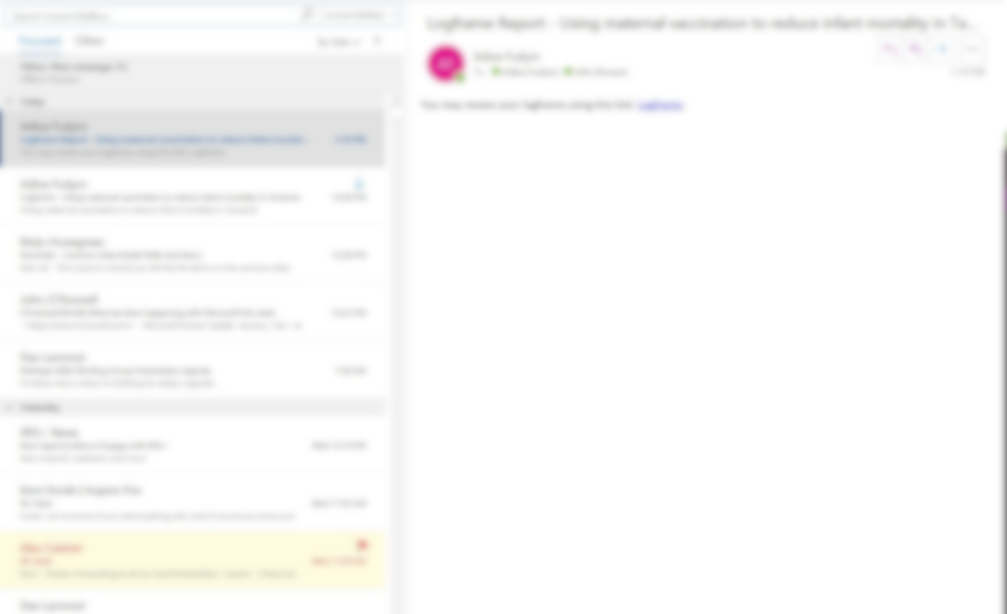

1. Alternatively, access the same Word document within the context of the application by clicking **Click here to generate shareable link.** Once the document link has been generated, a message will appear: **Your document is ready. Click here.**



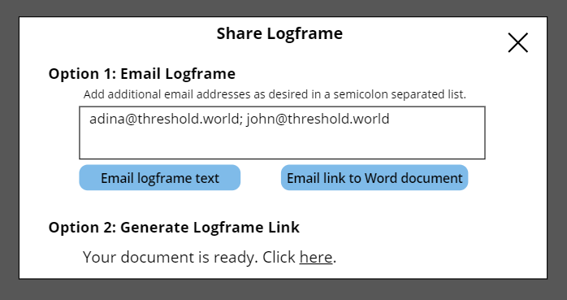

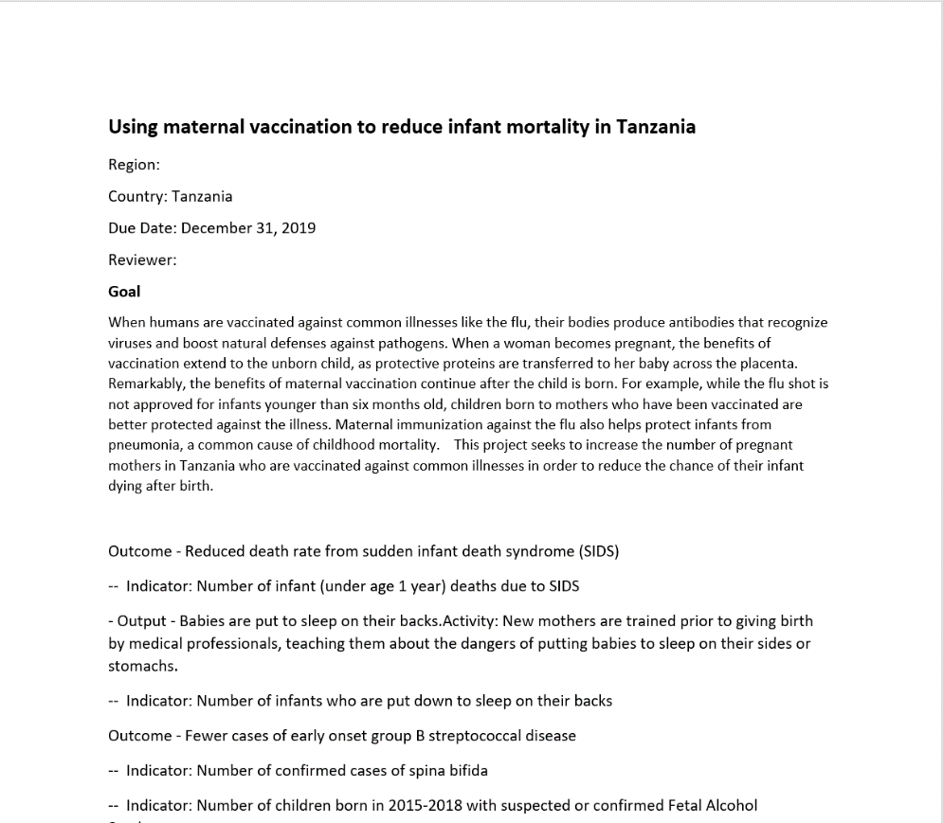

### My Logframes: View only your logframes

1. Use this screen to view all logframes that the logged-in user has authored.

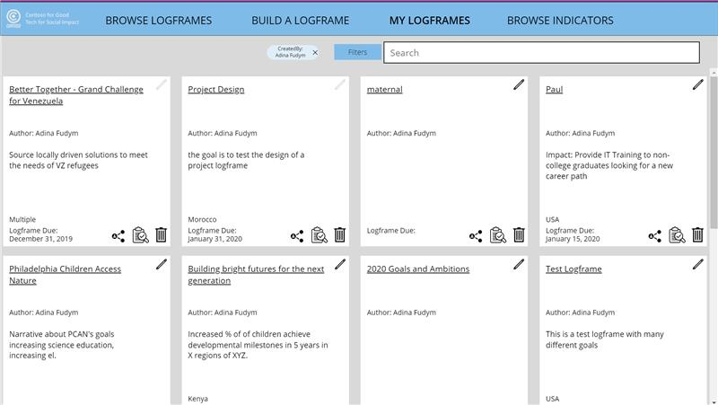

1. Either scroll through the logframes on the page and click **Using maternal vaccination to reduce infant mortality in Tanzania** OR
2. Use the search bar to search for **maternal** and then click on **Using maternal vaccination to reduce infant mortality in Tanzania,** as on the Browse Logframes screen.

### View and Modify Logframe Status

1. View the **review status** of the logframe by clicking the **clipboard + magnifying glass icon[1]** at the bottom of the logframe “card.”

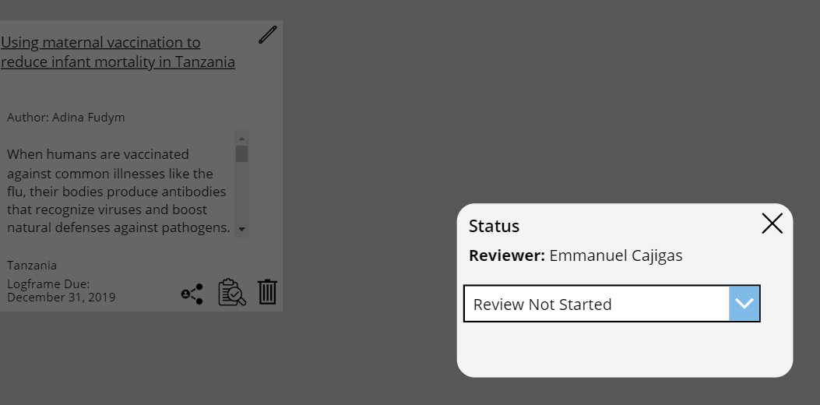

## Edit and Delete a Logframe

There is currently no role-based access control (RBAC) built into the design, so any system users can technically edit any logframe that hasn’t yet been approved or delete any logframe. This Template App may be delivered with RBAC in subsequent releases, although individual organizations can customize the accelerator at this point to include RBAC.

### Edit a Logframe

1. Using the search bar, search for **maternal**.
2. Locate the logframe **Using maternal vaccination to reduce infant mortality in Tanzania** and click on the **pencil icon** at the top right of the “card.” *(NOTE: only logframes that have not yet been approved will be editable. All Approved logframes will be locked from editing.)*

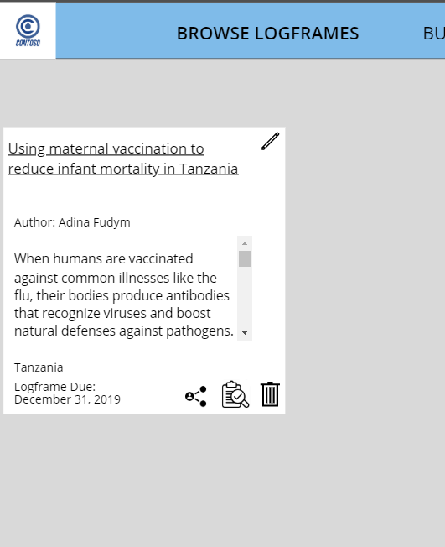

1. Users will be taken to the first screen of the Build a Logframe module and will be able to modify and add on to their logframe contents. *(NOTE: In subsequent releases, users may be directed to the part of the logframe creation process where they last left off.)*

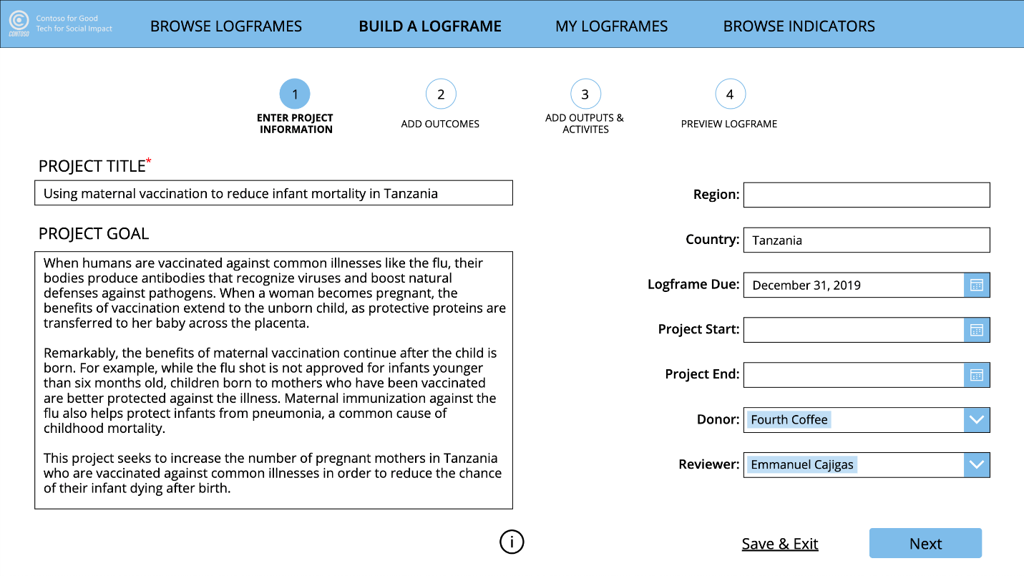

1. Click **Save & Exit** at the bottom right to save the contents in their current state.

### Delete a Logframe

1. Using the search bar, search for **maternal**. Locate the logframe **Using maternal vaccination to reduce infant mortality in Tanzania** and click on the trash can icon at the bottom right of the “card.”



1. A **confirmation message** will pop up asking users if they truly want to delete the logframe. *(NOTE: Clicking “Yes, Delete Logframe” results in a soft delete of the logframe. The logframe will not be visible in Browse Logframes or My Logframes but won’t be completely removed from the database.)*

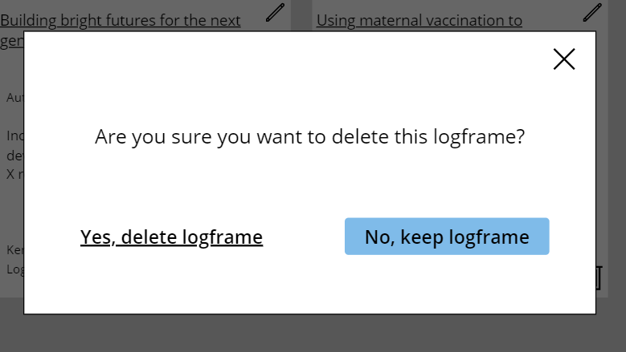

## Create a Logframe

Logframe creation happens within the Build a Logframe module. The bulk of the application’s functionality exists within this module. This section will step through each portion of the logframe creation process in detail.

### Initiate Logframe Creation

1. Click **Build a Logframe** in the main navigation to open a blank set of forms for creating a logframe.

### Enter Project Info

1. This screen enables entering basic identifying information for the project:
   1. **Project Title**: a unique identifier for the project.
   2. **Project Goal**: what the project is looking to achieve
   3. **Region**: broad area(s) where the project is taking place
   4. **Country**: country(ies) within a region where a project is taking place
   5. **Logframe Due**: date by when a logframe is due for inclusion in a proposal
   6. **Project Start**: project’s scheduled start date
   7. **Project End**: project’s schedule end date
   8. **Donor**: person/group financially supporting the project
   9. **Reviewer**: employee internal to the organization who will be responsible for reviewing and approving the logframe

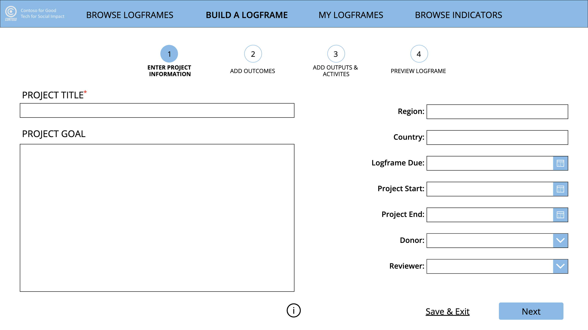

1. Enter the title, **Using maternal vaccination to reduce infant mortality in Tanzania**,in the Title form field. Fill in the remainder of the fields on this page, as desired.
   1. Entering a Title is the only native requirement for moving past the Project Info screen.   
      *(NOTE: organizations can customize the application to require that other fields be completed before allowing the user to move past this screen.)*

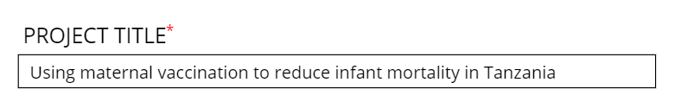

### Access Contextual Help

1. To view additional information on how to proceed through the Build a Logframe process, click the **“i” button** at the bottom of each screen. (*NOTE: Organizations can customize the help text on each page.)*

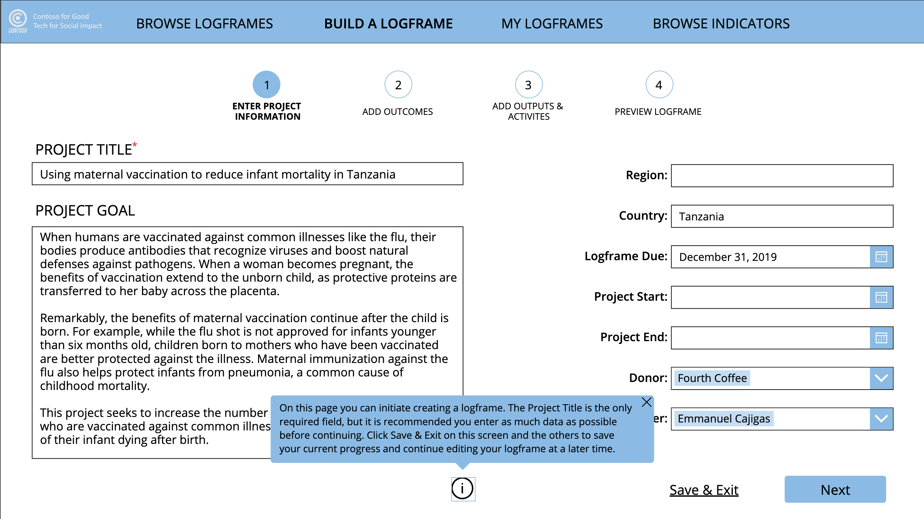

1. Click **Next** to proceed to the Add Outcomes screen OR click **Save & Exit** to save entered contents without proceeding to the Add Outcomes screen.

### Select Outcomes

1. This screen enables **selecting outcomes**—housed within outcome areas (some organizations may call these Sectors or a similar term)—**and indicators** associated with those outcomes.   
   (*NOTE: It is possible to choose outcomes from multiple outcome areas.*)

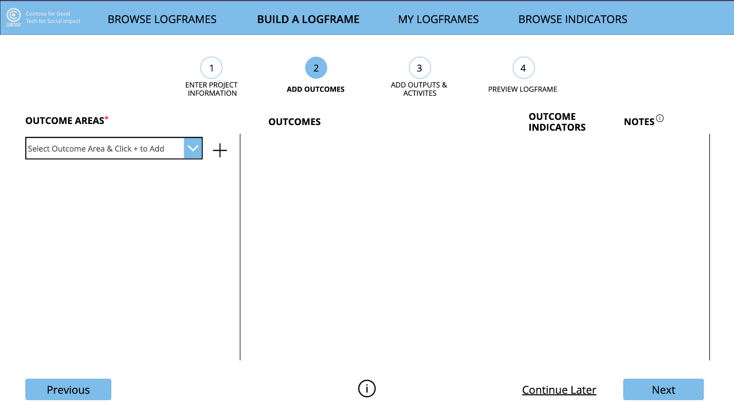

1. Click the **dropdown** that says **Select Outcome Area & Click + to Add**. Select **Maternal, Infant, and Child Health** from the dropdown menu and **click +** to the right of the menu to add it as an outcome area to the logframe. Do the same for **Immunization and Infectious Diseases**.

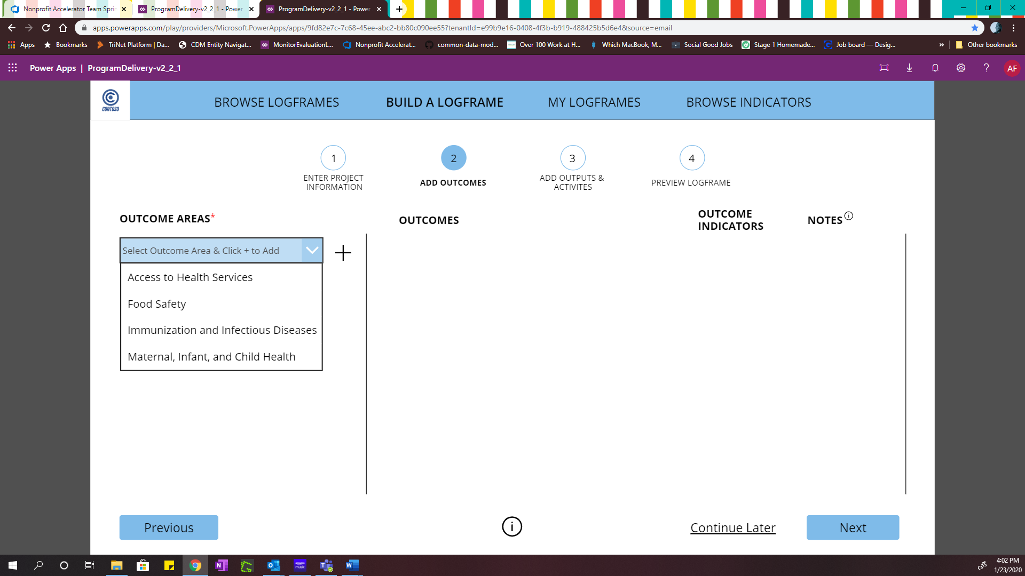

1. Click **Maternal, Infant, and Child Health** in the Outcome Areas column. Select **Reduced death rate from sudden infant death syndrome (SIDS)** and **More pregnant women receive early and adequate prenatal care** from the list of Outcomes by **checking the checkbox** next to each.

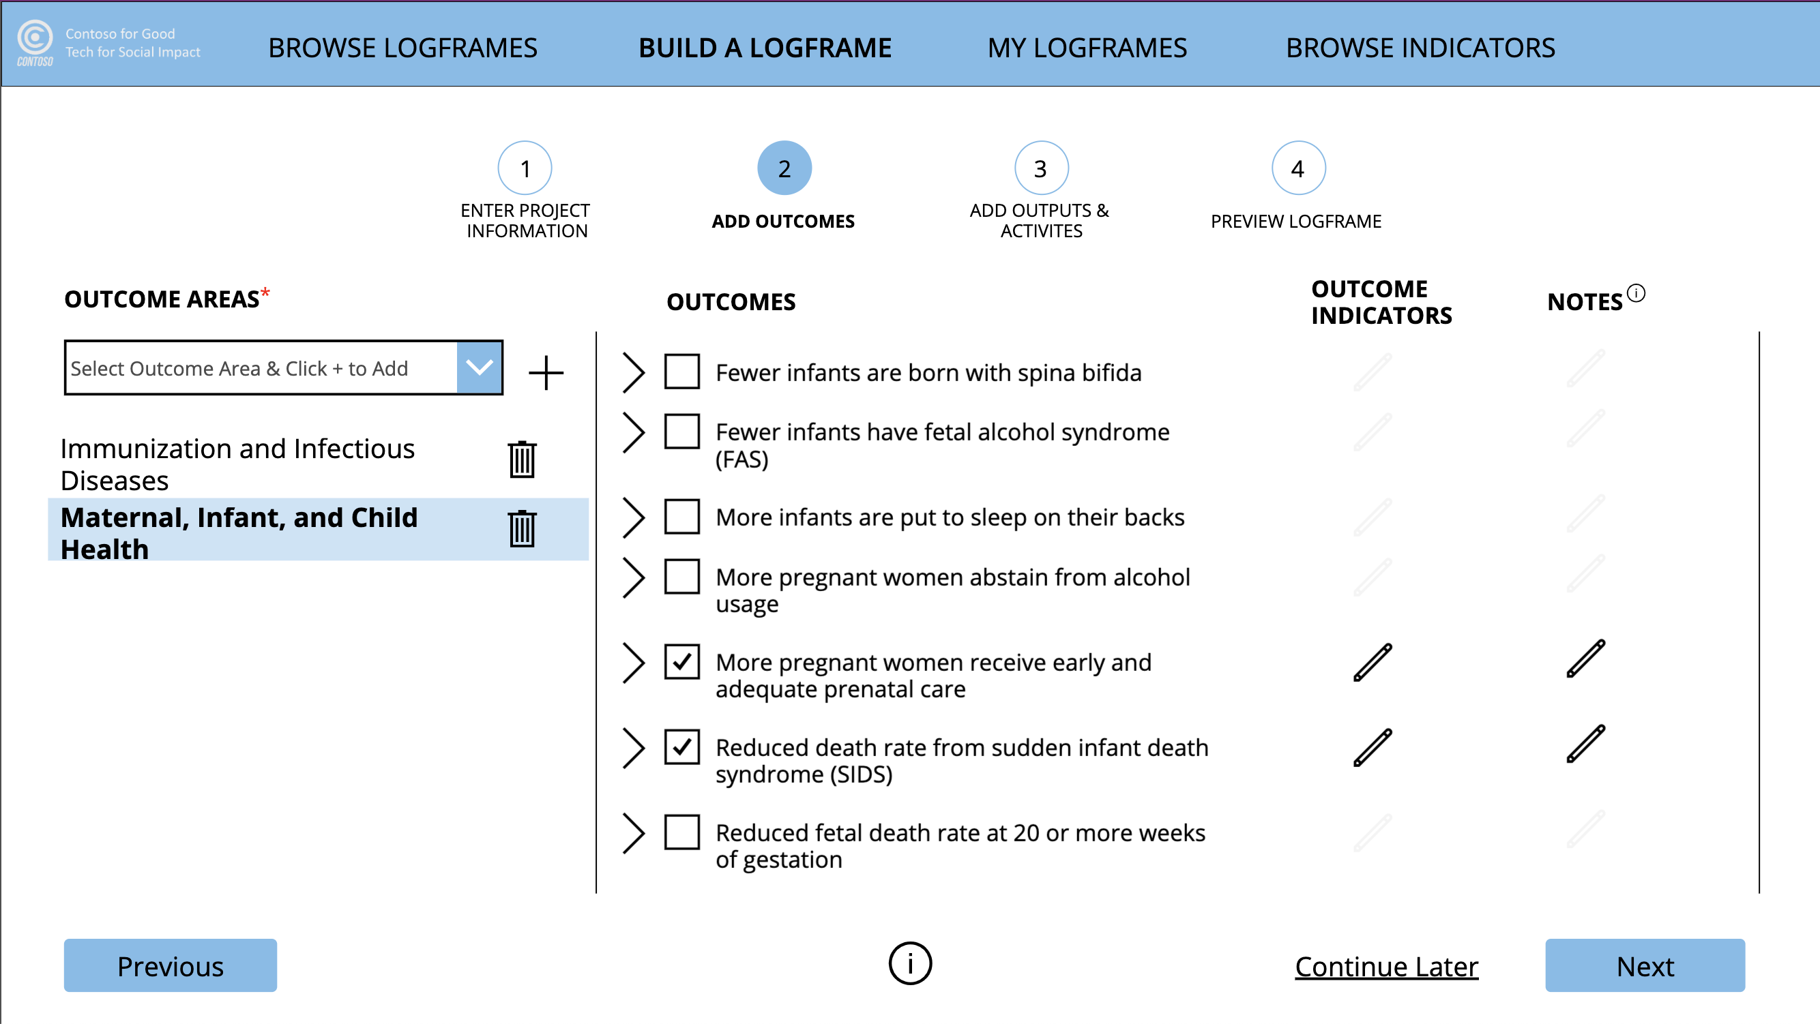

1. Click the carrot to the left of **Reduced death rate from sudden infant death syndrome (SIDS)** to view the description for that outcome.

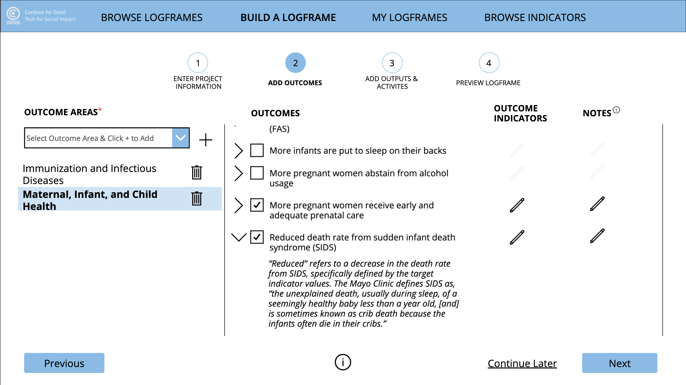

### Select Outcome Indicators

1. For the outcome **Reduced death rate from sudden infant death syndrome (SIDS),** click the **pencil icon** next to it, in the **Outcome Indicators column**.

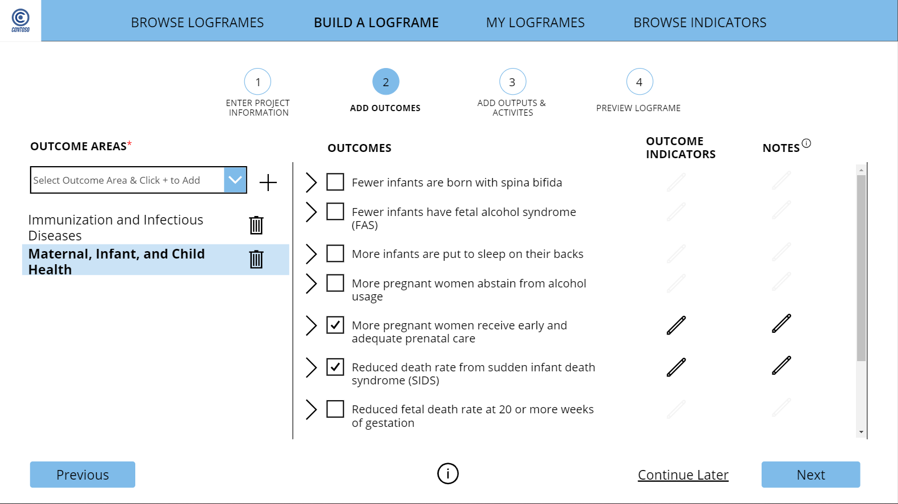

1. This screen presents the option to select from your organization’s **Internal indicators** or from indicators that are part of a **Standard library**. This release of the application features the UN’s **Sustainable Development Goals (SDGs)** within the Standards.
   1. Subsequent releases may include additional Standards libraries (e.g., IRIS+, GuideStar).
   2. While not featured in the screen design, organizations can customize the indicators list to include External (e.g., Donor) indicators as well.
   3. Subsequent releases may enable matching indicators from Internal libraries to External and Standards libraries.

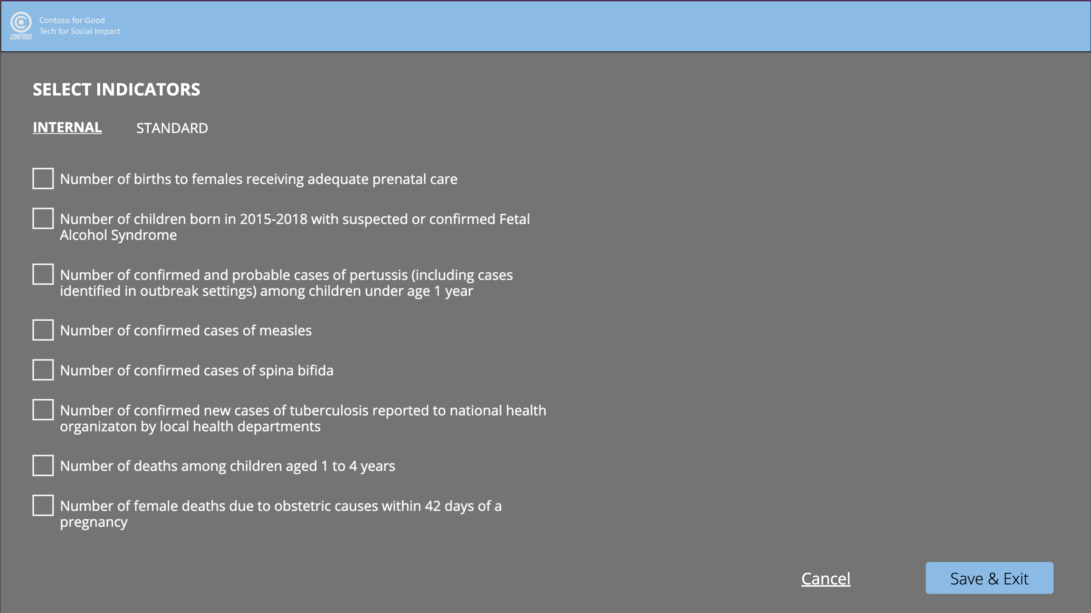

1. Select **Number of infant (under age 1 year) deaths due to SIDS** from the **Internal** library by checking the checkbox next to this indicator.

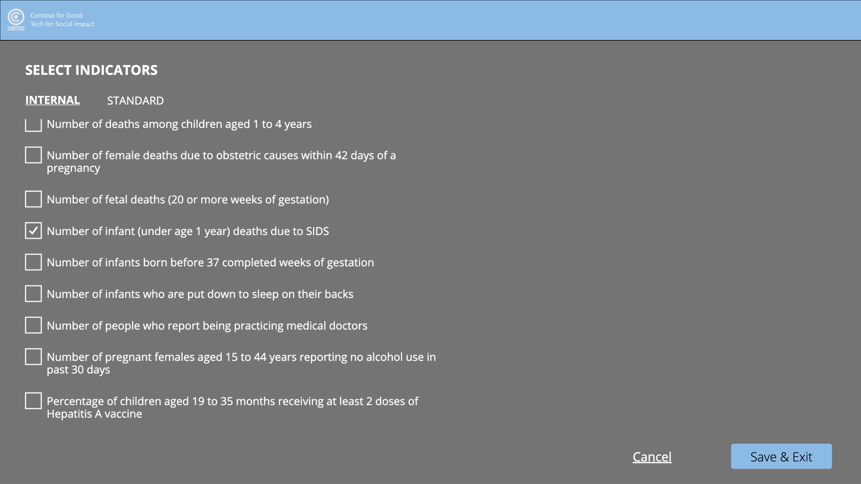

1. Click the **Standard** tab, and then select **Sustainable Development Goals** from the **Indicator Library dropdown menu.** Select **SDG3: Ensure healthy lives and promote well-being for all at all ages** from the **Individual SDGs dropdown menu**.

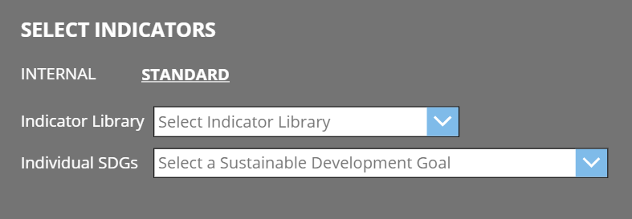

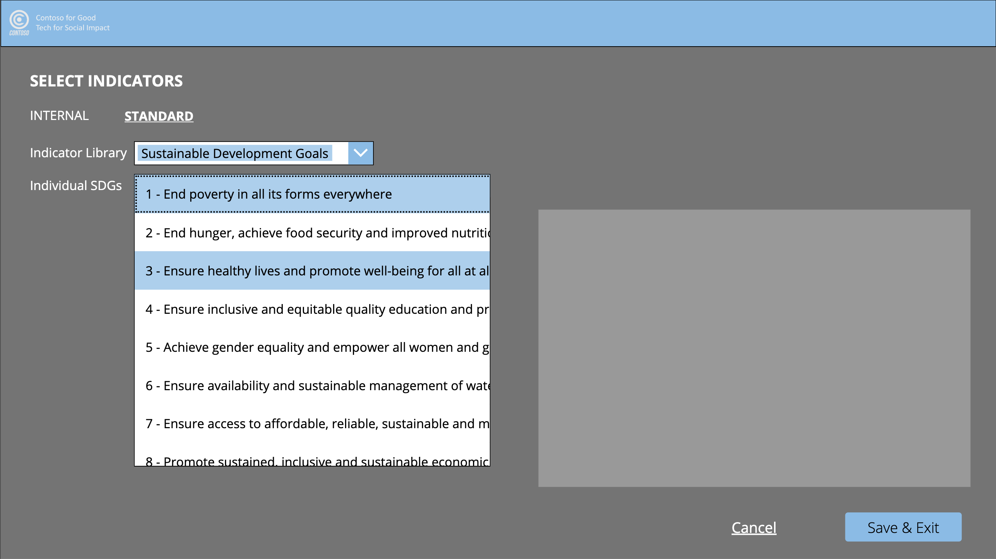

1. The list of all SDG3 targets and indicators are now in view. Select the target **3.2 -** **By 2030, end preventable deaths of newborns and children under 5 years of age, with all countries aiming to reduce neonatal mortality to at least as low as 12 per 1,000 live births and under-5 mortality to at least as low as 25 per 1,000 live births.** View related indicators in the right-hand panel. Select the indicator **3.2.2 -** **Neonatal mortality rate** by checking the checkbox to its left.

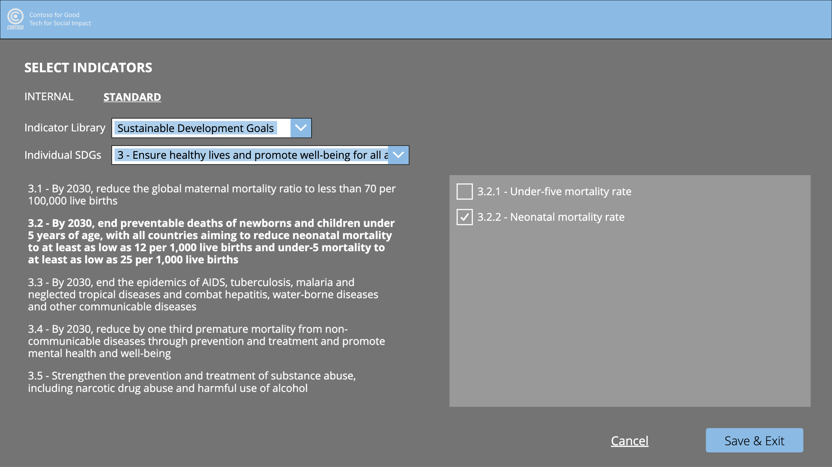

1. Click **Save & Exit** to add the selected indicators to the selected outcome.
2. Choose **indicators for the other selected outcomes**, if desired.
3. To view or edit the selected indicators for any outcome, click the **pencil icon in the Outcome Indicators column** again .

### Enter Outcome Notes

1. If desired, click **the pencil icon in the Notes column** to add further detail or context to the selected outcome, **More pregnant women receive early and adequate prenatal care**.

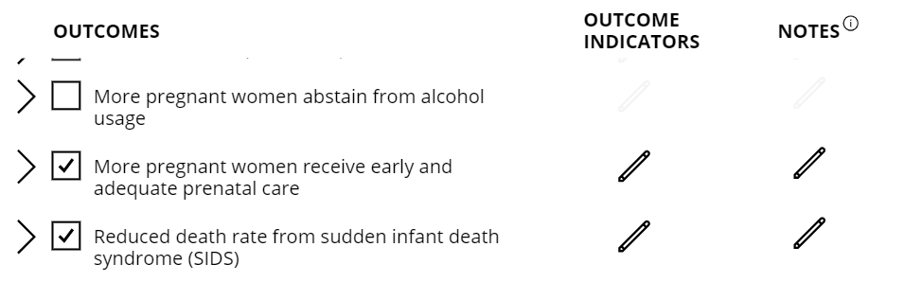

1. In the pop-up box, enter the text: **Need to be aware of what’s typically defined as “adequate prenatal care” in Tanzania** for the note, and click **Save**.

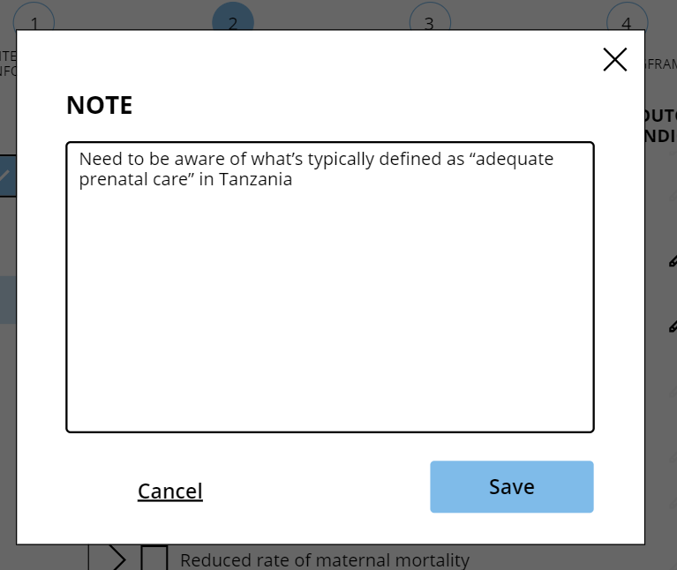

1. Click **Next** to proceed to the Add Outputs & Activities screen.

### Enter Outputs & Activities

1. Select **Reduced death rate from sudden infant death syndrome (SIDS)** from the **Selected Outcome** column.

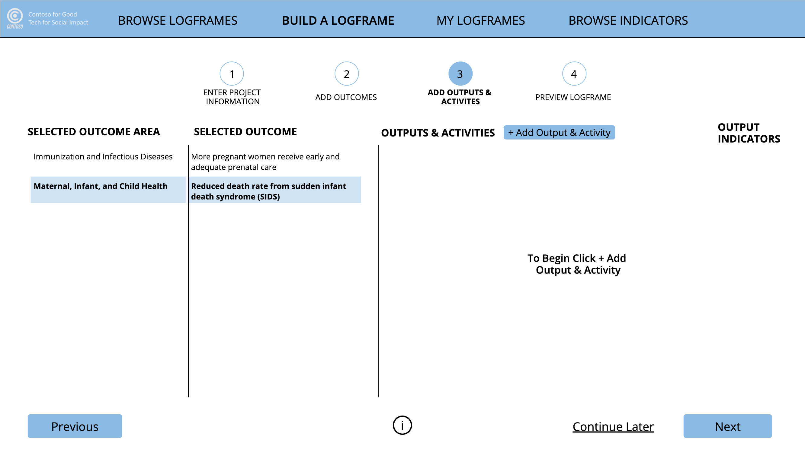

1. Click **+Output & Activity** to add an output (and associated activity) to the selected outcome.



1. In the pop-up box, enter **Babies are put to sleep on their backs** as the output, and **New mothers are trained prior to giving birth by medical professionals, teaching them about the dangers of putting babies to sleep on their sides or stomachs** as the associated activity, and click **Save**.

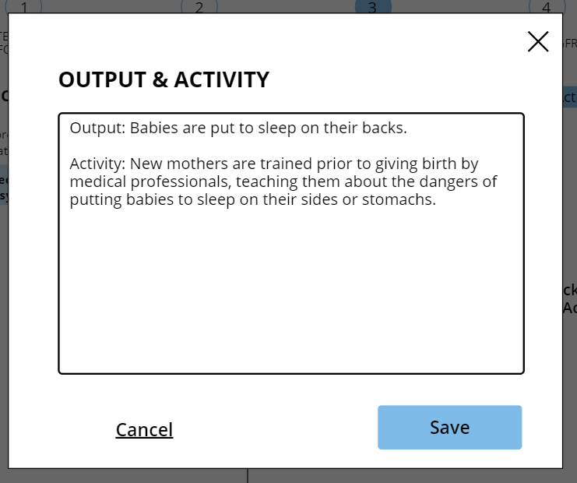

1. If desired, **add more outputs and activities**, and associated indicators to the currently selected outcome, or other outcomes on this screen.
2. Click the **pencil icon** located above and on the right-hand side of the entered Output & Activity text **to edit this text**. **Click the X** to the pencil’s right **to remove** the added Output & Activity.

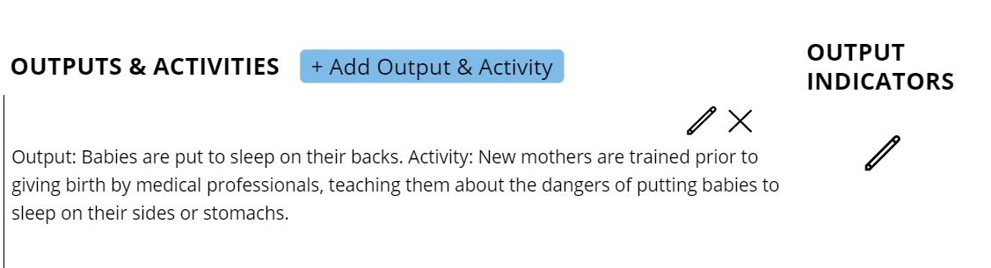

1. Click the **pencil icon in the Output Indicators column** to the right of the entered Output & Activity to add one or more indicators to the Output. The interface and interactions are the same as on the Outcomes screen.



## Prepare Logframe for Review

The final step of the Build a Logframe process enables triggering the logframe review process, whereby the selected reviewer will receive an email indicating that the logframe is ready for review.

### Preview the Logframe

1. Click **Next** on the Add Outputs & Activities screento navigate to the **Preview Logframe** step of Build a Logframe. This screen displays the **complete logframe**, per the selections made and text entered on the previous three screens.

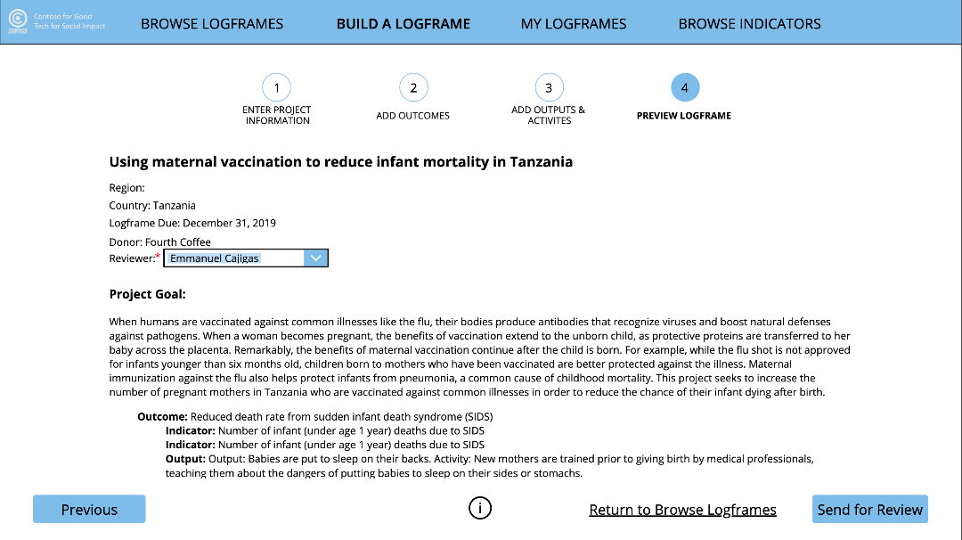

### Send Logframe for Review

1. Select a **Reviewer** from the **dropdown menu**. If one was already selected on the Enter Project Information screen, the selected name will already be populated here. (*NOTE: selecting a Reviewer is required to proceed on this screen, as the Send for Review functionality is tied to this selection. Organizations can make modifications as needed to suit their business processes*.)

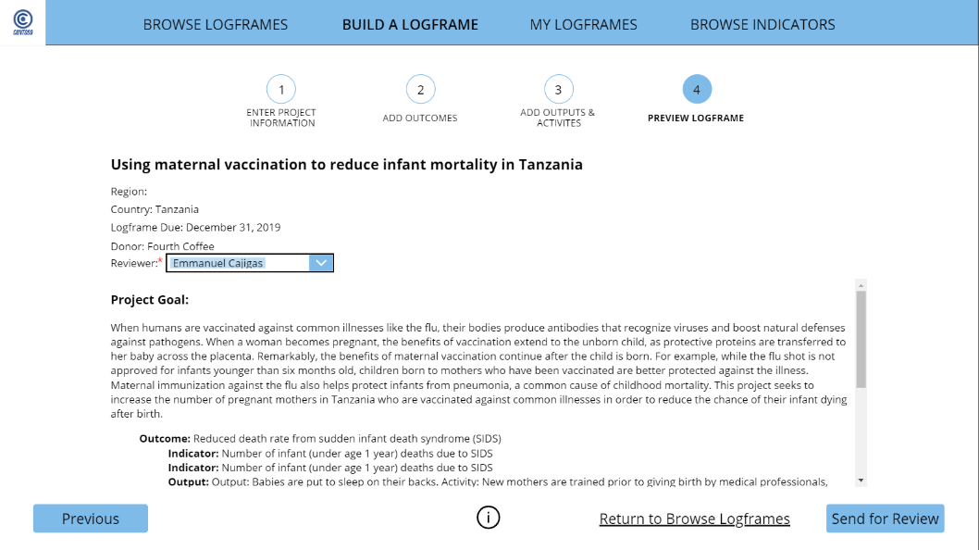

1. Click **Send for Review** at the bottom right of the Preview screen once you’re ready for the reviewer to review the logframe.



1. Click **My Logframes** (or Browse Logframes). Locate the logframe you just created. Click the **clipboard + magnifying glass icon**. Click on the dropdown menu and change the status from **Review Not Started** to **Review in Progress** once the reviewer has begun reviewing the logframe.

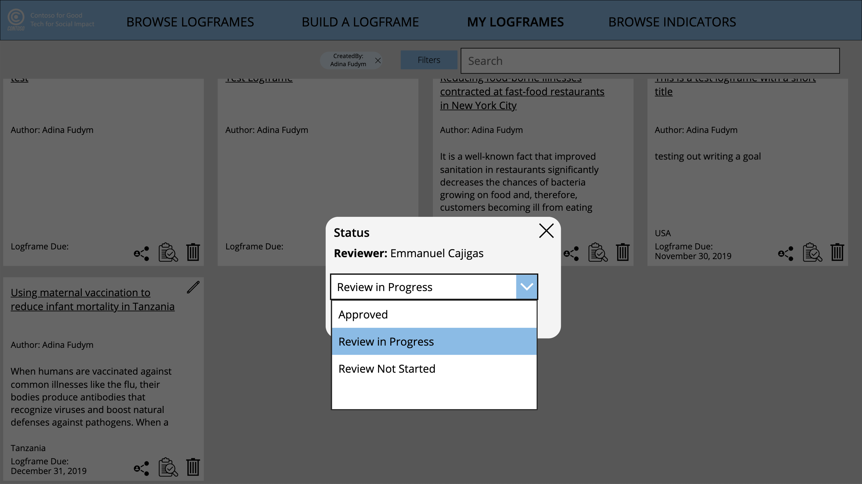

1. Once the reviewer has finished his review, change the dropdown menu status from **Review in Progress** to **Approved.** *(NOTE: In subsequent releases, a review and approval workflow will potentially be built into the application, which will auto-update the review status accordingly.)*

## Browse Indicators

This module enables browsing all indicators available for users at an organization, including Internal (i.e., native to the organization), External (e.g., donor) and Standard (i.e., from a reputed library). The application isn’t currently loaded with any External indicators, but organizations have the capability to load them on their own, if desired.

### Browse Internal Indicators

1. Click **Browse Indicators** in the main navigation.
2. From the **Indicator Type** **dropdown menu**, select **Internal**.

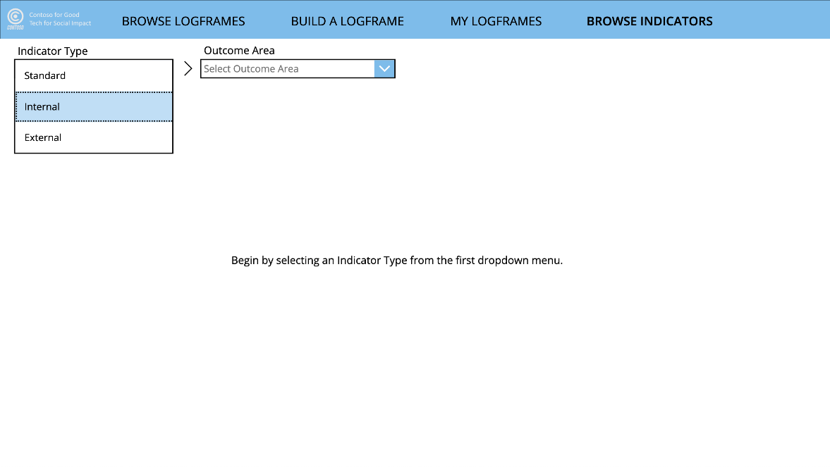

1. From the **Indicator Library** **dropdown menu**, select **Food Safety** to see a list of all Food Safety outcomes and corresponding indicators.

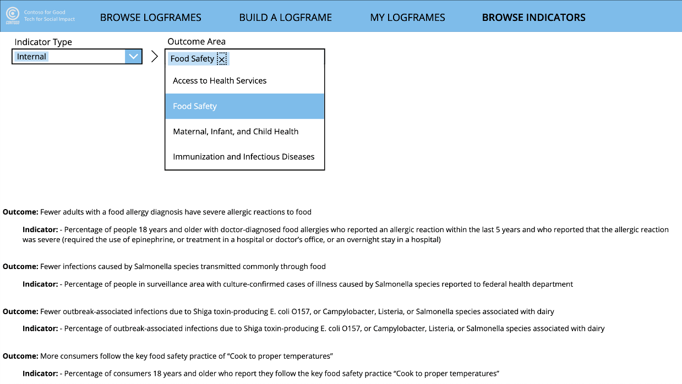

1. Click the **Outcome Area dropdown menu** again to view the outcomes and indicators housed within the **other Outcome Areas**.

### Browse Standard Indicators

1. On the Browse Indicators page, select **Standard** from the **Indicator Type dropdown menu**.

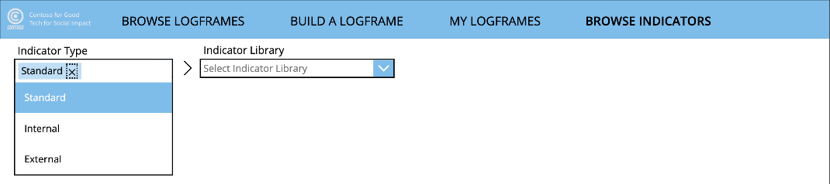

1. From the **Indicator Library dropdown menu**, select **Sustainable Development Goals**.



1. Click on the icon for **SDG1: No Poverty** to view all targets and associated indicators for this SDG. Use the **carousel control** to navigate to **SDG icons not currently in view**.

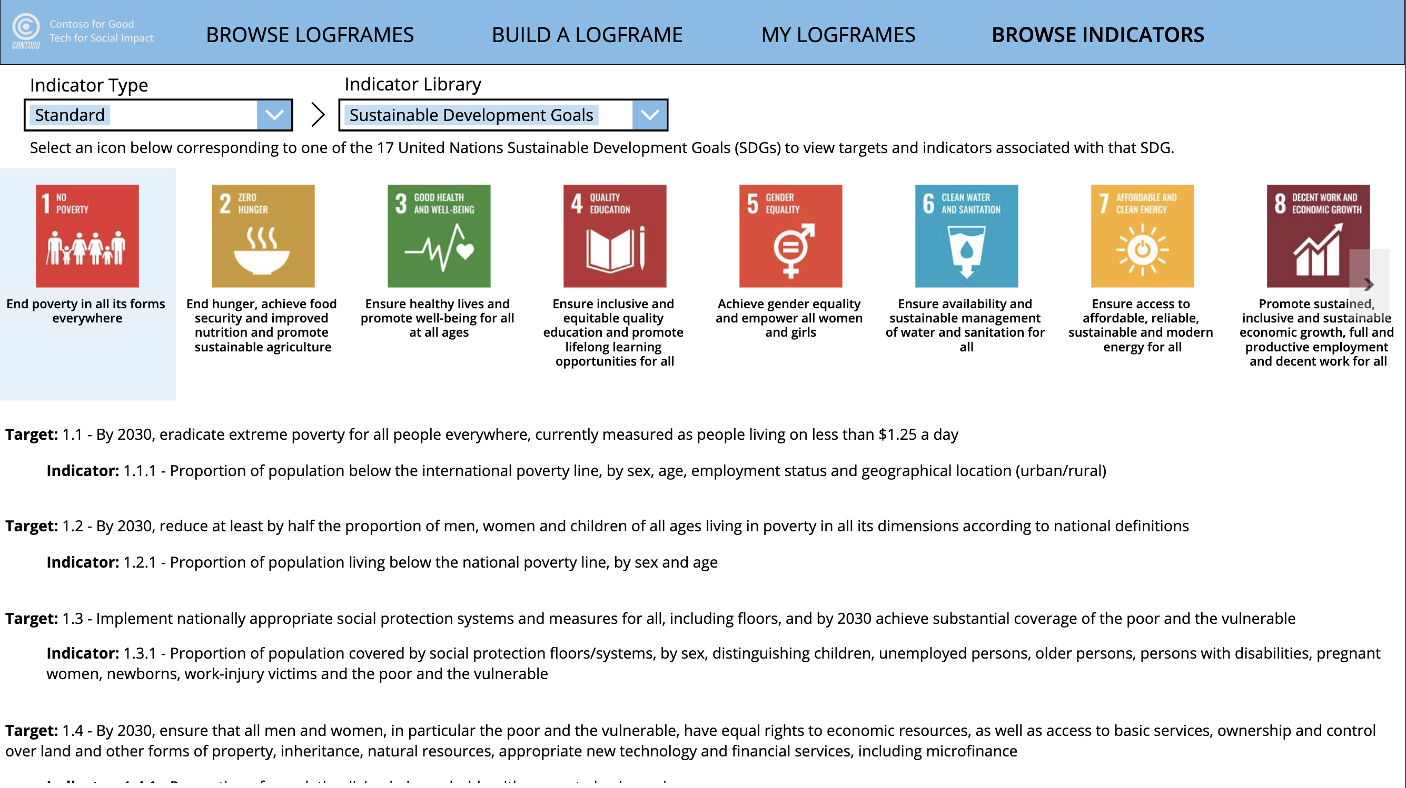

1. If desired, click on the icon for **any of the other SDGs** to view their targets and associated indicators.

# IATI

The Nonprofit Accelerator has a Nonprofit IATI add-on solution that can be utilized to export an IATI xml file. This section outlines some of the functionality that this solution provides.

## Key Tables & Navigation

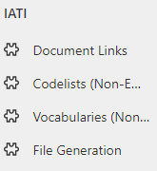

#### Document Links

#### This stored links to an online, publicly accessible web page or document as well as recording its file type and publication date.

#### Codelists (Non-Embedded)

Non-functional codelists that usually provide lookup information on e.g. currencies, languages in use, countries, etc.

#### Vocabularies (Non-Embedded)

Sources for non embedded codelists.

#### File Generation

Table used for the generation of IATI XML files.

## IATI File Export process

1. Navigate to the make.powerapps.com and click Apps, then click on **IATI Hub**.
2. On the **Site Map**, scroll to the **IATI** section and click **File Generation**.

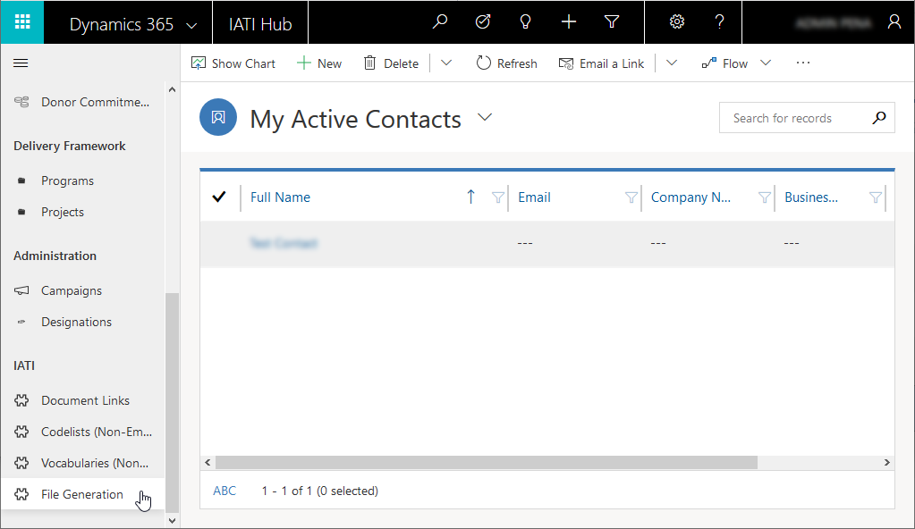

1. Select an **existing record** (to generate IATI files using an existing selection of activities and/or organizations) or **create a new record** (to generate IATI files with a new selection of activities and/or organizations) by clicking the **New** button.

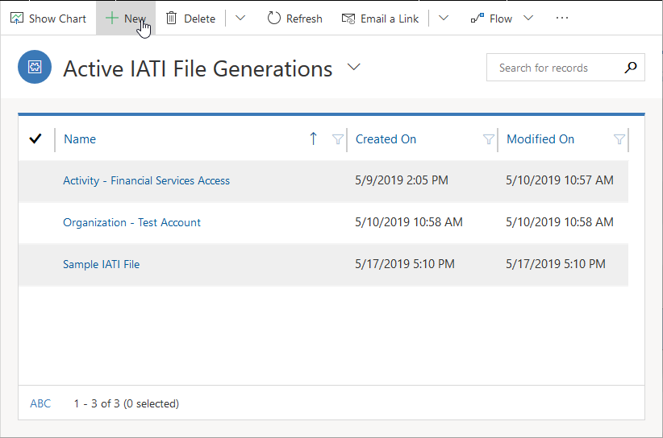

1. Specify a **name** for the file generation instance.

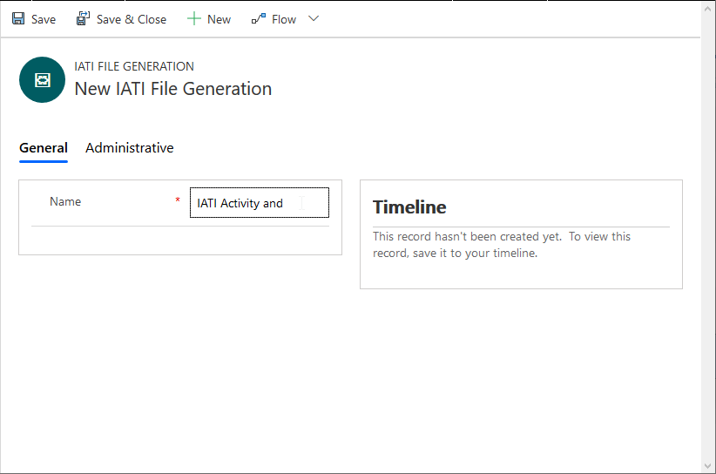

1. Click **Save**.

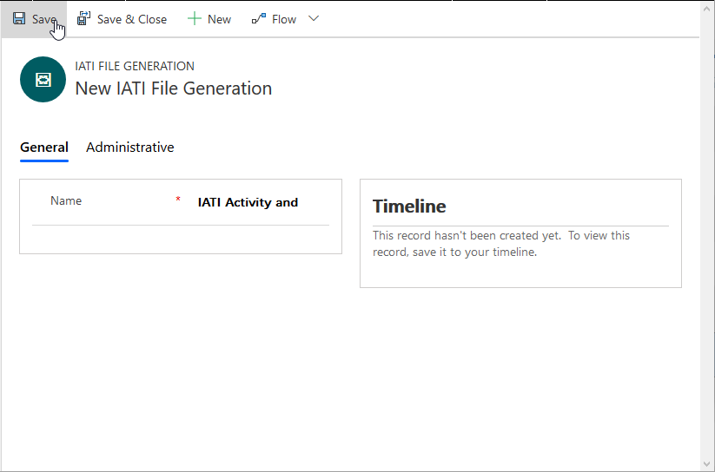

1. If you wish to generate an Activity Standard file, click **Related**, and then click **Delivery Frameworks**. If not, skip to step 10.

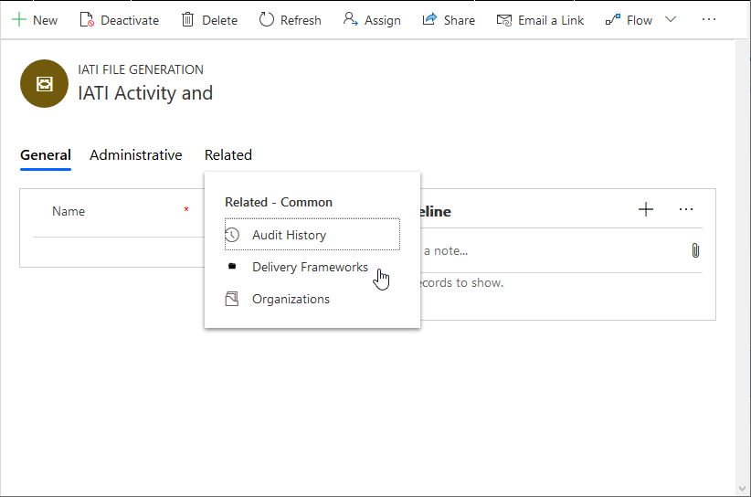

1. Click **Add Existing Delivery Framework**

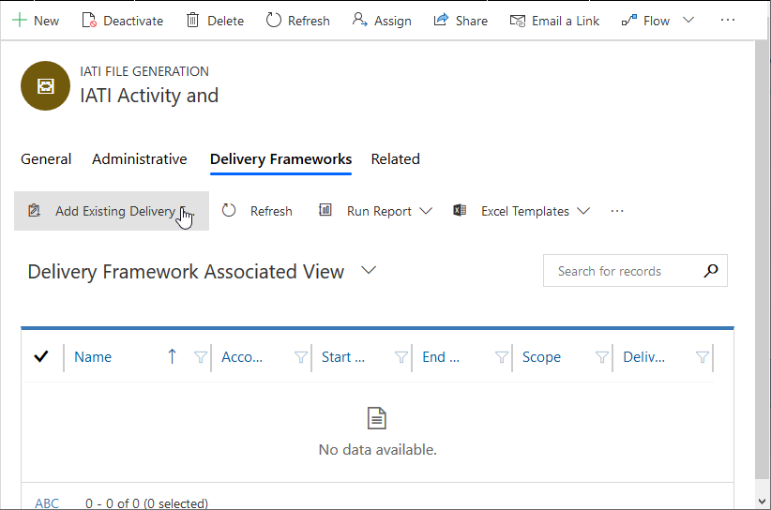

1. Search for and select the desired **Delivery Frameworks** (activities).

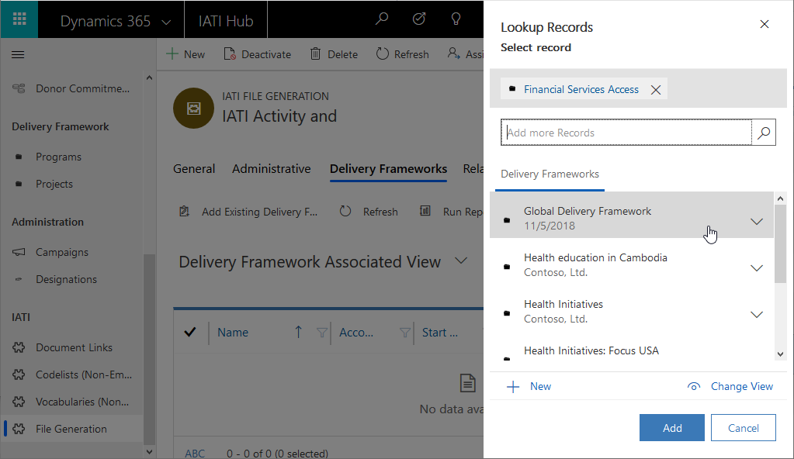

1. When done adding Delivery Frameworks, click **Add**.

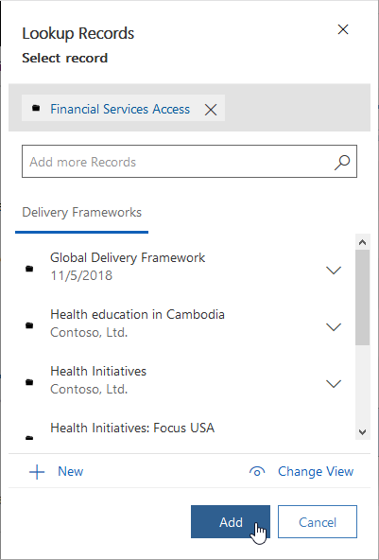

1. If you wish to generate an Organization Standard file, click **Related**, and then click **Organizations**. If not, skip to step 14.

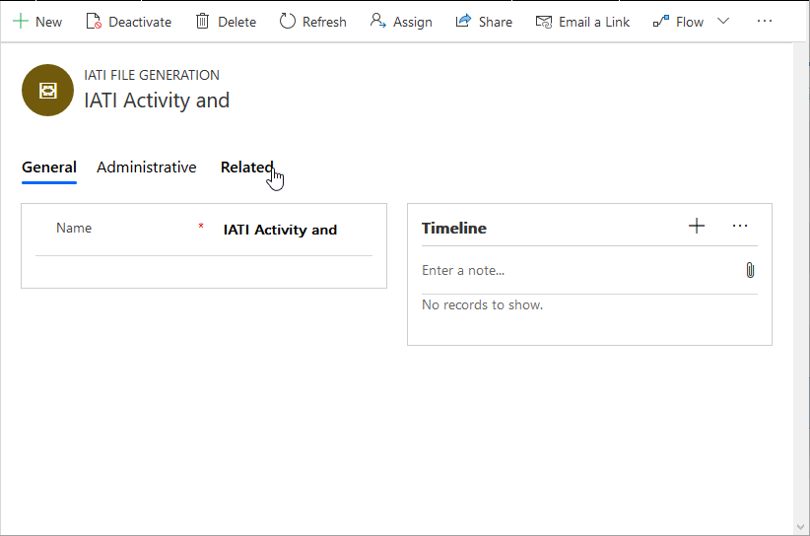

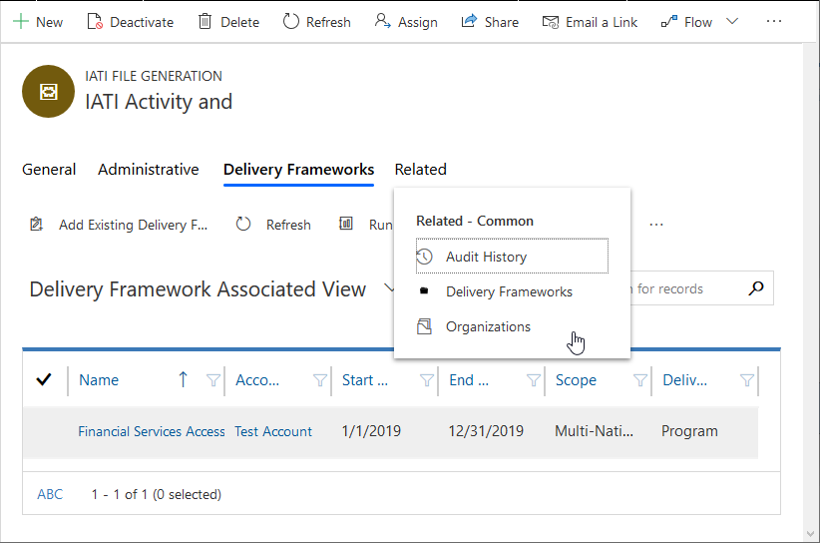

1. Click **Add Existing Account**.

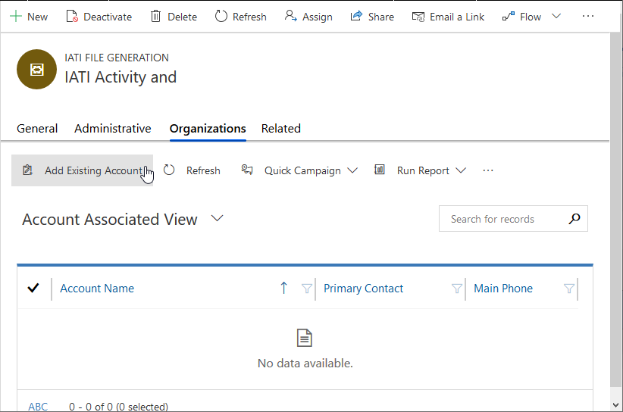

1. Search for and select the desired **Accounts** (organization).

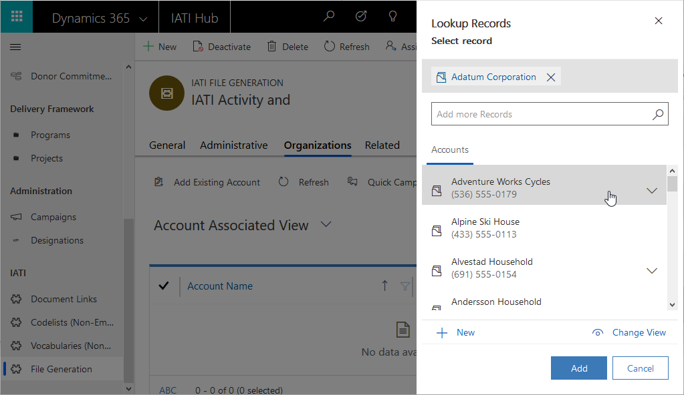

1. When done adding Accounts, click **Add**.

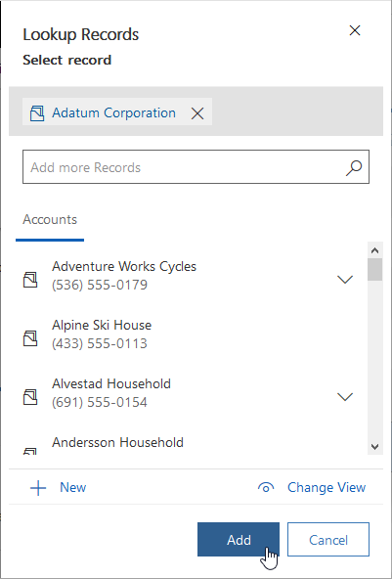

1. After selecting Delivery Frameworks and/or Accounts, click **Flow**.

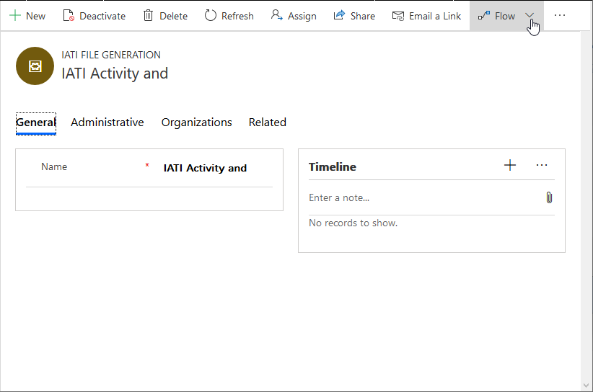

1. Click **Generate IATI XML**.

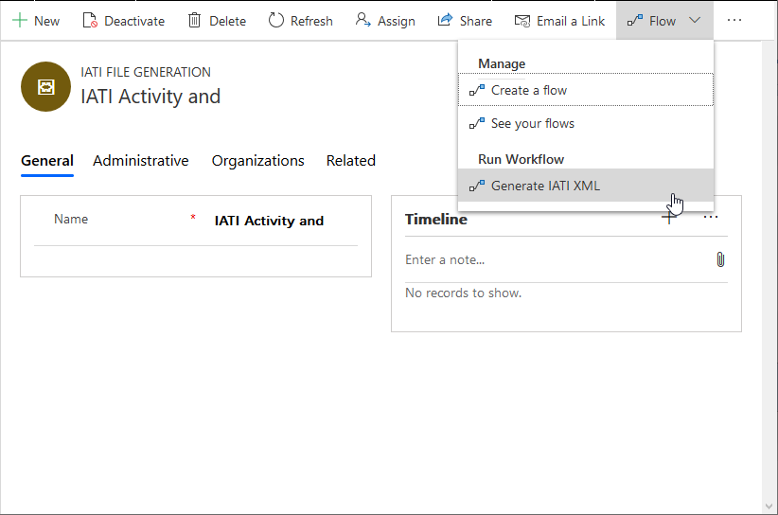

1. Click **OK**.

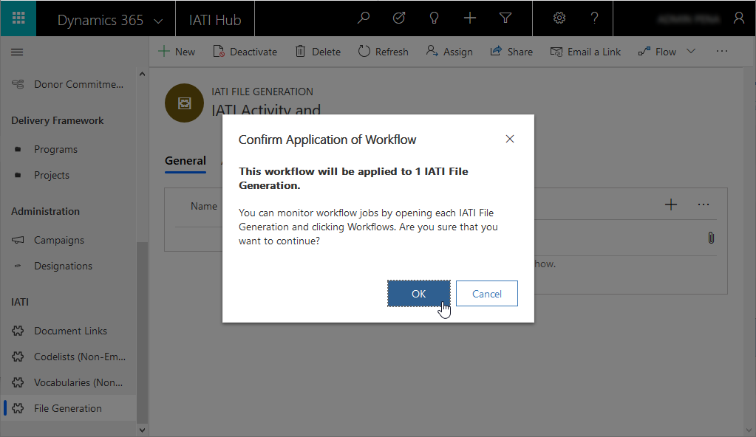

1. Allow a couple of minutes for the process to complete; execution time will vary depending on the amount of selected Delivery Frameworks and Accounts. Click **… (More commands)** on the Timeline section.

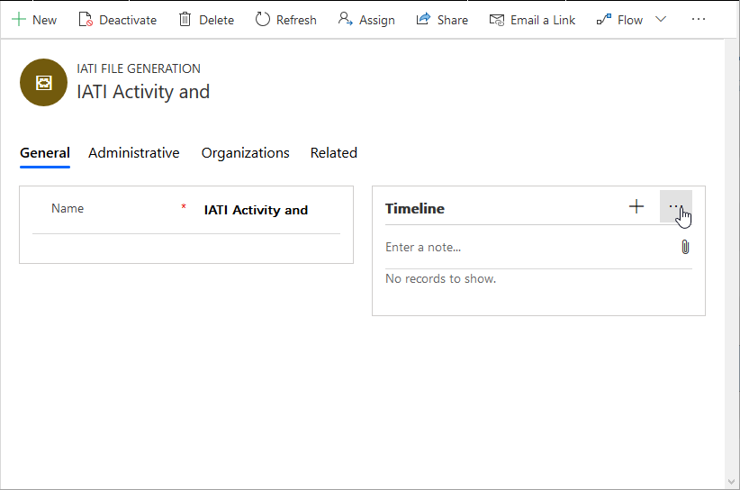

1. Click **Refresh Timeline**.

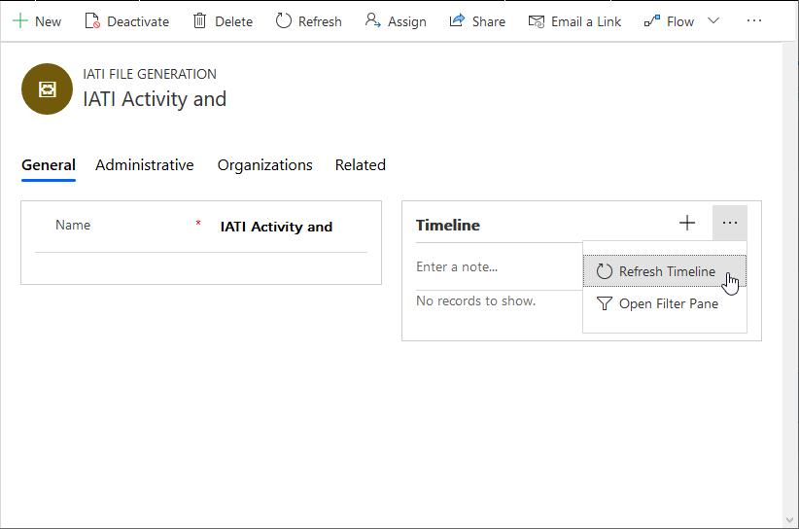

1. The Timeline section will display the generated file(s). The file(s) can be downloaded, verified and uploaded to IATI.

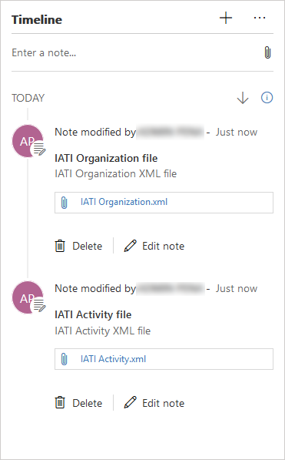

## IATI References

The following is a list of IATI references:

1. IATI Standard

<https://iatistandard.org/>

1. IATI version 2.03 Reference Landing Page

<http://reference.iatistandard.org/203/>

1. Activity Standard

<http://reference.iatistandard.org/203/activity-standard/>

1. Organization Standard

<http://reference.iatistandard.org/203/organisation-standard/>

1. Codelist Reference

<http://reference.iatistandard.org/203/codelists/>

1. Non-Embedded Codelist Repository (GitHub)

<https://github.com/IATI/IATI-Codelists-NonEmbedded>

# Administration

The Nonprofit Accelerator includes an Administration sample application that includes key nonprofit accelerator components that are generally reserved for application administrators or super users. It includes the following components:

#### Graphical user interface, application navigation

#### Designations

An area to which funds may be allocated, including a GL-relevant accounting code. Designations are the way a donor instructs the nonprofit to direct their donation.

#### Payment Methods

Payment Method is a placeholder table for payment method customizations that may be supported by partner or custom applications.

#### Membership Categories

Represents the types of membership associated to products.

#### Resources Catalog

Catalog that contains beneficiaries that are not contacts/accounts.

1. <https://thenounproject.com/icon/2362503/>